Summary of the problems encountered in the cascade board
一、Problems encountered
According to the guidance of the official document, the downloaded mmwave_studio script is run: Cascade_Configuration_MIMO.lua and Cascade_Capture.lua, and the running results are shown in the figure:
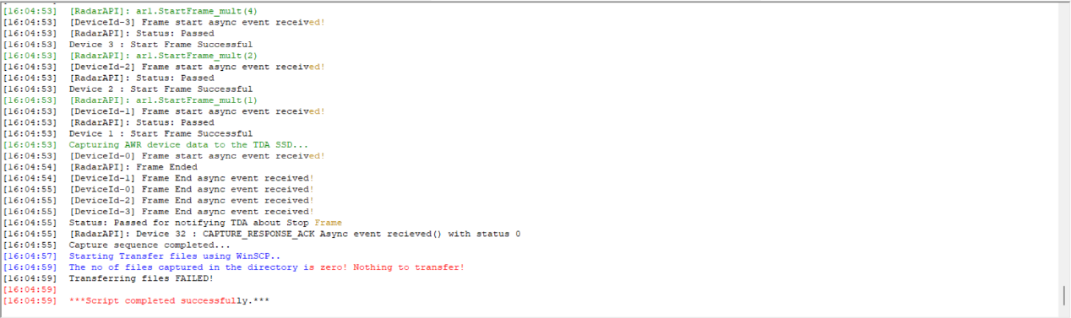
图1 mmwave_studio运行结果
Using WinSCP to view SSD, only a new folder and no data under the folder, as shown in the figure:
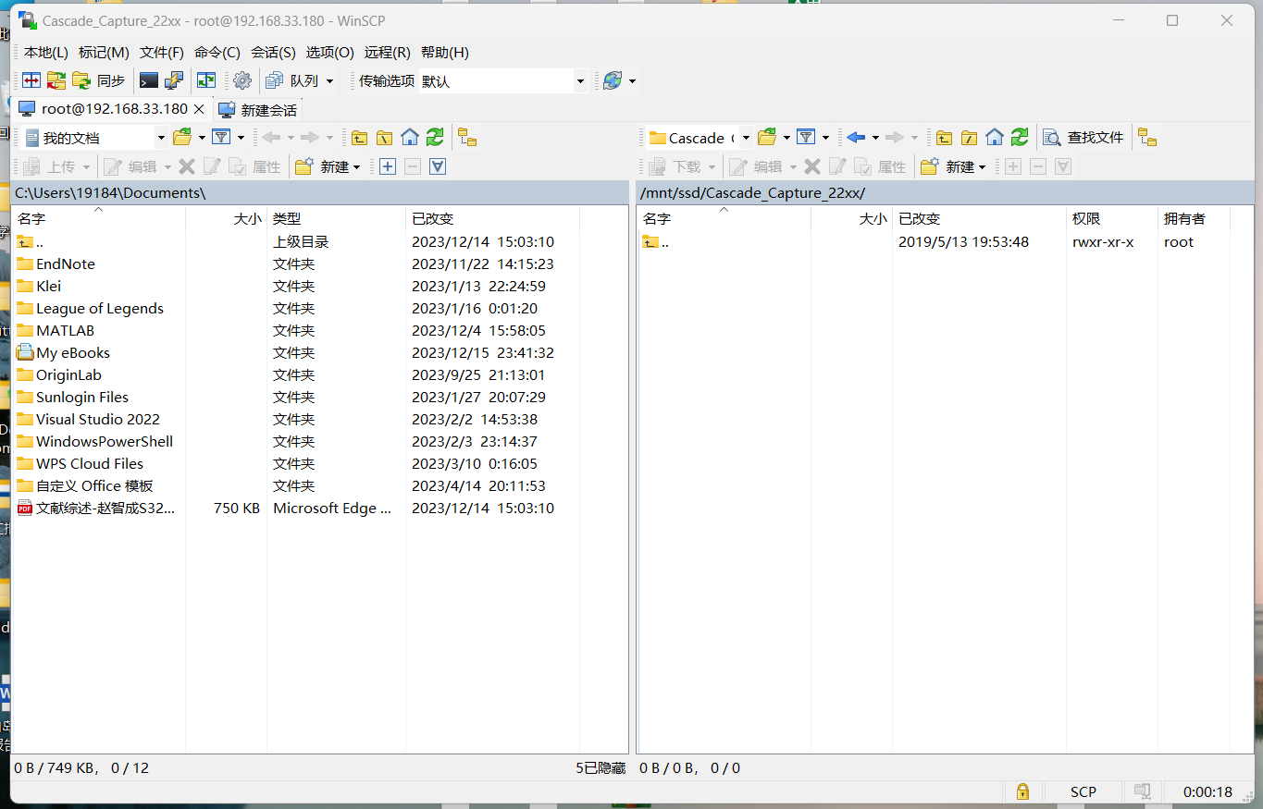
Figure 2 There is no radar echo data under the folder in the SSD
The DSP board status is as shown below:
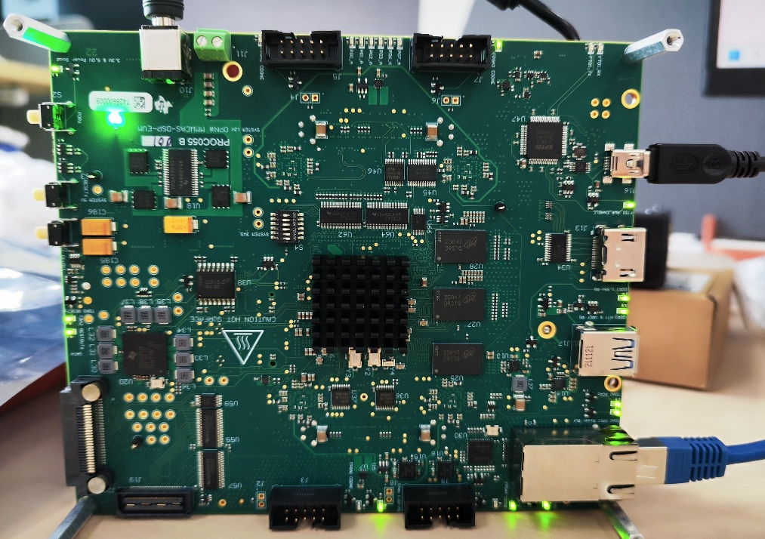
图3 DSP板运行状态图
二、Forum information
Check the related problems and solutions to the forum, mainly refer to the following two articles: AWR1243: Cascade EVM-No data files in SSD after successful running script Cascade_Capture.lua-Sensor Forum-Sensor-TI E2E Support Forum and MMWCAS-DSP-EVM: Cascade EVM-No data files in SSD after successful running script Cascade_Capture.lua-Sensor Forum-Sensor-TI E2E Support Forum:
For the first forum, mmwave_studio error is shown in the figure:
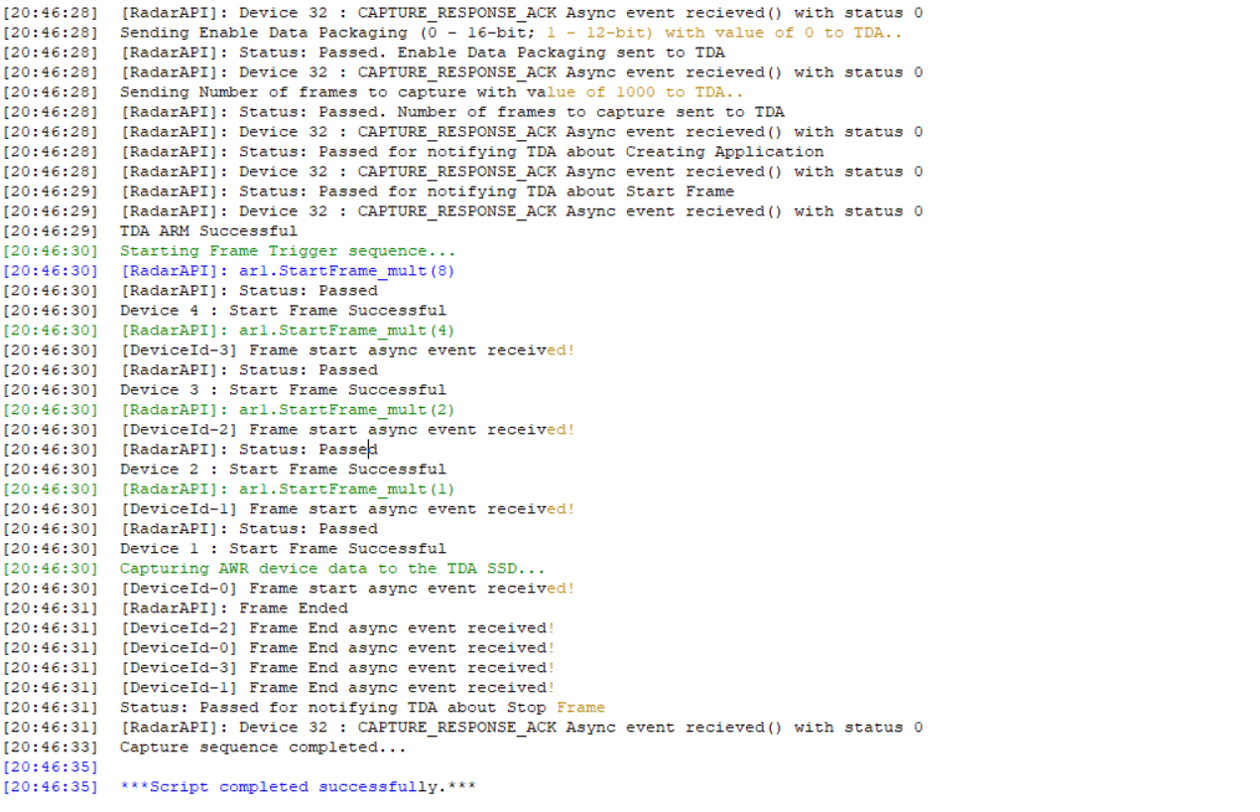
Figure 4, mmwave _ studio, reported an error
The official explanation given by the forum is the FPGA start timing problem, and the DSP back indicator should be shown in the figure:
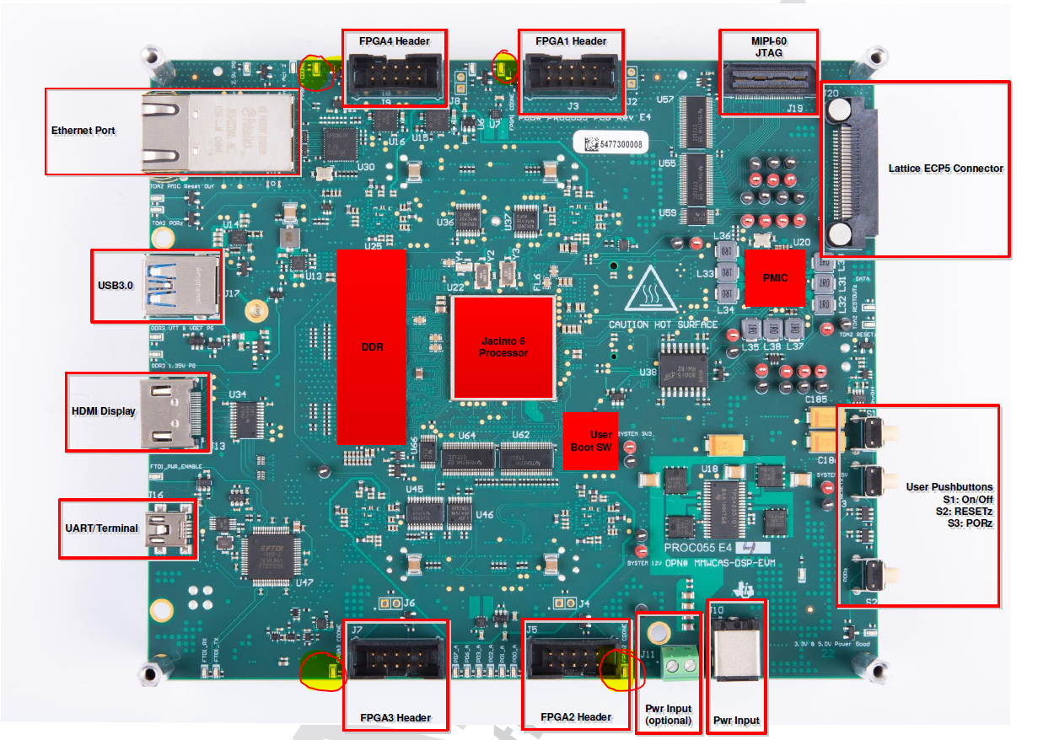
Figure 5 DSP normal display Fig
The four FPGA indicators should be lit normally, and our board can only be lit on FPGA 3. As shown in figure 3 above, nothing else can be lit up, but the problem is not solved.

