PGA460测试异常：
原理图：
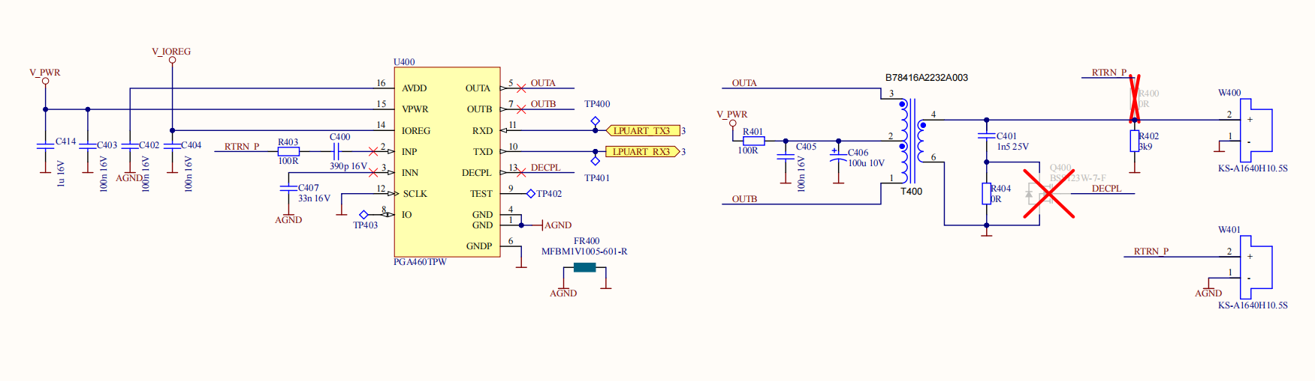
在生产过程中测试，出现测试不通过的现象。
测试数据如下：
"name": "PGA460",
"testId": 14,
"startTimeMs": 125,
"stopTimeMs": 459,
"durationMs": 334,
"success": false,
"serialLog": [
"[ 125] PGA460: START",
"[273]PGA460:LISTEN-ECHO: 2,1,1,0,1,1,1,1,1,1,1,1,1,1,1,1,1,1,1,2,2,2,1,1,2,4,4,4,6,7,6,7,8,10,13,15,15,20,22,21,20,18,22,24,25,25,31,32,31,24,27,31,29,28,23,20,22,23,28,26,24,25,25,26,22,19,22,22,24,19,23,24,23,24,36,36,34,26,25,23,22,19,23,28,33,29,21,23,27,31,42,42,31,32,35,34,36,36,34,28,25,30,26,26,23,24,24,25,31,30,25,28,29,29,25,22,22,23,22,28,28,29,29,25,23,25,27,27",
"[355]PGA460:BURST-ECHO: 8,7,6,6,8,7,3,2,1,1,1,1,1,1,1,1,1,1,1,2,2,2,2,2,2,2,2,4,6,6,6,7,9,10,10,9,11,13,14,18,18,17,19,16,19,20,18,18,23,21,22,25,28,31,32,31,29,26,24,25,22,27,27,24,29,31,29,29,31,30,24,26,29,29,29,27,28,28,23,26,28,29,25,28,24,23,24,22,23,23,22,24,26,31,30,30,29,28,25,27,30,33,29,24,20,27,27,27,27,30,27,23,23,26,33,32,28,27,29,25,23,24,24,30,30,30,27,27",
"[ 432] PGA460: FREQ: 30.000",
"[ 436] PGA460: DECAY US: 4080",
"[ 439] PGA460: DIE TEMP: 1.333",
"[ 443] PGA460: AMBIENT TEMP: -7.315",
"[ 447] PGA460: NOISE: 20",
"[ 459] PGA460: FINISHED" ],
"results": [
{
"message": "TEST STARTED",
"success": true
},
{
"message": "ERROR: Listen echo too high",
"success": false
},
{
"message": "Burst echo ok",
"success": true
},
{
"message": "Frequency ok",
"success": true
},
{
"message": "Decay us ok",
"success": true
},
{
"message": "Die temp ok",
"success": true
},
{
"message": "Ambient temp ok",
"success": true
},
{
"message": "Noise ok",
"success": true
},
{
"message": "TEST FINISHED 334ms",
"success": true
}
]
},
备注：测试过程中未接探头。
如下问题请帮忙确认：
- 从原理图看，未接探头时PGA460第二极为浮空状态。请问浮空时读取的数据是否稳定?这样测试是否合理？
- 冶具上的应力会不会影响PGA460的测试结果？
- 未状探头的情况下，外部是否会存在干扰源（声、射频、磁、……）影响PGA460正常运行？冶具上是否需要做屏蔽箱？
- PGA460的供电有哪些具体要求？对电源纹波是否敏感？是否需要较大的瞬间供电能力？

