问题汇总
单独isk烧写
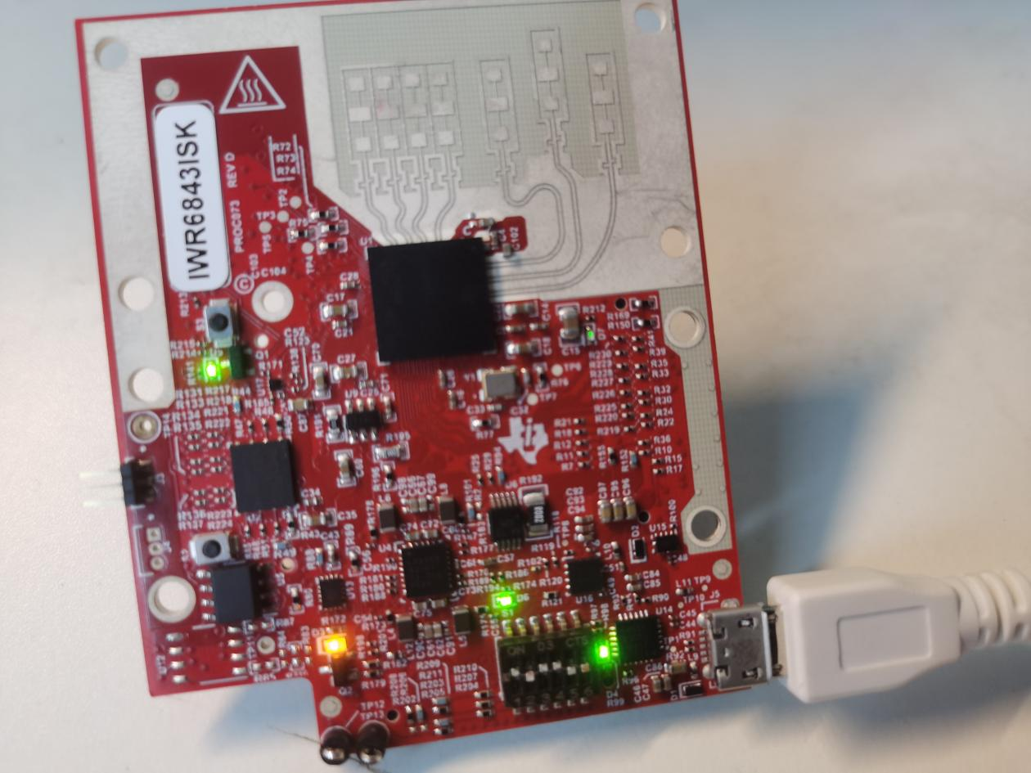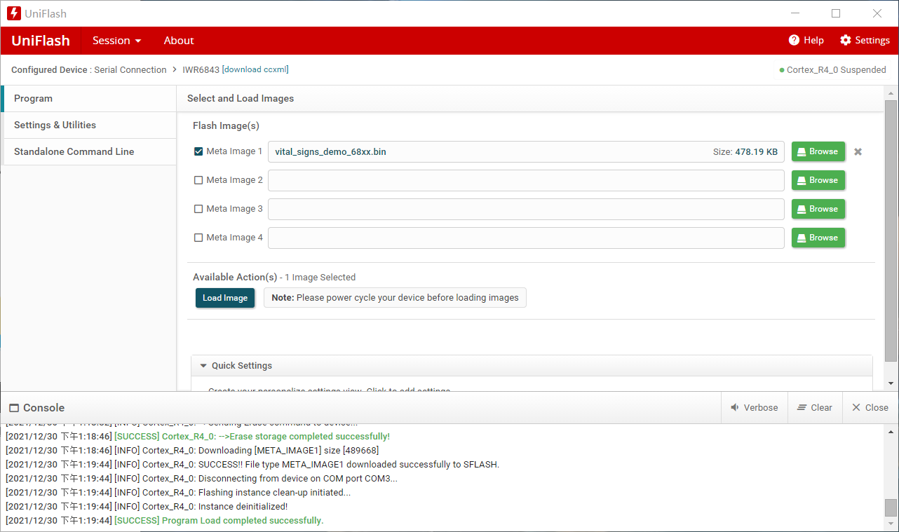
配合MMWAVEICBOOST烧写
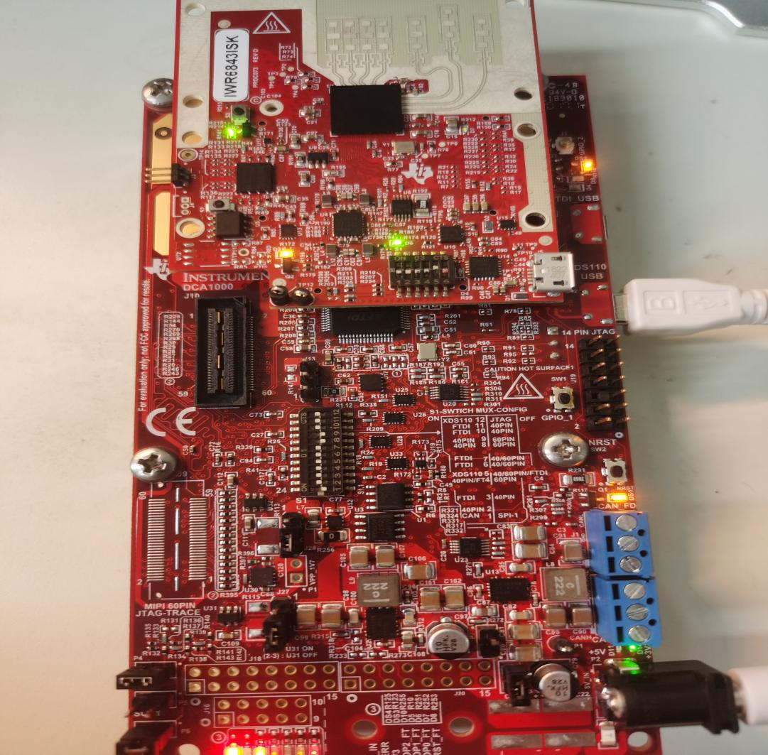
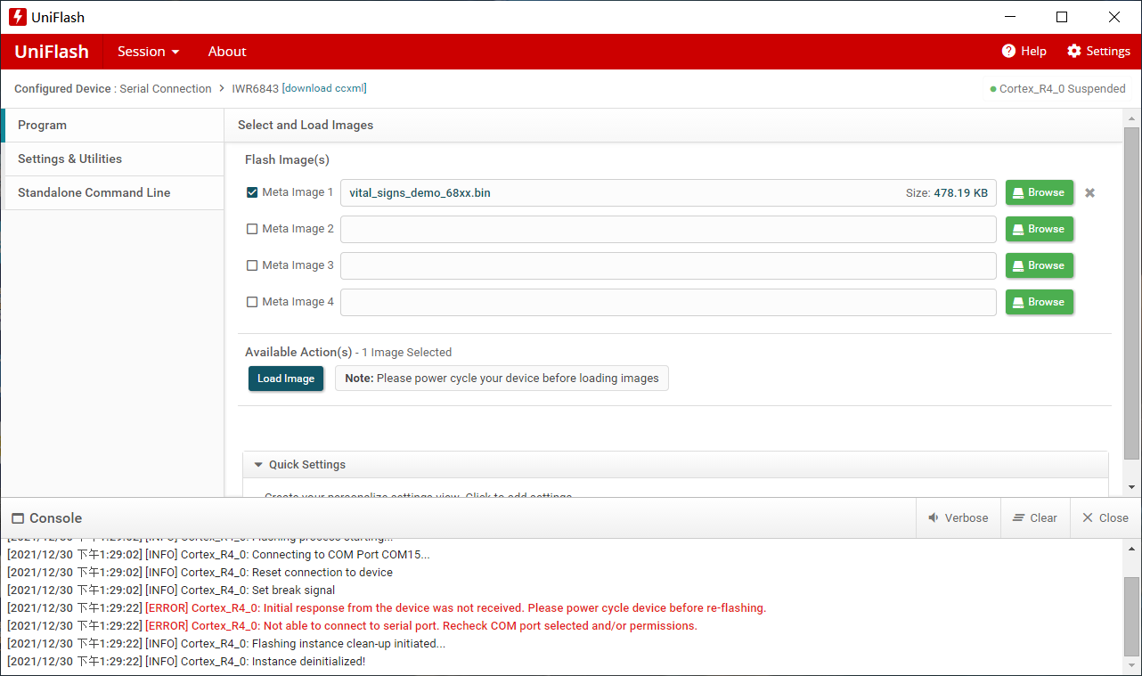
[2021/12/30 下午1:29:22] [ERROR] Cortex_R4_0: Initial response from the device was not received. Please power cycle device before re-flashing.
[2021/12/30 下午1:29:22] [ERROR] Cortex_R4_0: Not able to connect to serial port. Recheck COM port selected and/or permissions

在ccs上使用，端口选用Texas Instruments XDS110 USB Debug Probe，点击save后，我点击Test connection出现问题
[Start: Texas Instruments XDS110 USB Debug Probe_0]
Execute the command:
%ccs_base%/common/uscif/dbgjtag -f %boarddatafile% -rv -o -S integrity
[Result]
-----[Print the board config pathname(s)]------------------------------------
C:\Users\Lenovo\AppData\Local\TEXASI~1\CCS\
ccs1100\0\0\BrdDat\testBoard.dat
-----[Print the reset-command software log-file]-----------------------------
This utility has selected a 100- or 510-class product.
This utility will load the adapter 'jioxds110.dll'.
The library build date was 'Oct 8 2021'.
The library build time was '13:26:36'.
The library package version is '9.5.0.00143'.
The library component version is '35.35.0.0'.
The controller does not use a programmable FPGA.
The controller has a version number of '5' (0x00000005).
The controller has an insertion length of '0' (0x00000000).
This utility will attempt to reset the controller.
This utility has successfully reset the controller.
-----[Print the reset-command hardware log-file]-----------------------------
The scan-path will be reset by toggling the JTAG TRST signal.
The controller is the XDS110 with USB interface.
The link from controller to target is direct (without cable).
The software is configured for XDS110 features.
The controller cannot monitor the value on the EMU[0] pin.
The controller cannot monitor the value on the EMU[1] pin.
The controller cannot control the timing on output pins.
The controller cannot control the timing on input pins.
The scan-path link-delay has been set to exactly '0' (0x0000).
-----[An error has occurred and this utility has aborted]--------------------
This error is generated by TI's USCIF driver or utilities.
The value is '-233' (0xffffff17).
The title is 'SC_ERR_PATH_BROKEN'.
The explanation is:
The JTAG IR and DR scan-paths cannot circulate bits, they may be broken.
An attempt to scan the JTAG scan-path has failed.
The target's JTAG scan-path appears to be broken
with a stuck-at-ones or stuck-at-zero fault.
[End: Texas Instruments XDS110 USB Debug Probe_0]
然后我Launch selected configuration
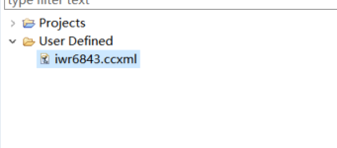
出现如下图：
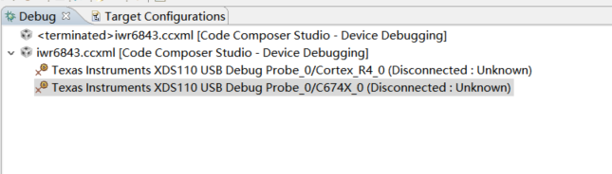
接着选择Texas Instruments XDS110 USB DebugProbe_0/C674X_0(Disconnected : Unknown) 点击connect target继续出现刚才报错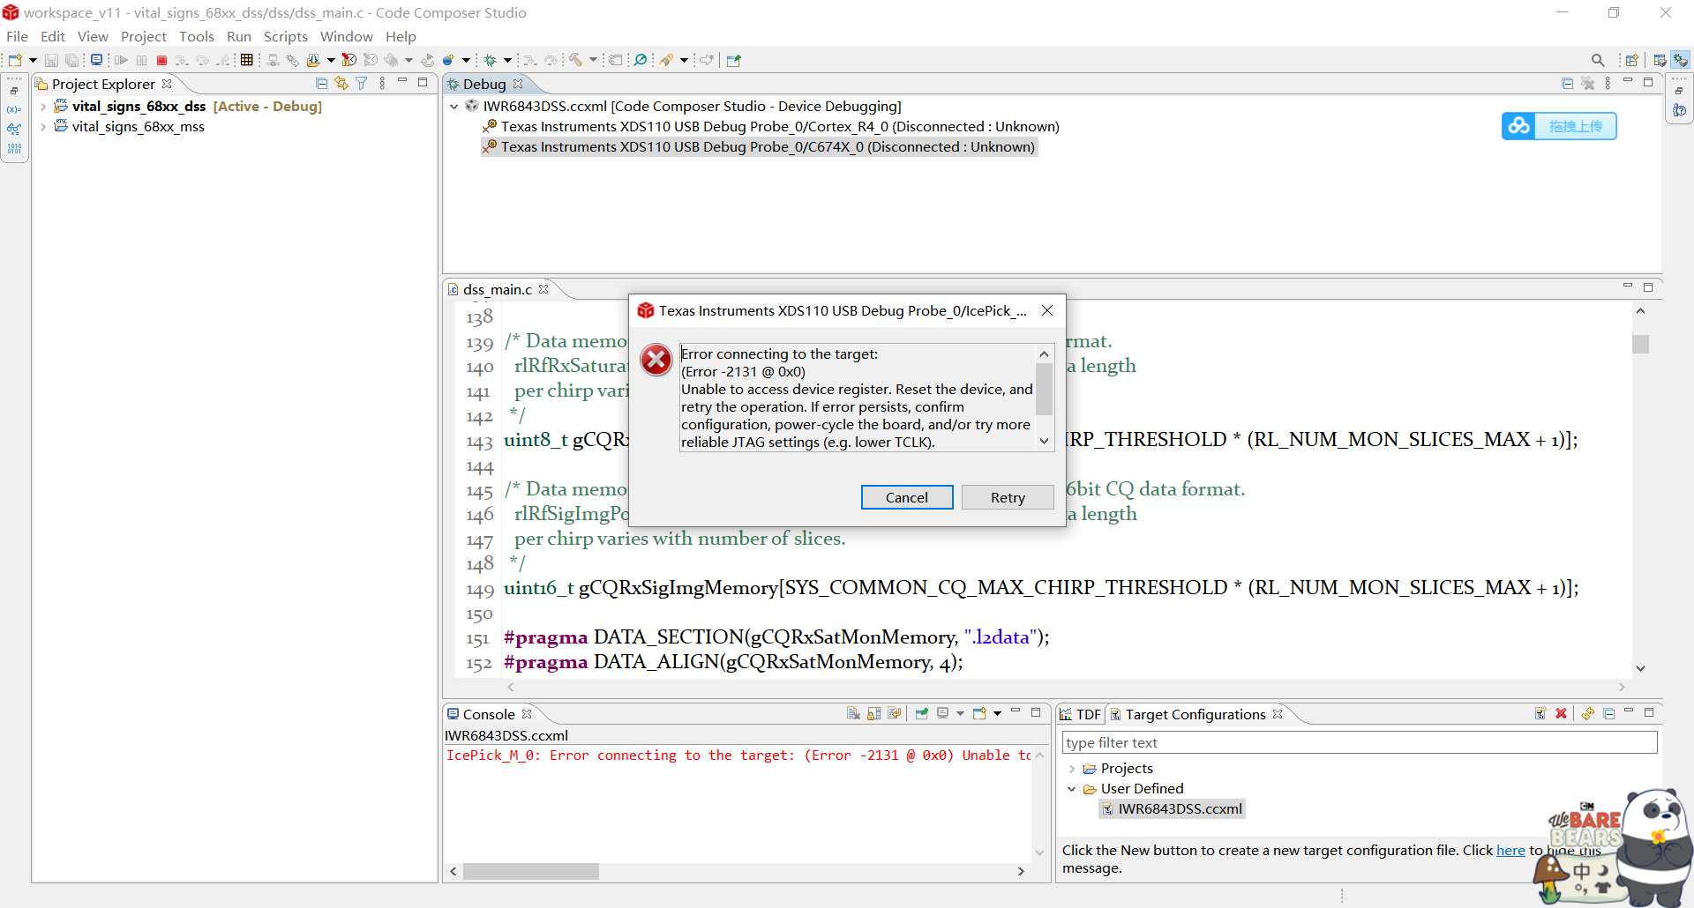
Error connecting to the target:
(Error -2131 @ 0x0)
Unable to access device register. Reset the device, and retry the operation. If error persists, confirm configuration, power-cycle the board, and/or try more reliable JTAG settings (e.g. lower TCLK).
(Emulation package 9.5.0.00143)
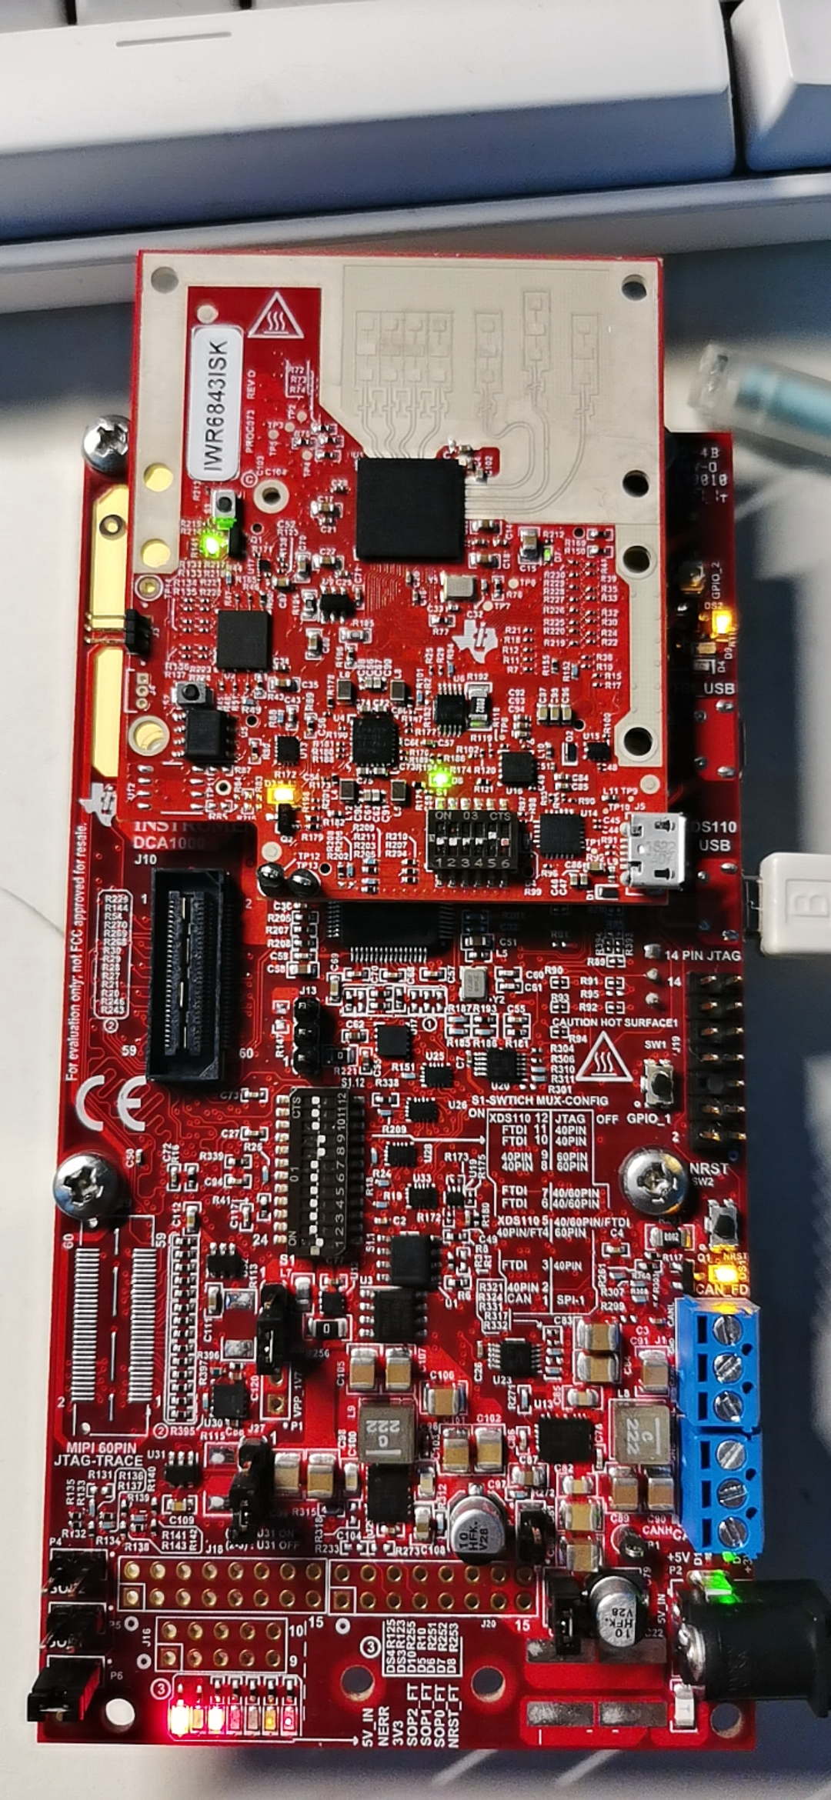沃野设置成001功能末世

之前有几次成功烧写进去，然后想打开gui试试，可是没有波形
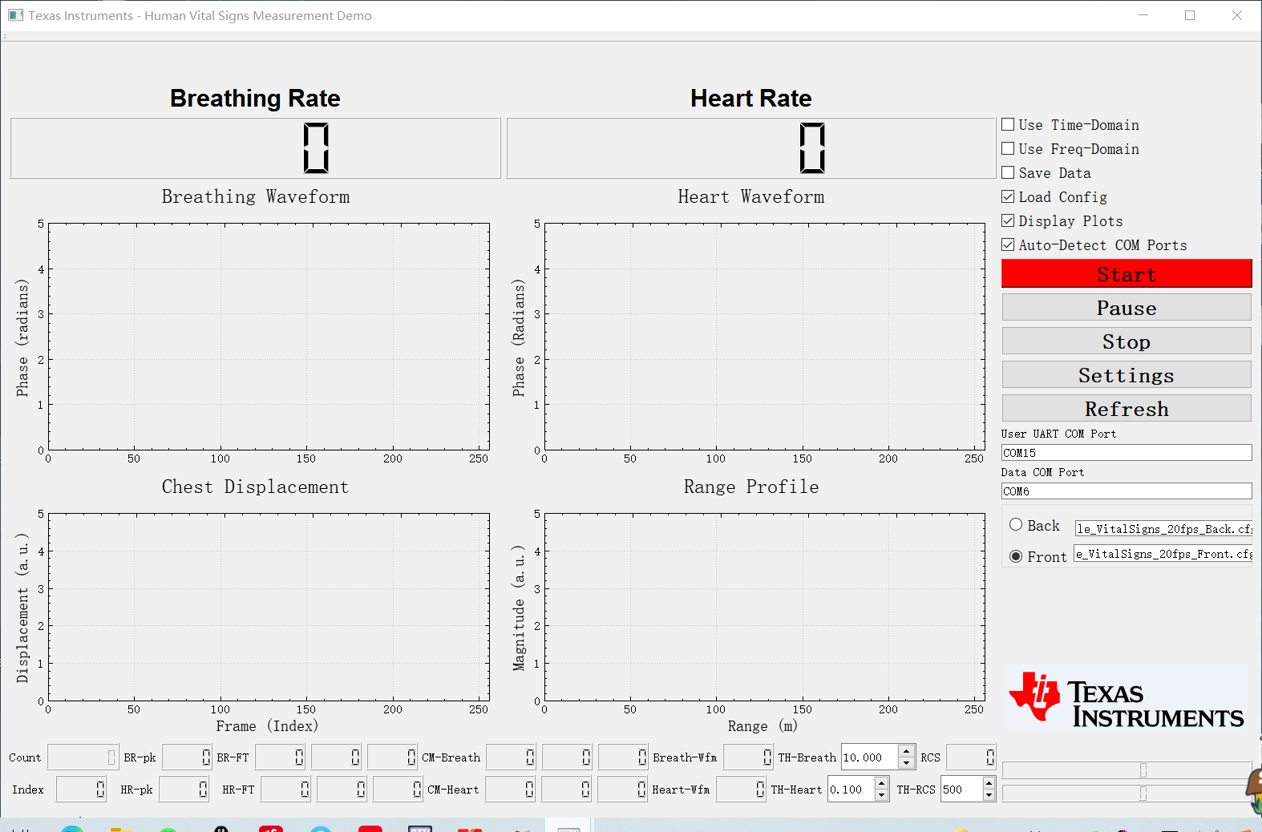
QT version = 5.9.1
QMetaObject::connectSlotsByName: No matching signal for on_buttonBox_accepted()
Serial Port Found
Data Port Number is "COM6"
User Port Number is "COM15"
Data port succesfully Open
User port succesfully Open
