Instructions to Build CCS based Flash Writers from Serial Flash and boot Utilities in CCSv7.
Software required:
Serial flash and boot utilities for OMAPL138
Compiler CGTools 7.4x [Flash writers projects are configured to build in COFF binaries and CGTools v8.x only builds ELF]
Step 1: Add path to Compiler 7.4.x in the CCS compiler discovery path. Go to Windows->Preferences:
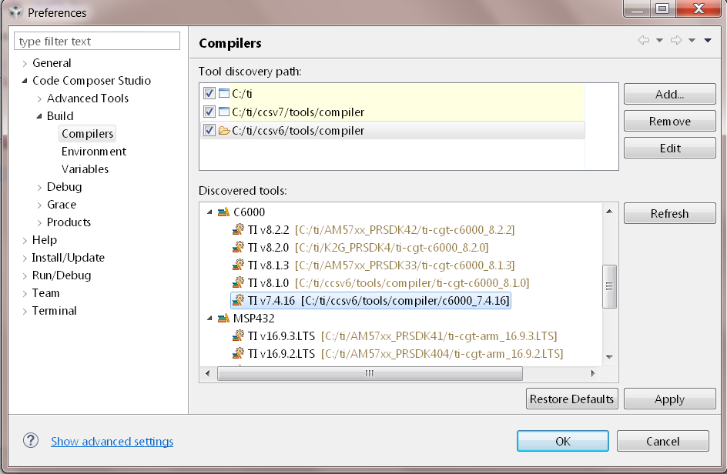
Step 2: Import the project as Legacy CCSv3.3 project and select compiler 7.4 and the common root as shown below:
