1, SBL Boot Process
The SDK also provides a method for using SBL to boot PSDKRA + PSDKLA.
The boot process of Jacinto7 is relatively complex. SBL (Secondary Bootloader) is a very lightweight bootloader written by TI, which can configure peripheral devices, such as DDR, and load and boot other cores. In order to meet the requirements of fast boot and execute related applications, MCU can be booted first and then use BOOT APP to boot other applications. In the SBL boot process, SBL can directly load the Linux kernel and DTB. The process is shown in the following figure:
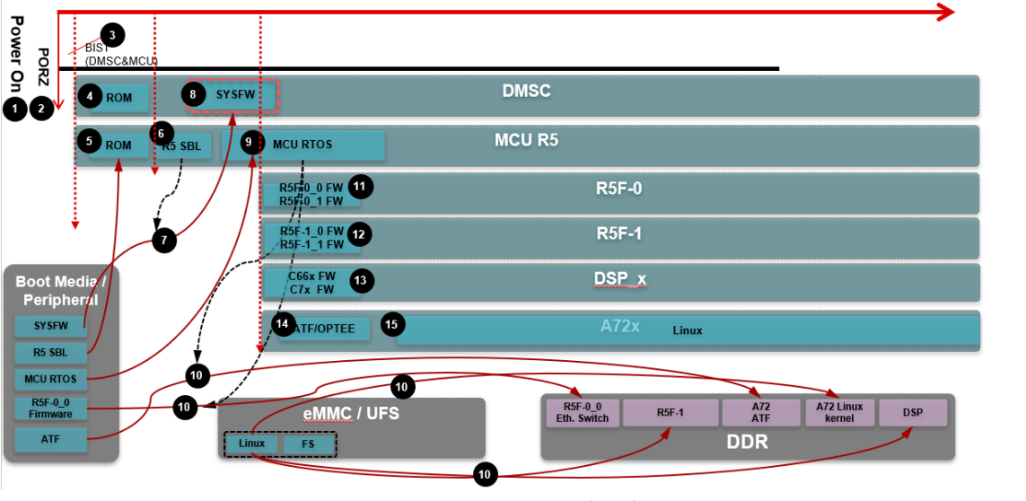
1. System power-on
2. Soc PORZ
3. DMSC&MCU BIST (optional)
4. DMSC ROM starts execution
5. MCU R5 ROM starts execution
6. MCU R5 ROM loads and runs SBL
7. MCU R5 SBL (tiboot3.bin) loads SYSFW
8. DMSC authenticates and starts SYSFW
9. MCU R5 SBL loads MCU Boot App, runs Sciclient Server.
10. MCU R5 Boot App loads Main R5F, DSP, ATF, DTB, Kernel Image respectively.
11. Main R5F 0 starts running
12. Main R5F 1 starts running
13. C66x, C7x start running
14. ATF starts running
15. Kernel Image starts executing and then mounts the file system to run to the Linux console.
16. Run the application.
Above is the boot process of SBL. In the next section, we will introduce how to run TI Demo based on the above boot process to run PSDKRA.

2, RUN PSDKRA Demo
The previous section described the SBL boot process of TI PSDKLA+PSDKRA, and the MCU R5 BOOT APP is responsible for loading and starting the other cores, as shown in Figure 7. It is worth noting that in the above boot process, for the Linux boot process on A72, we directly load the DTB, ATF, and Kernel Image of Linux from the BOOT APP. This is different from the SPL boot process (which does not load and run the SPL and Uboot.img images for A72). In terms of the boot process, this process optimizes the boot process of A72 Linux and reduces the boot time. Another thing to note is the DTB. The dtb in it needs to update the bootargs, and if you need to run the Demo of PSDKRA, you also need to make corresponding modifications to DTB.

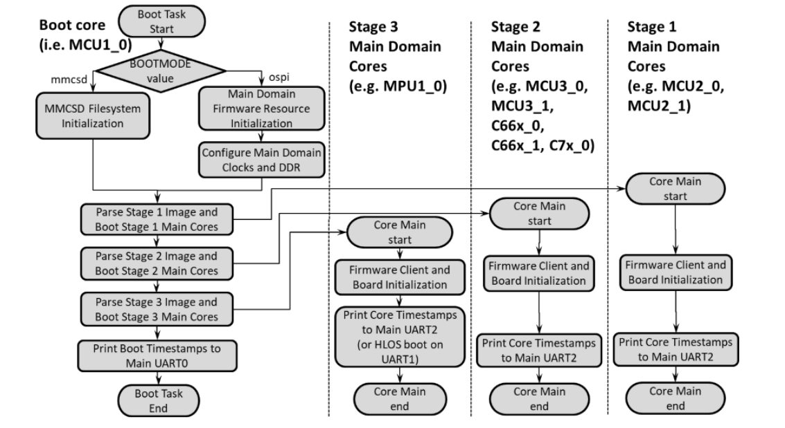
- Compile SBL: Compile PSDKRA PDK sbl_mmcsd_img to generate sbl_mmcsd_img_mcu1_0_release.bin, and then copy it to the boot partition tiboot3.bin of the SD card. The compilation method is as follows:
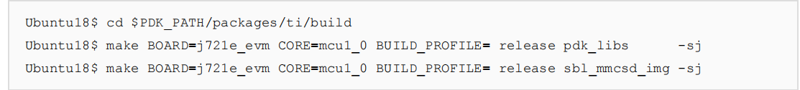

- Compile CAN Boot App: Compile the Image in PSDKRA MCUSW (starting from SDK 8.1, you can also compile the image from the vision_app, and the command is sbl_mcusw_bootimage_sd. The compiled image is in $PATH_VISION_SDK_BUILD/out/sbl_bootfiles/app): can_boot_app_mcu_rtos_mcu1_0_release.appimage, and then copy it to the app partition of the SD card boot.（copy can_boot_app_mcu_rtos_mcu1_0_release.appimage to SD as app） The compilation method is as follows:
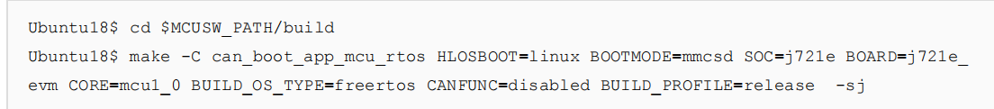

3, Compile DTB: To directly boot Linux with SBL + BOOT APP, you need to update the bootargs of DTB and add the content of k3-j721e-vision-apps.dts in k3-j721e-common-proc-board.dts, and finally compile it into a single dtb to support the running environment of PSDKRA demo. Compile k3-j721e-common-proc-board.dtb and copy it to PSDKRA/board-support/prebuilt-images/base-board.dtb. The bootargs configuration for k3-j721e-common-proc-board.dts is as follows:
Update to

4, Convert the Linux ATF, dtb, and kernel Image.
After conversion, you will get atf_optee.appimage, tidtb_linux.appimage, tikernelimage_linux.appimage, and these images also need to be copied to the boot partition of the SD card

5, Combine C66/C7x/R5F Core Image: Combine the images of MCU2_0 and MCU2_1 to form lateapp1. Combine C6x_1, C6x_2, and C7x to form lateapp2.

After the above steps, we have prepared the files required for SBL boot. Next, we need to copy these images to the SD card for verification:
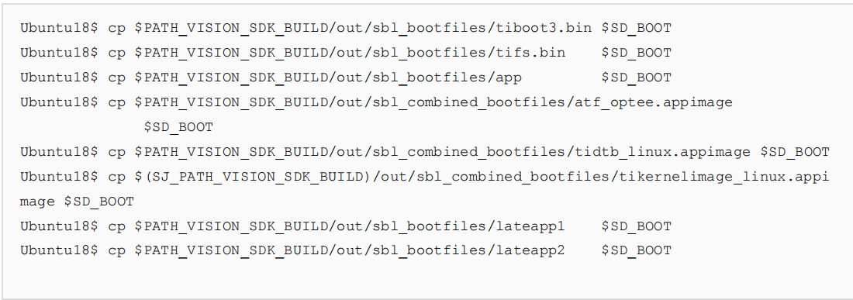

MCU BOOT LOG:
