1. The waveform below is the normal waveform：

waveform1：nFAULT

waveform2：pwm_back

waveform3：pwm_out1

The load current is 3.9A。

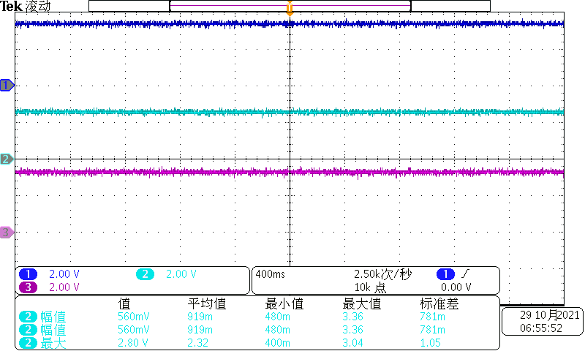

1. When the load current becomes 4.9A，The waveform of the nFAULT foot starts to be pulled down periodically。Cycle of 648.0 ms。

waveform1：nFAULT

waveform2：pwm_back

waveform3：pwm_out1

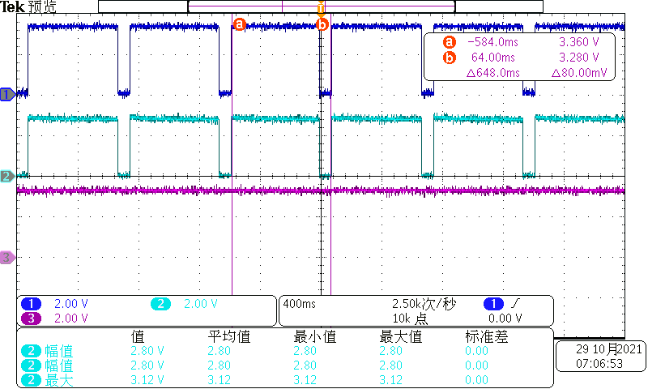

1. When the load current becomes 4.6A，The waveform of the nFAULT foot starts to be pulled down periodically。Cycle of 1.416s。

waveform1：nFAULT

waveform2：pwm_back

waveform3：pwm_out1

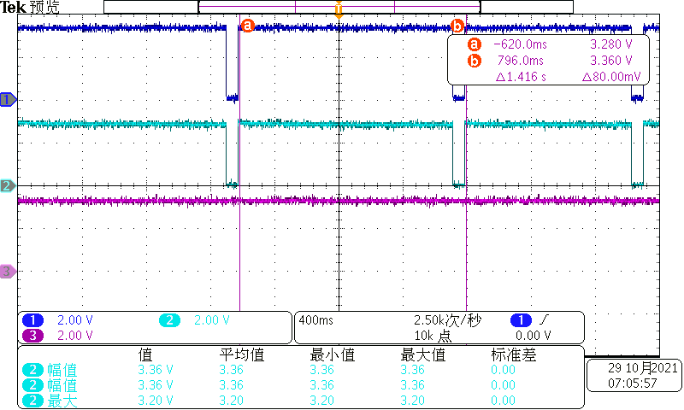

1. When the load current becomes 4.3A，The waveform of the nFAULT foot starts to be pulled down periodically。Cycle of 1.904s。

waveform1：nFAULT

waveform2：pwm_back

waveform3：pwm_out1

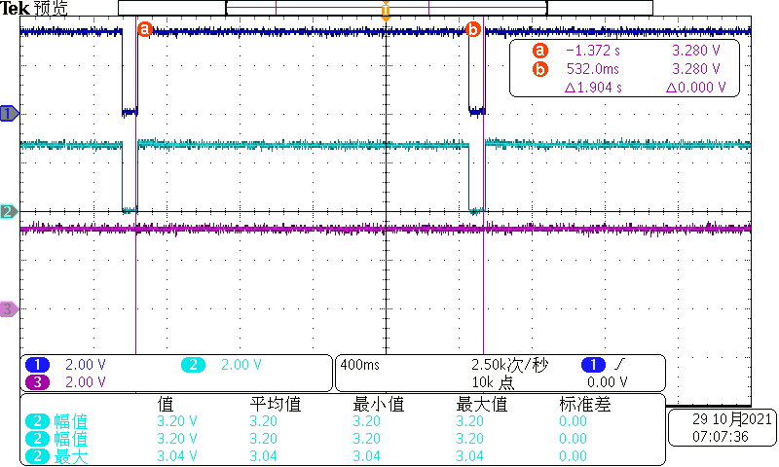

The low level duration is 96ms per cycle。Please see below。

