1、CCS的报错
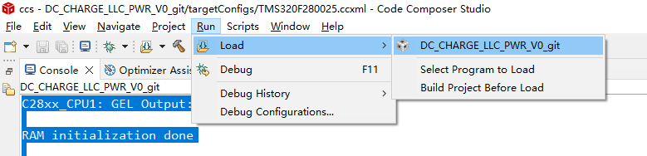

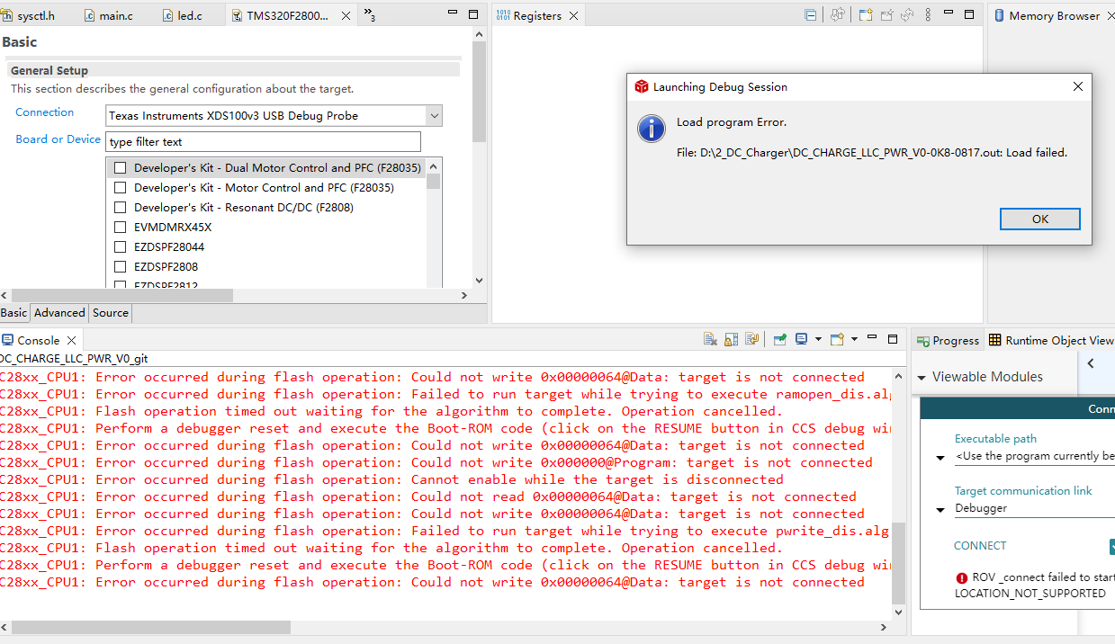

C28xx_CPU1: GEL Output:

RAM initialization done

C28xx_CPU1: GEL Output:
Memory Map Initialization Complete
C28xx_CPU1: GEL Output: ... DCSM Initialization Start ...
C28xx_CPU1: GEL Output: ... DCSM Initialization Done ...
C28xx_CPU1: GEL Output: ... DCSM Initialization Start ...
C28xx_CPU1: GEL Output: ... DCSM Initialization Done ...
C28xx_CPU1: GEL Output: ... DCSM Initialization Start ...
C28xx_CPU1: GEL Output: ... DCSM Initialization Done ...
C28xx_CPU1: Error: (Error -1044 @ 0x0) The debug probe reported an error. Confirm debug probe configuration and connections, reset the debug probe, and retry the operation. (Emulation package 9.12.0.00150)
C28xx_CPU1: Unable to determine target status after 20 attempts
C28xx_CPU1: Failed to remove the debug state from the target before disconnecting. There may still be breakpoint op-codes embedded in program memory. It is recommended that you reset the emulator before you connect and reload your program before you continue debugging
C28xx_CPU1: Error occurred during flash operation: Could not write 0x00000064@Data: target is not connected
C28xx_CPU1: Error occurred during flash operation: Could not read 0x000136@Program: target is not connected
C28xx_CPU1: Error occurred during flash operation: Could not read 0x00012C@Program: target is not connected
C28xx_CPU1: Flash Programmer: Error erasing Sector 0. FMSTAT (STATCMD on some devices) value = 0. Operation Cancelled (0).
C28xx_CPU1: File Loader: Memory write failed: Unknown error
C28xx_CPU1: GEL: File: D:\2_DC_Charger\DC_CHARGE_LLC_PWR_V0-0K8-0817.out: Load failed.
C28xx_CPU1: Error occurred during flash operation: Could not read register PC: target is not connected
C28xx_CPU1: Error occurred during flash operation: Could not write register PC: target is not connected
C28xx_CPU1: Error occurred during flash operation: Could not write 0x000000@Program: target is not connected
C28xx_CPU1: Error occurred during flash operation: Cannot enable while the target is disconnected
C28xx_CPU1: Error occurred during flash operation: Could not read 0x00000064@Data: target is not connected
C28xx_CPU1: Error occurred during flash operation: Could not write 0x00000064@Data: target is not connected
C28xx_CPU1: Error occurred during flash operation: Failed to run target while trying to execute ramopen_dis.alg
C28xx_CPU1: Flash operation timed out waiting for the algorithm to complete. Operation cancelled.
C28xx_CPU1: Perform a debugger reset and execute the Boot-ROM code (click on the RESUME button in CCS debug window) before erasing/loading the Flash. If that does not help to perform a successful Flash erase/load, check the Reset cause (RESC) register, NMI shadow flag (NMISHDFLG) register and the Boot-ROM status register for further debug.
C28xx_CPU1: Error occurred during flash operation: Could not write 0x00000064@Data: target is not connected
C28xx_CPU1: Error occurred during flash operation: Could not write 0x000000@Program: target is not connected
C28xx_CPU1: Error occurred during flash operation: Cannot enable while the target is disconnected
C28xx_CPU1: Error occurred during flash operation: Could not read 0x00000064@Data: target is not connected
C28xx_CPU1: Error occurred during flash operation: Could not write 0x00000064@Data: target is not connected
C28xx_CPU1: Error occurred during flash operation: Failed to run target while trying to execute pwrite_dis.alg
C28xx_CPU1: Flash operation timed out waiting for the algorithm to complete. Operation cancelled.
C28xx_CPU1: Perform a debugger reset and execute the Boot-ROM code (click on the RESUME button in CCS debug window) before erasing/loading the Flash. If that does not help to perform a successful Flash erase/load, check the Reset cause (RESC) register, NMI shadow flag (NMISHDFLG) register and the Boot-ROM status register for further debug.
C28xx_CPU1: Error occurred during flash operation: Could not write 0x00000064@Data: target is not connected

2、c2prog的报错
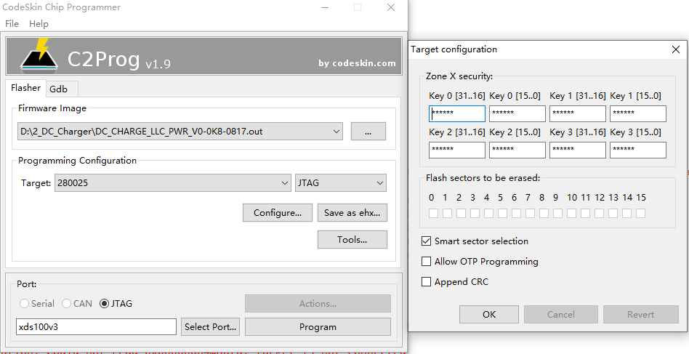

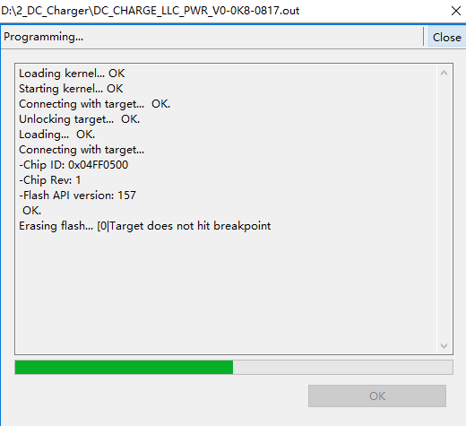

3、Uniflash
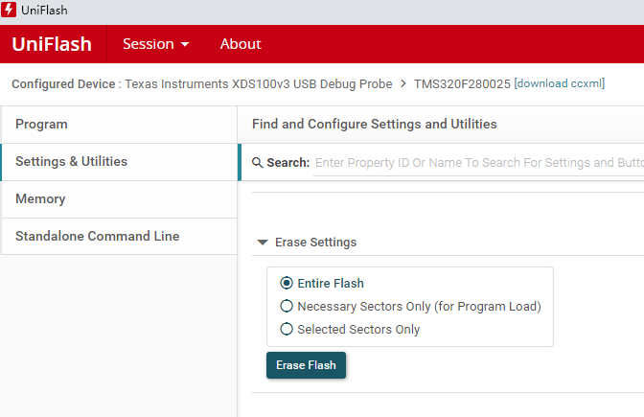

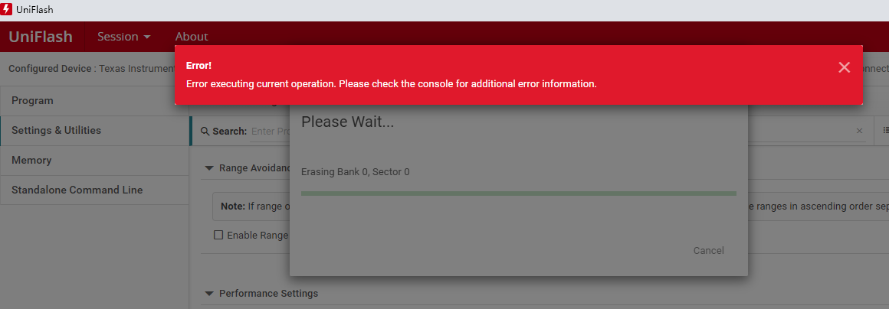

[2023/9/13 下午3:58:57] [INFO] C28xx_CPU1: GEL Output: RAM initialization done
[2023/9/13 下午3:58:57] [INFO] C28xx_CPU1: GEL Output: Memory Map Initialization Complete
[2023/9/13 下午3:58:57] [INFO] C28xx_CPU1: GEL Output: ... DCSM Initialization Start ...
[2023/9/13 下午3:58:57] [INFO] C28xx_CPU1: GEL Output: ... DCSM Initialization Done ...
[2023/9/13 下午3:58:57] [INFO] C28xx_CPU1: Erasing Flash memory...
[2023/9/13 下午3:58:57] [INFO] C28xx_CPU1: GEL Output: ... DCSM Initialization Start ...
[2023/9/13 下午3:58:58] [INFO] C28xx_CPU1: GEL Output: ... DCSM Initialization Done ...
[2023/9/13 下午3:59:00] [ERROR] C28xx_CPU1: Error: (Error -1044 @ 0x0) The debug probe reported an error. Confirm debug probe configuration and connections, reset the debug probe, and retry the operation. (Emulation package 9.12.0.00150)
[2023/9/13 下午3:59:00] [ERROR] C28xx_CPU1: Trouble Halting Target CPU: (Error -1135 @ 0x0) The debug probe reported an error. Confirm debug probe configuration and connections, reset the debug probe, and retry the operation. (Emulation package 9.12.0.00150)
[2023/9/13 下午3:59:00] [ERROR] C28xx_CPU1: Unable to determine target status after 20 attempts
[2023/9/13 下午3:59:00] [ERROR] C28xx_CPU1: Failed to remove the debug state from the target before disconnecting. There may still be breakpoint op-codes embedded in program memory. It is recommended that you reset the emulator before you connect and reload your program before you continue debugging
[2023/9/13 下午3:59:20] [ERROR] C28xx_CPU1: Error occurred during flash operation: Could not write 0x00000064@Data: target is not connected
[2023/9/13 下午3:59:20] [ERROR] C28xx_CPU1: Error occurred during flash operation: Could not read 0x000136@Program: target is not connected
[2023/9/13 下午3:59:20] [ERROR] C28xx_CPU1: Error occurred during flash operation: Could not read 0x00012C@Program: target is not connected
[2023/9/13 下午3:59:20] [ERROR] C28xx_CPU1: Flash Programmer: Error erasing Sector 0. FMSTAT (STATCMD on some devices) value = 0. Operation Cancelled (0).
[2023/9/13 下午3:59:20] [ERROR] C28xx_CPU1: Flash Programmer: Error erasing flash. Please check if the device is locked.
[2023/9/13 下午3:59:20] [ERROR] C28xx_CPU1: Error occurred during flash operation: Could not write register PC: target is not connected
[2023/9/13 下午3:59:20] [ERROR] C28xx_CPU1: Error occurred during flash operation: Could not write 0x000000@Program: target is not connected
[2023/9/13 下午3:59:20] [ERROR] C28xx_CPU1: Error occurred during flash operation: Cannot enable while the target is disconnected
[2023/9/13 下午3:59:20] [ERROR] C28xx_CPU1: Error occurred during flash operation: Could not read 0x00000064@Data: target is not connected
[2023/9/13 下午3:59:20] [ERROR] C28xx_CPU1: Error occurred during flash operation: Could not write 0x00000064@Data: target is not connected
[2023/9/13 下午3:59:20] [ERROR] C28xx_CPU1: Error occurred during flash operation: Failed to run target while trying to execute ramopen_dis.alg
[2023/9/13 下午3:59:20] [ERROR] C28xx_CPU1: Flash operation timed out waiting for the algorithm to complete. Operation cancelled.
[2023/9/13 下午3:59:20] [ERROR] C28xx_CPU1: Perform a debugger reset and execute the Boot-ROM code (click on the RESUME button in CCS debug window) before erasing/loading the Flash. If that does not help to perform a successful Flash erase/load, check the Reset cause (RESC) register, NMI shadow flag (NMISHDFLG) register and the Boot-ROM status register for further debug.
[2023/9/13 下午3:59:20] [ERROR] C28xx_CPU1: Error occurred during flash operation: Could not write 0x00000064@Data: target is not connected
[2023/9/13 下午3:59:20] [ERROR] C28xx_CPU1: Error occurred during flash operation: Could not write 0x000000@Program: target is not connected
[2023/9/13 下午3:59:20] [ERROR] C28xx_CPU1: Error occurred during flash operation: Cannot enable while the target is disconnected
[2023/9/13 下午3:59:20] [ERROR] C28xx_CPU1: Error occurred during flash operation: Could not read 0x00000064@Data: target is not connected
[2023/9/13 下午3:59:20] [ERROR] C28xx_CPU1: Error occurred during flash operation: Could not write 0x00000064@Data: target is not connected
[2023/9/13 下午3:59:20] [ERROR] C28xx_CPU1: Error occurred during flash operation: Failed to run target while trying to execute pwrite_dis.alg
[2023/9/13 下午3:59:20] [ERROR] C28xx_CPU1: Flash operation timed out waiting for the algorithm to complete. Operation cancelled.
[2023/9/13 下午3:59:20] [ERROR] C28xx_CPU1: Perform a debugger reset and execute the Boot-ROM code (click on the RESUME button in CCS debug window) before erasing/loading the Flash. If that does not help to perform a successful Flash erase/load, check the Reset cause (RESC) register, NMI shadow flag (NMISHDFLG) register and the Boot-ROM status register for further debug.
[2023/9/13 下午3:59:20] [ERROR] C28xx_CPU1: Error occurred during flash operation: Could not write 0x00000064@Data: target is not connected

