辅助源管子替代与磁密计算

1 IPD95R1K2P7磁密计算与波形

辅助源变压器：Lp=1.21mH，匝比84:7:7:7，VCCP12=10.7，Q11=IPD95R1K2P7

B=L*Ipk/(N*Ae)，Ipk1是磁化电流，**ΔIpk2(A)是MOS-Coss充电产生的电流；**

|  |  |  |  |  |  |  |  |  |  |  |
| --- | --- | --- | --- | --- | --- | --- | --- | --- | --- | --- |
| **Vin(V)** | **Lp(mH)** | **VCCP12(V)** | **Ipk1(A)** | **Ton1(us)** | **B1(T)** | **ΔIpk2(A)** | **Ton2(us)** | **B2(T)** | **B(T)** | **评价**  高温下磁芯会饱和；  DMR95在25℃的Bs=0.53T，100℃的Bs=0.41T |
| 400 | 1.21 | 11.68 | 0.18 | 0.62 | 0.2108 | 0.19 | 0.22 | 0.2225 | 0.4333 |
| 500 | 1.21 | 11.68 | 0.19 | 0.56 | 0.2225 | 0.195 | 0.19 | 0.2284 | 0.4509 |
| 540 | 1.21 | 11.68 | 0.2 | 0.52 | 0.2342 | 0.203 | 0.21 | 0.2377 | 0.4720 |
| 600 | 1.21 | 11.68 | 0.215 | 0.49 | 0.2518 | 0.225 | 0.24 | 0.2635 | 0.5153 |

2 IPD95R1K2P7测试波形

___________________________________________________________________________________________

2.1 Vin=400V，CH2=DRV，CH3=Vcs（C210=470p根部），CH4=Ip电流（电流枪），

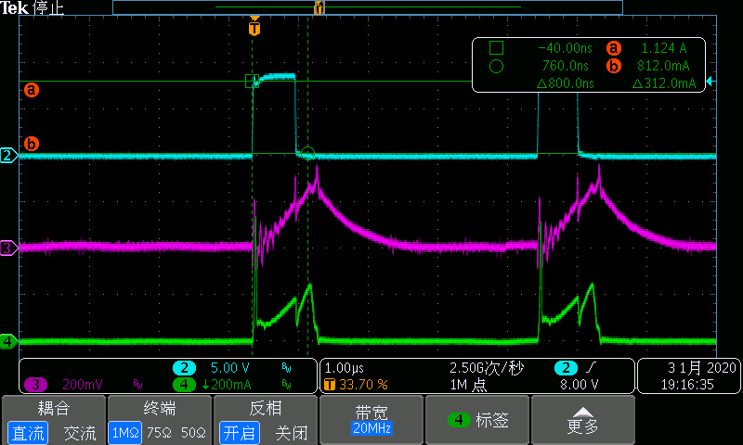

___________________________________________________________________________________________

2.2 Vin=500V，CH2=DRV，CH3=Vcs（C210=470p根部），CH4=Ip电流（电流枪），

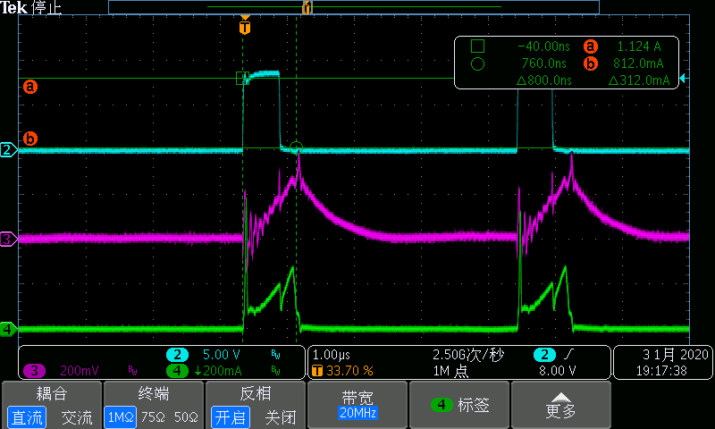

___________________________________________________________________________________________

2.3 Vin=540V，CH2=DRV，CH3=Vcs（C210=470p根部），CH4=Ip电流（电流枪），

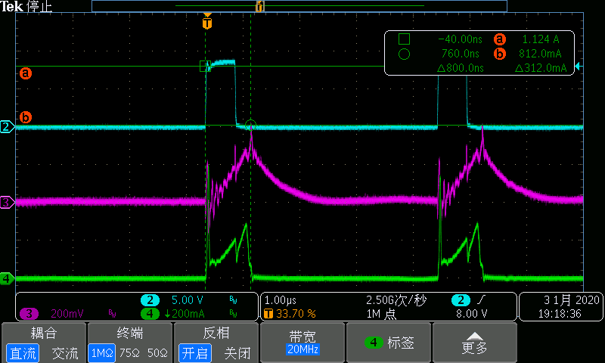

___________________________________________________________________________________________

2.4 Vin=600V，CH2=DRV，CH3=Vcs（C210=470p根部），CH4=Ip电流（电流枪），

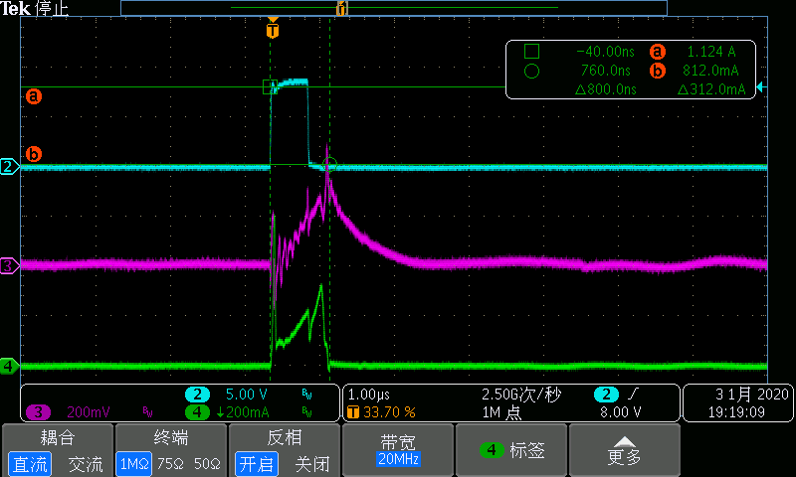

3 STD5N95K3磁密计算

辅助源变压器：Lp=1.21mH，匝比84:7:7:7，VCCP12=10.7，Q11=STD5N95K3

B=L*Ipk/(N*Ae)，Ipk1是磁化电流，**ΔIpk2(A)是MOS-Coss充电产生的电流；**

|  |  |  |  |  |  |  |  |  |  |  |
| --- | --- | --- | --- | --- | --- | --- | --- | --- | --- | --- |
| **Vin(V)** | **Lp(mH)** | **VCCP12(V)** | **Ipk1(A)** | **Ton1(us)** | **B1(T)** | **ΔIpk2(A)** | **Ton2(us)** | **B2(T)** | **B(T)** | **评价** |
| 400 | 1.21 | 11.68 | 0.18 | 0.57 | 0.2108 | 0.08 | 0.14 | 0.0937 | 0.3045 | 余量适中，DMR95在25℃的Bs=0.53T，100℃的Bs=0.41T， |
| 500 | 1.21 | 11.68 | 0.19 | 0.55 | 0.2225 | 0.1 | 0.15 | 0.1171 | 0.3396 |
| 540 | 1.21 | 11.68 | 0.195 | 0.52 | 0.2284 | 0.08 | 0.14 | 0.0937 | 0.3221 |
| 600 | 1.21 | 11.68 | 0.21 | 0.5 | 0.2459 | 0.09 | 0.12 | 0.1054 | 0.3513 |
| 650 | 1.21 | 11.68 | 0.22 | 0.47 | 0.2576 | 0.09 | 0.12 | 0.1054 | 0.3630 |

4 STD5N95K3测试波形

___________________________________________________________________________________________

4.1 Vin=400V，CH2=DRV，CH3=Vcs（C210=470p根部），CH4=Ip电流（电流枪），

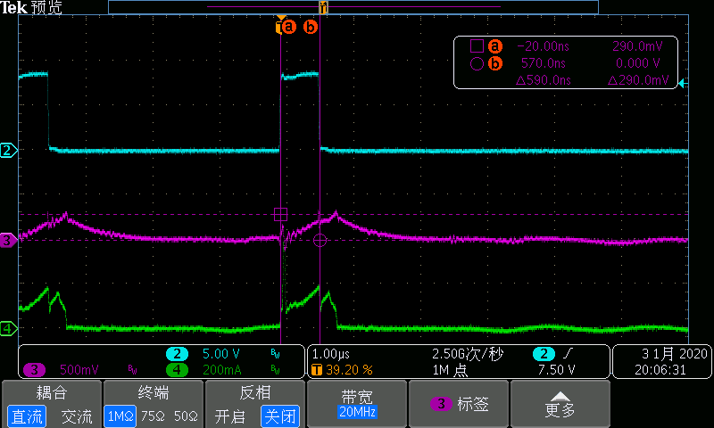

___________________________________________________________________________________________

4.2 Vin=500V，CH2=DRV，CH3=Vcs（C210=470p根部），CH4=Ip电流（电流枪），

忘存波形。

___________________________________________________________________________________________

4.3 Vin=540V，CH2=DRV，CH3=Vcs（C210=470p根部），CH4=Ip电流（电流枪），

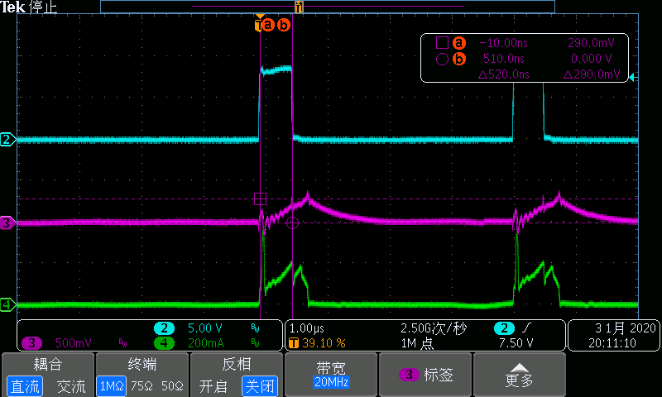

___________________________________________________________________________________________

4.4 Vin=600V，CH2=DRV，CH3=Vcs（C210=470p根部），CH4=Ip电流（电流枪），

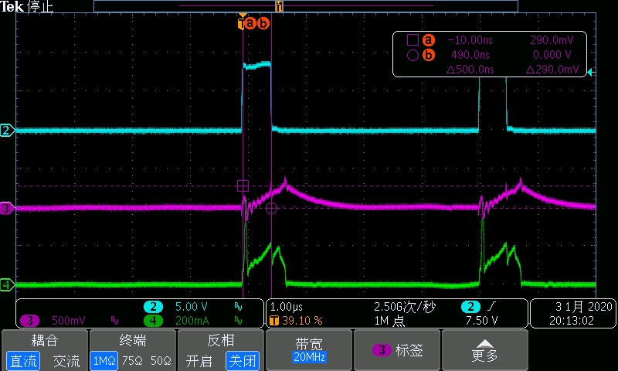

___________________________________________________________________________________________

4.5 Vin=650V，CH2=DRV，CH3=Vcs（C210=470p根部），CH4=Ip电流（电流枪），

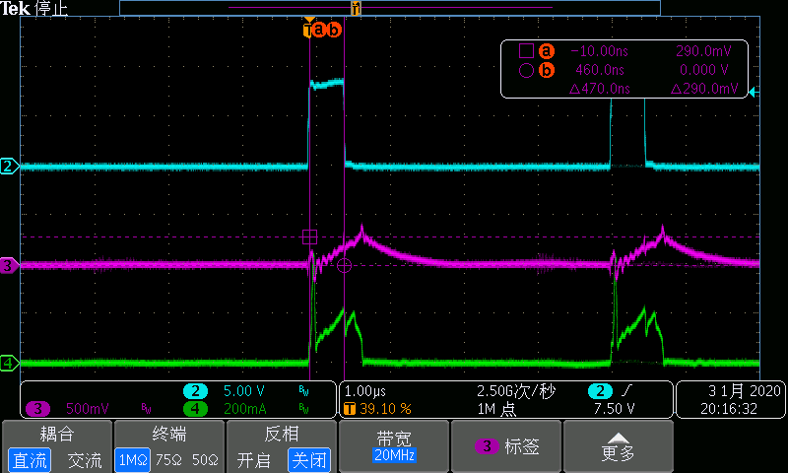

至此，辅助源参数如下：

工作频率：250KHz左右；

变压器匝比：84:7:7:7，Lp=1.21mH；

RCD吸收电阻，R208/R209由51.1K更改为150K；

MOS：由IPD95R1K2P7更改为STD5N95K3；

驱动电阻：R212由2欧更改为56欧；

电流取样电阻：R210保持2欧不变；

反馈稳压管：Z3由10V更改为11V；

输入过压保护电路：Q13取消；