Profile: 20220818 | Page No.: 1
Engineer: OLAN
Site: TR1 | Time: 2022/08/18 - 19:09
Limit: EN55032_CE_Mains_ClassB | Margin: 0
Probe: NNLK 8129_(0.009-30MHz) | Polarity: Line1
EUT: SINF | Power: DC 24V
Note: add filter capacitor 47uF
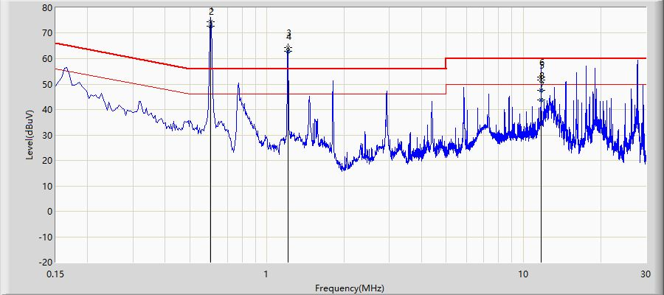
No | Mark | Frequency  (MHz) | Measure Level  (dBuV) | Reading Level  (dBuV) | Over Limit  (dB) | Limit  (dBuV) | Probe  (dB) | Cable  (dB) | Amp  (dB) | Type
1 |  | 0.602 | 74.578 | 73.787 | 18.578 | 56.000 | 0.742 | 0.050 | 0.000 | QP
2 | * | 0.602 | 72.767 | 71.975 | 26.767 | 46.000 | 0.742 | 0.050 | 0.000 | AV
3 |  | 1.206 | 64.412 | 63.822 | 8.412 | 56.000 | 0.526 | 0.064 | 0.000 | QP
4 |  | 1.206 | 62.868 | 62.279 | 16.868 | 46.000 | 0.526 | 0.064 | 0.000 | AV
5 |  | 11.710 | 51.709 | 50.966 | -8.291 | 60.000 | 0.524 | 0.218 | 0.000 | QP
6 |  | 11.710 | 52.888 | 52.145 | -7.112 | 60.000 | 0.524 | 0.218 | 0.000 | QP
7 |  | 11.710 | 43.666 | 42.924 | -6.334 | 50.000 | 0.524 | 0.218 | 0.000 | AV
8 |  | 11.710 | 47.589 | 46.846 | -2.411 | 50.000 | 0.524 | 0.218 | 0.000 | AV

Note:
1. All Readings below 1GHz are Quasi-Peak, above are performed with peak and/or average measurements as necessary.
2. " * ", means this data is the worst emission level.
3. Measurement Level = Reading Level + Factor(Probe+Cable-Amp).
Profile: 20220818 | Page No.: 2
Engineer: OLAN
Site: TR1 | Time: 2022/08/18 - 19:20
Limit: EN55032_CE_Mains_ClassB | Margin: 0
Probe: NNLK 8129_(0.009-30MHz) | Polarity: Line1
EUT: SINF | Power: DC 24V
Note: add filter capacitor 47uF-remove other units
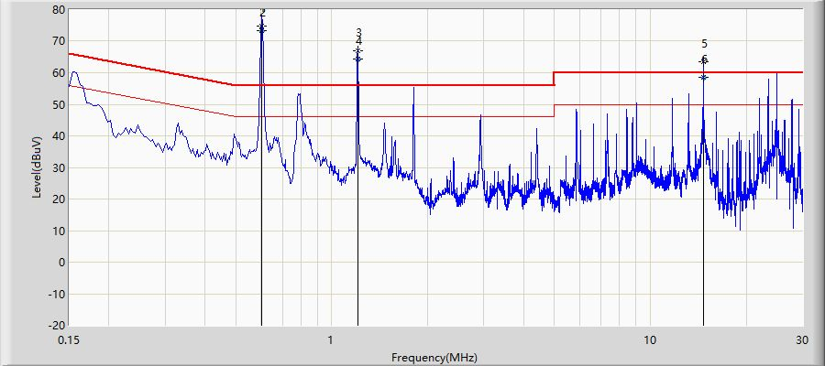
No | Mark | Frequency  (MHz) | Measure Level  (dBuV) | Reading Level  (dBuV) | Over Limit  (dB) | Limit  (dBuV) | Probe  (dB) | Cable  (dB) | Amp  (dB) | Type
1 |  | 0.602 | 74.751 | 73.959 | 18.751 | 56.000 | 0.742 | 0.050 | 0.000 | QP
2 | * | 0.602 | 73.298 | 72.506 | 27.298 | 46.000 | 0.742 | 0.050 | 0.000 | AV
3 |  | 1.206 | 66.921 | 66.332 | 10.921 | 56.000 | 0.526 | 0.064 | 0.000 | QP
4 |  | 1.206 | 64.457 | 63.868 | 18.457 | 46.000 | 0.526 | 0.064 | 0.000 | AV
5 |  | 14.646 | 63.382 | 62.552 | 3.382 | 60.000 | 0.583 | 0.247 | 0.000 | QP
6 |  | 14.646 | 58.447 | 57.618 | 8.447 | 50.000 | 0.583 | 0.247 | 0.000 | AV

Note:
1. All Readings below 1GHz are Quasi-Peak, above are performed with peak and/or average measurements as necessary.
2. " * ", means this data is the worst emission level.
3. Measurement Level = Reading Level + Factor(Probe+Cable-Amp).

