How to connect hardware and configure software of BQ40Z80RSMT
1 circuit board
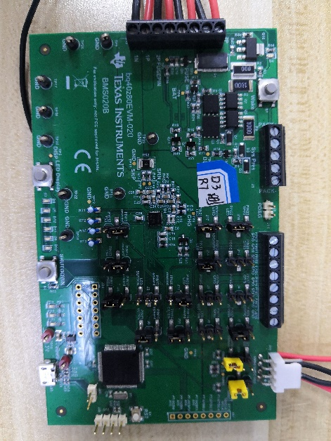
1.1: evaluation board bq40z80evm-020, bms020b, hereinafter referred to as EVM

EVMP

1.2: circuit board BP, hereinafter referred to as BP
U3 model in the figure is bq40z80rsmt

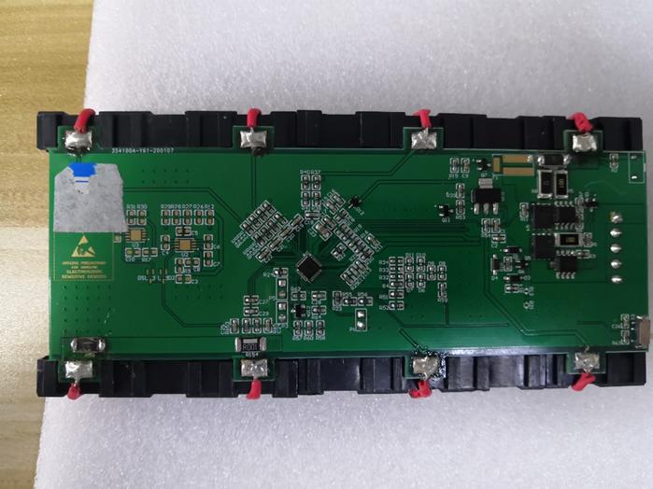

P2-1=0V

P2-3=8V

P2-5=16V

P2-7=24V
P2-2=4V
P2-4=12V
P2-6=20V
P2-8=28V
P4-1=PACK+
P4-2=SMBC
P4-3=SMBD
P4-4=
P4-5=PACK-
BP
U3

2 normal use
2.1: how to connect EVM and BP normally, so that BP can be used normally, i.e. charge and discharge

