IMPORTANT NOTE:
- Only devices procured directly from TI or an authorized distributor are warranted for failure verification.
- The returned units must be in testable conditions and in proper container (ESD protective packaging materials). If the units returned in un-acceptable conditions, the case will be closed as Non-Actionable Case. See details in Appendix 1: Guidelines for returning parts for failure analysis.

Customer Job Tracking#: | Click here to enter text. | FAR form created date: | Click here to enter a date.

Customer Contact:  客户信息：  Please fill in your contact information in case additional information is required for TI verification and/or to share the TI reports. | Company Name: 客户: | 广东省豪鹏新能源科技有限公司
 | Contact Person: 联系人: | banguoshuai
 | Address:地址: | 广东省惠州市惠城区松柏岭大道38号
 | Phone: 电话： | 17837019121
 | E-Mail: 邮件： | banguoshuai@highpowertech.com
Sales Channel:  购买渠道：  First involve the distributor as your business partner to align with the distributor return process. | 从TI直接购买
 | TI Sales Contact Name销售代表: | Click here to enter text.
 | TI Sales E-Mail Address: | Click here to enter text.
 | 从TI授权的代理商购买
 | Distributor Name:代理商： | 艾睿
 | Distributor Contact E-Mail Address: | BILLY.LIU@arrow.com
Board Manufacturer:  PCB板加工：  In the case of a 3rd party manufacturing the boards. | 不使用外包工厂贴板
 | 使用外包工厂贴板
 | Board Manufacturer Name:相关工厂名字 | 深圳市吉瑞达电路科技有限公司
 | Board Manufacturer E-Mail Address: | gc@jrdvip.com

Customer Priority:  优先级: | Unacceptable field reliability
Customer Priority:  优先级: | Choose an item.
Customer Priority:  优先级: | Choose an item.
Project Name: 项目名称 | I0882A
Project stage: 项目阶段 | Pilot Run
Application: 客户应用 | Consumer Pls specify if “Others”
Detection Place问题发现地点 | Functional Test(FCT) Pls specify if “Others”
Type of failure 失效类型 | Functional failure Pls specify if “Others”
Type of failure 失效类型 | Choose an item. Pls specify if “Others”
Type of failure 失效类型 | Choose an item. 印度客户端

Product Details: 产品细节:
TI Part Number (P/N): | BQ40Z50RSMR-R2 | Customer  Part Number (CP/N): | DL10000568
Total Quantity of Devices that have Failed:总不良数量 | 4 | Total Quantity of Devices Tested:总测试数量 | 128
Failure Rate:失效率 | 3.125% | Returned Failing Quantity: (to TI for FA) 返回失效数量 | 2
1st Failure Occurring Date:  问题首次发生日期 | 2026-03-20 | Run Rate:  (e.g. 40ku/day): 用量 | /
Good Datecode (DC): | / | Failing Datecode (DC): | /
Failing Device Marking:  失效IC的丝印 | BQ40Z50 TI 568 C6XL | Good Device Marking:  正常IC的丝印 | BQ40Z50 TI 568 C6XL
Failing Ship Track Code (STC): 失效的STC | / | Good Ship Track Code (STC): 正常的STC | /
Failing Lot#: 失效的批次号 | BQ40Z50 TI 568 C6XL | Good Lot#:正常的批次号 | BQ40Z50 TI 568 C6XLClick here to enter text.
Refer to Appendix 2 for how to find STC# or Lot# on TI label and Appendix 3 for How to read LTC from TI marking. Please attach the photo of marking here: 附件有关于STC#和Lot#(批次号)以及LTC(丝印)的介绍.请在此附上照片：
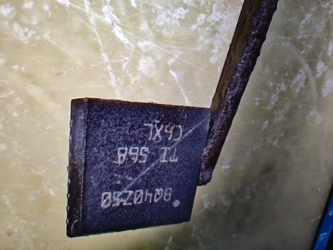
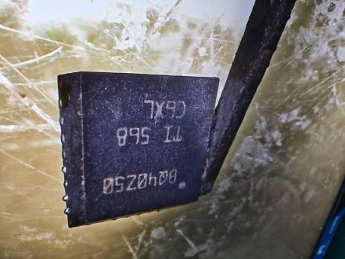

For Electrical Failure Only: 电性能失效： For Visual / Mechanical or Shipping failure, please click here

Failure Isolation & Application Information from the Customer: 问题定位和相关应用信息：
What is the condition of the failed device(s)? 问题是重复发生还是偶然发生的？
Did the same problem occur in the past? 过去有相同问题发生吗？
If yes, what’s conclusion? 有的话，请问是什么结论？ |  |  |  | /
For this failure mode, could you provide the failure rate(failed qty/production qty) of this device in recent six months in customer’s production line?  关于这个问题，请提供过去6个月的失效率？ |  |  |  | /
Was the failure verified on device level outside the application? 在单颗器件上是否验证了失效？
Did replacing the “failing” device with a new one resolve the problem? 把该IC替换掉是否能解决问题？
Was the “failing” device installed onto another passing board causing that board to fail (A-B-A swap)? Means did the failure follow the “failing” device?
把“坏”IC放到一个好板上是否仍然看到问题？失效是否跟随着这个“坏”IC？
This is an essential part of the troubleshooting analysis. Please ensure this has been performed!
Is the “failing” device used in more than one location on the circuit board?
一个板子上用了多颗这个IC吗？
If yes, how many locations? 如果是，几个位置？ |  |  |  | /
Is it just one location that is consistently causing the failures? 只有一个位置出问题吗？
Which locations are causing the failure? 哪一个位置总是出问题？ |  |  |  | /
If output is fault, are inputs verified to meet requirement? 如果是输出有问题，所有的输入端使能端都确认是符合要求的吗？
Is this a new application? 这是一个新的应用设计吗？
When was device designed into this application? 这个设计在什么时候开始使用这个IC的？ |  |  |  | 2025/4/14
Was the application/design changed or modified recently? 这个设计最近有修改过吗？
 | Please specify the corresponding testing conditions when the unit(s) failed: 请提供具体测试条件：
 | Temperature [°C]: | 25.0°C. | Vcc / Vdd [V]: | 14.4VDC
 | Frequency [f]: | / | Load current[A]: | /
 | Vin [V] | / | Other: | /
Please describe manufacturing flow to include any incoming testing, soldering, board electrical testing, etc. AND how you discover this failure.  1. 来料检验正常  2.SMT贴片正常；  3.单板功能测试正常；  4.电芯、结构等物料组装后进行功能测试，未通讯，无法进行后续测试；充电激活电池，发现仍未成功通讯  综合分析，本次锂离子电池组异常是由于通讯异常而导致. |  |  |  | 请描述相关的生产流程（包括来料检查，焊接，单板测试，等等），以及您如何发现这个问题？
Please specify the Board/System level failure symptom:  1. 锂离子电池组半成品中通讯测试不成功  2.拆机分析PCBA中芯片控制模块；  3.分析控制模块发现控制信号有故障；  4.对控制模块各部件进行排查分析， 确认控制芯片有异常  5.置换新的控制芯片，PCBA 功能正常，通讯正常；将不良芯片安装到好板上，不能通讯，通过A-B-A交叉验证确定不良跟着芯片走。  综合分析，本次锂离子电池组通讯测试异常是由于芯片的异常而导致,请分析异常原因. |  |  |  | 请详细描述板级的失效症状
Did you do Impedance measurement at IC level (After remove from the board)?
If yes, to provide the pins vs. GND comparison between failed IC and good IC.
把IC从板上取下来之后，是否有做阻抗测量？请提供“好”“坏”IC的阻抗对比

Did you see any burnt mark/package crack on the IC? 在问题IC上有看到烧毁或开裂的痕迹？
Please specify which pin/parameter cannot meet TI datasheet or your spec.  Please provide more details here if needed: 请提供更多细节：  芯片无法通讯 |  |  |  | 请定位出IC的哪一个参数或者引脚性能不符合TI规格书的要求
  Affected Parameter/Pin: | /
  Failure data measured by customer: | /
  Customer’s spec: 客户的测试规格 | /
  TI product datasheet spec: | /
Please provide Bad waveform vs Good waveform if possible:  Bad waveform:  Good waveform: |  |  |  | 尽可能提供好坏IC的波形图：
Please attach the schematic here: 请提供应用原理图：

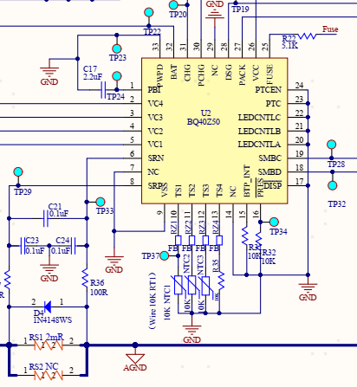

Chipcon Low-Power RF Products (CCxxxx Device):
Device Register Settings? 该器件寄存器设置？ | Click here to enter text.

 | For embedded processing devices (MSP430, C2000, etc.):
JTAG access? 使用JTAG吗？
Security fuse blown? If yes please provide the customer code! 是否使用烧录密码？ 是的话请提供客户密码
 | For devices where the observed failure requires FLASH validation and FLASH is locked with a “password”, the “password” MUST be provided to enable FLASH failure analysis. 如果FLASH是用密码锁住，请提供相应密码  In case a FRAM device needs to be replaced on an application board the customer must be aware that the memory content can be changed by the de-soldering process. Therefore it is recommended to analyze any wrong application behavior directly on the application board or read out the memory content of the device before de-soldering. | Enter your password:  Click here to enter text.

For Visual / Mechanical or Shipping Failure Only: 外观或机械或运输类缺陷：
For Electrical Failure, please click here

Was the failure inducing any electrical functional failure? 该缺陷是否导致电性能失效？ | 
What is the condition of the failed device(s)? 缺陷重复发生还是偶尔发生？
For this failure mode, could you provide the failure rate (failed quantity/production quantity) of this device in recent six months in customer’s production line?  关于这个问题，请提供过去6个月的失效率？ | Click here to enter text.
Was the failure verified on device level outside the application?  在单颗器件上是否验证了失效？ | 
Did you see any failure in Raw Materials still in TI original packing? 在没有使用过的原始物料中是否有发现同样的问题? | 
Please describe manufacturing flow to include any incoming testing, soldering, board electrical testing, etc. AND how you discover this failure. | 请描述相关的生产流程（包括来料检查，焊接，单板测试，等等），以及您如何发现这个问题？
Please provide more details about this failure: | 请提供更多细节:
Please attach the photos for the failure here: | 请附上该缺陷的照片:

Appendix 1: Detailed Guidelines for returning parts for failure analysis:

- Any sample return for verification/analysis (if not requested by TI) need to be sent de-soldered from its PCB/board/application.
Note: TI normally does not recommend hand soldering of any SMD but recommends use of a SMD rework station. When reworking Electronic Assemblies Texas Instruments recommends utilization a SMD rework station whenever possible as well utilization of industry standard IPC-771. When Hand soldering is utilized solder iron can start at 315°C (as noted within IPC-771) and be adjusted as required to liquefy solder used at mount. Dwell time per lead should not exceed 4~5 seconds and encapsulated device should never exceed a temperature of 260°C.
A white paper report has been published as an application note on our SC Quality External Website: http://focus.ti.com/lit/an/slva439a/slva439a.pdf or visit http://www.ipc.org/4.0_Knowledge/4.1_Standards/7711-chg1.pdf

- The samples must be returned in testable condition (avoid bending leads, solder bridging) and in proper containers (approved ESD protective packaging materials). Please see below examples of returns in un-acceptable conditions, and recommended ESD packing methodology.

- The unit should be baked before de-mounting it from board, if the device was classified as Moisture Sensitive (MSL>=2). Prior to extracting the unit from the board, please dry-bake the board for 48hrs at 125°C as per J-STD-033 to avoid potential package cracking during extraction.

Suspect TI parts must be finally packed in ESD protective materials for return shipment.

Electronic device sample(s) need to be handled, packed and shipped adequately in order to not to introduce further failures.

Electro Static Discharge (ESD) damage to parts and assemblies can be minimized by adopting appropriate ESD handling procedures. EIA-625 (Requirements for Handling ESD Sensitive Devices) is a good specification to use as a reference.

- Handle Electrostatic Discharge Sensitive Devices (ESDS) only in an ESD protected area.
- Avoid electrostatic potential differences and electrostatic discharges at all cases.
- No electrostatic generating materials are allowed in ESD protected area or for packing ESD sensitive devices.
- Use only approved ESD protective packaging materials such as electrically conductive bags, hinged utility boxes, and adhesive grid tape to return parts to TI for analysis

Therefore the following specific ESD standards for the packing of semiconductors must be applied. Examples of appropriate ESD packaging material (always look for the ESD logo):

Do not use insulation packing materials (such as plastic bag or paper) to pack the units, since the insulation materials might induce secondary ESD damage to the units.
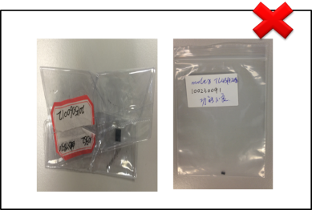

Suspect TI part(s) must be free of mechanical damage & in a testable condition.

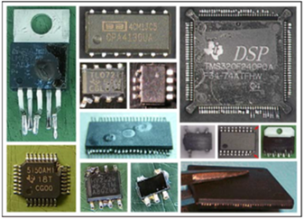
Mechanical damages (e.g. broken or bent leads) on a sample are in most cases a result of careless and inappropriate device handling/treatment. TI will reject the analysis of these devices. Sampled must be removed very carefully and the removed samples must be handled appropriately to avoid the introduction of additional false failures. Examples of returns in an unacceptable condition:

- Heavily bent leads/pins
- Contaminated package
- Coated package
- Excessive solder with solder bridging
- Missing or cut-off leads/pins
- Package defects/gross mechanical damages,
as a result of a careless removal process

Appendix 2: How to find LOT# and STC# from TI label (either pasted on reel or on carton box):

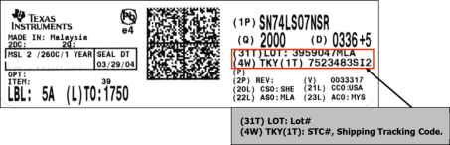

Appendix 3: How to read LTC from TI marking

Each TI part is marked with a unique Lot Trace Code (LTC) YMLLLLS. It might appear in a single line or in double line.
Y = year (e.g. 1 = 2011, 2 = 2012 etc.)
M = month (e.g. 1 = Jan, 2 = Feb ... 9 =
Sep, A = Oct, B = Nov & C = Dec)
LLLL = independent Assembly Number and S
= Assembly Site Code.

For example, 97BKL2K is the LTC, in which:
- 9: 2009, or 2019
- 7: July
- BKL2: Independent Assembly Number
- K: Site code for TI Malaysia

Typical marking formats:



Additional special format (Binary Date Code format) is used on very small packages, such as SOT/TO. This package is very small and has space for only 4 characters of marking. In this example, the manufacturing Year is 0101(binary) = 5, Month is 1001(binary) =9.

