Overshoot when insert and plug PSE cable
- I found test point 1 and point 2 had overshoot, the waveform is as follows:
Figure 1: I had test two points, the position as Figure 1.
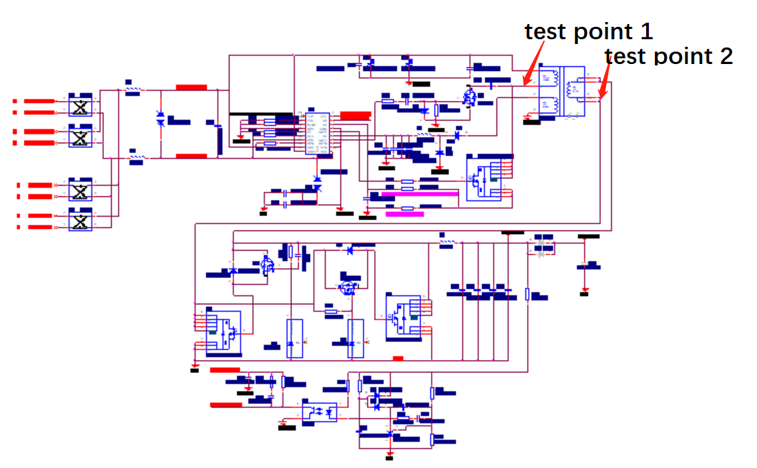
Figure 1 test point display
- Test point 1
When I plug the PSE cable, There is an overshoot at the test point 2(as Figure 3),the overshoot is about 160v 2us, and at the same time the 12V power supply drops.
My question: Does this overshoot need to be solved? If I need to solve, and How to solve this problem?
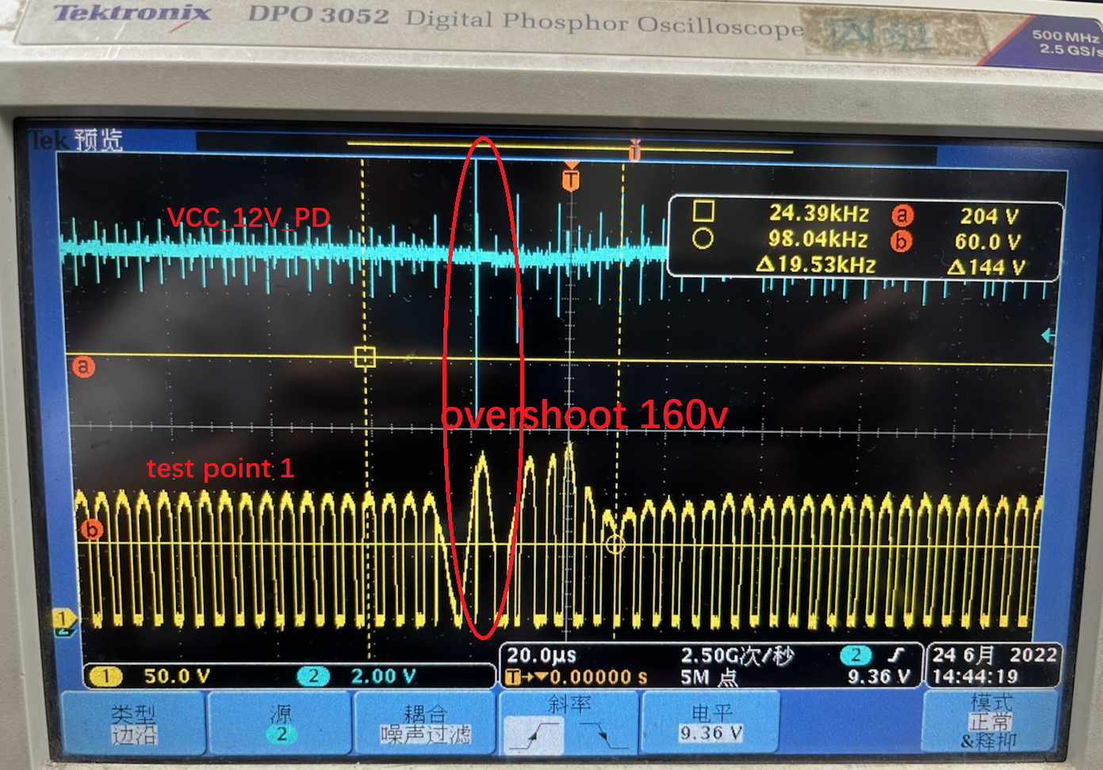
Figure 2 test point 1

- Test point 2
When I insert the PSE cable, There is an overshoot at the test point 2(as Figure 3 ).Figure 4 is is an enlarged view of Figure 3.
the overshoot is about 155v 20ns.
My question: Does this overshoot need to be solved? If I need to solve, and How to solve this problem?

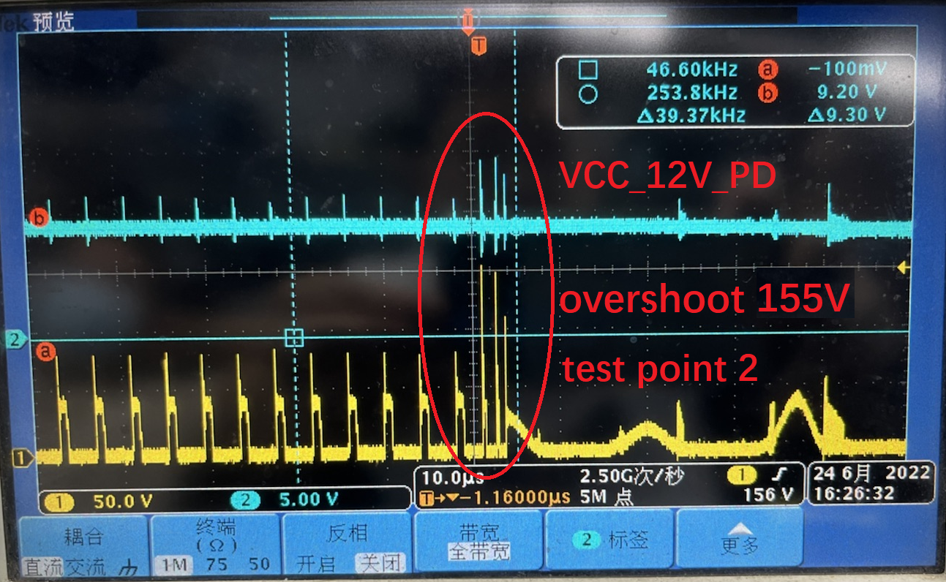
Figure 3 test point 2
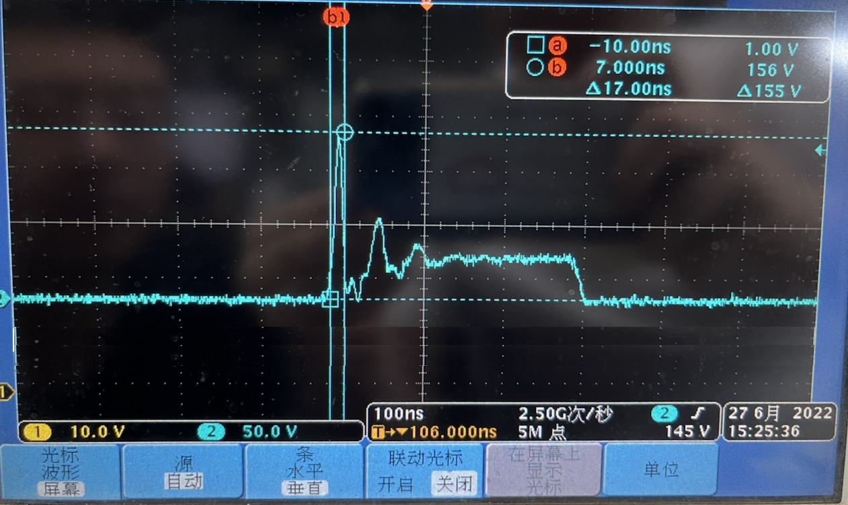
Figure 4 test point 2 zoom in

- How to select the appropriate NMOS and PMOS？？
My question: How to select the appropriate NMOS and PMOS？？
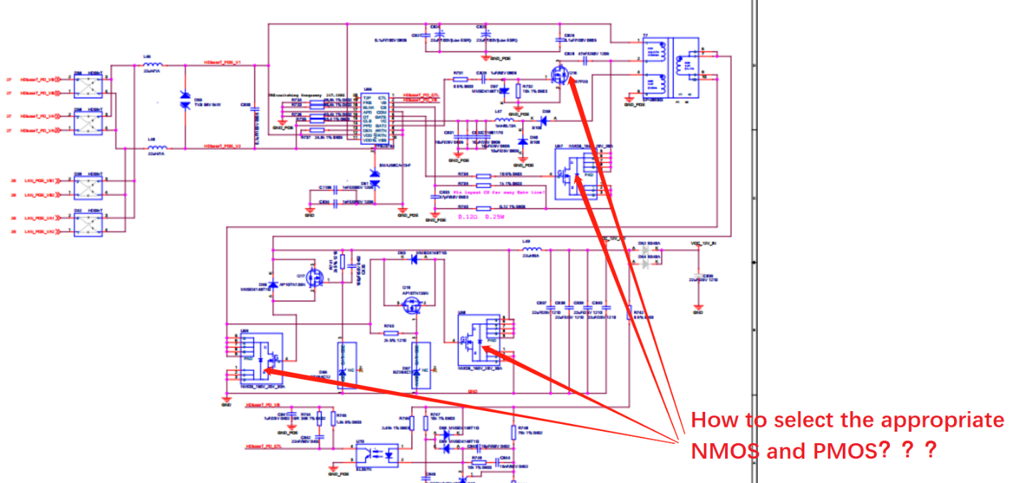
Note:s schematic will be found at attachment.

