**Low Frequency and Popcorn Noise in High Speed Amplifiers**

Michael Steffes June 2020

Low frequency noise is one of the more elusive issues in applying high speed op amps and fully differential amplifiers (FDA’s). Converting a spectral 1/f noise profile to the industry standard 0.1Hz to 10Hz VPP noise will be described along with a typical measurement preamp. This same preamp is used to test for popcorn noise with example measurements shown. All of these measurements are input referred as either voltage or input current noise effects. They then get to the output through the desired gain and resistor values used.

Most input noise modeling operates as a swept frequency spot noise extraction using low noise preamps and spectrum analyzers. These generate the typical curves found in devices like the OPA827 (a replacement for the industry standard OPA627) as shown in Figure 1 (Reference 1). Here, these front-page plots for this JFET input device shows no current noise and 0.1Hz to 10Hz bandlimited time domain noise over a 10sec sweep.

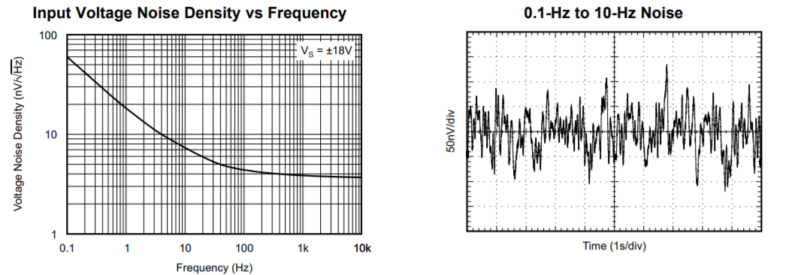

Figure 1. Input spot noise over frequency and low frequency time domain noise for the OPA827.

All JFET and Bipolar input type amplifiers show a 1/f corner effect in their input noise. Most CMOS input amplifiers do as well with the exception of CMOS chopper amplifiers that have a flat noise response going down in frequency (and no popcorn noise!!).

One approach to mapping the noise spectral density to expected low frequency VPP noise is to compute the equivalent flat spot noise value that will integrate to the same noise power over the expected frequency span. This is completely general, but will be applied here to the 0.1Hz to 10Hz span commonly shown in many amplifier datasheets. Equation 1 shows that simple computation where EN is the flatband noise in nV/√Hz, F1 is the minimum frequency, F2 is the maximum frequency, and F3dB is the frequency at which the spot noise has increased √2 from the flatband value - the 1/f frequency (derivation on page 7, Reference 2).

Equation 1. 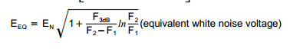

Testing the OPA827 TINA model for its input voltage noise model shows a flatband noise of 3.8nV/√Hz and a 1/f noise corner at 24Hz. Putting those numbers into equation 1 using F2=10Hz and F1 =0.1Hz yields an equivalent white noise of 13.3nV/√Hz. To convert that flat spot noise to RMS noise, multiply by the square root of the noise power bandwidth, or √9.9Hz. This yields an expected RMS noise in that span of 42nVRMS. Figure 2 shows this simulated noise integration for the OPA827 set up as a gain of 1 with a zero-ohm feedback resistor – this should just be the modeled input voltage noise integrated from 0.1Hz to 10Hz. The 10Hz value shows a reasonably close match at 40.9nVRMS validating equation 1. This curve is continuing up as there is no bandlimiting in this simulation – yet.

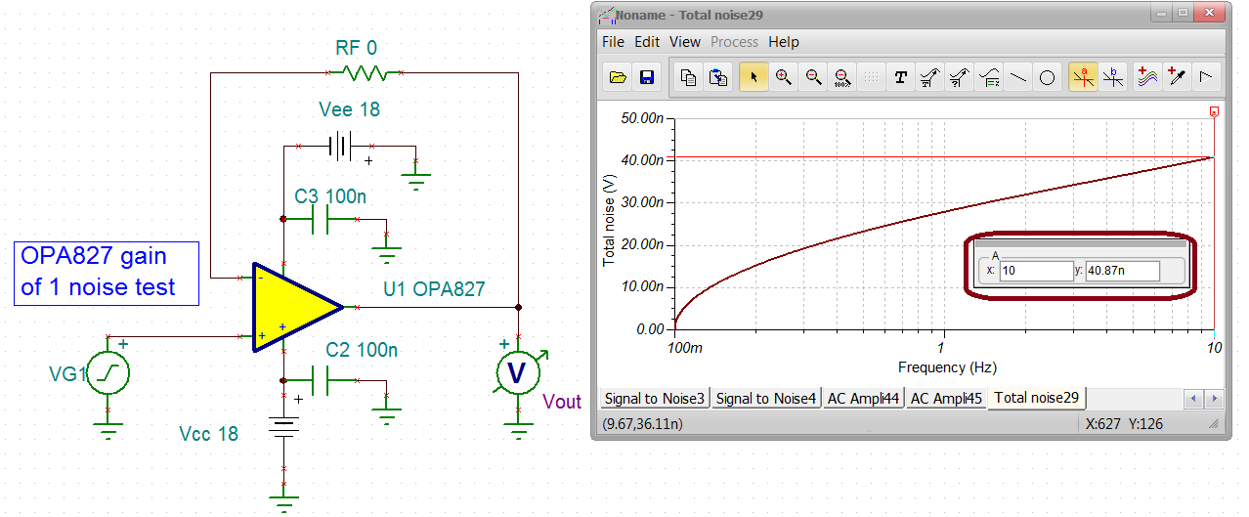

Figure 2. Integrated noise over the 0.1Hz to 10Hz span for the OPA827 TINA model at gain of 1V/V.

To convert this RMS noise to expected VPP, some estimate of crest factor is required. Typical values for noise are 6.0X to 6.6X. These relatively high crest factors are aimed at predicting a maximum VPP that the actual device will rarely exceed. For any particular device, the 10sec test in Figure 1 will show a different VPP on each sweep – such is the nature of noise. This crest factor choice is somewhat arbitrary as its imputed accuracy is swamped by the larger part to part variation for noise in the 1/f region. The model delivers a typical profile, but physical devices vary widely on their low frequency noise profile over frequency. Whatever is calculated here should be taken as very approximate. Using a 6X crest factor would predict 6*42nVRMS = 252nVPP closely matching the typical datasheet value of 250nVPP since that specification was also developed using this 6X number. Remember, this is input referred so multiply by the noise gain in your application to get an output noise.

**Measuring Low Frequency Noise**

By far the most common noise measurements use a spectrum analyzer. In the early days of op amp development, a 10sec sweep of a 0.1Hz to 10Hz bandlimited VPP noise became standard as an easy comparison metric. For that, a high gain, bandpass filtered, noise preamp is required. The early Burr Brown low frequency noise preamp used popcorn screened OPA627’s. Later work (Reference 3) went to the more recent OPA827 device. Both of these devices have their own 1/f noise characteristics and possibly popcorn noise. One of the more recent gain of 100V/V 3-stage active filter designs has been adapted to an even more recent OPA388 (Reference 4) CMOS chopper amplifier in Figure 3. CMOS chopper amplifiers have an intrinsic flat noise spectrum going down in frequency and are themselves popcorn free. This relatively high-speed device offers a flat 7nV/√Hz input noise with 10Mhz gain bandwidth product. This noise preamp uses a 1st stage gain of 10V/V 2nd order Butterworth high pass filter at 0.1Hz. This blocks off any DUT DC offset for later stages. The original designs followed that with a gain of 10V/V 4th order Butterworth filter at 10Hz. Figure 3 shows the most recent low pass stages implementing a sharper cutoff 0.1dB 4th order Chebychev at 10Hz. The 2nd order high pass is rolled off about -3dB from the mid-band gain of 40dB at 0.1Hz. The sharper cutoff 0.1dB Chebyshev is actually flat at 40dB gain through 10Hz then rolls off at a 4th order rate (-80dB/decade).

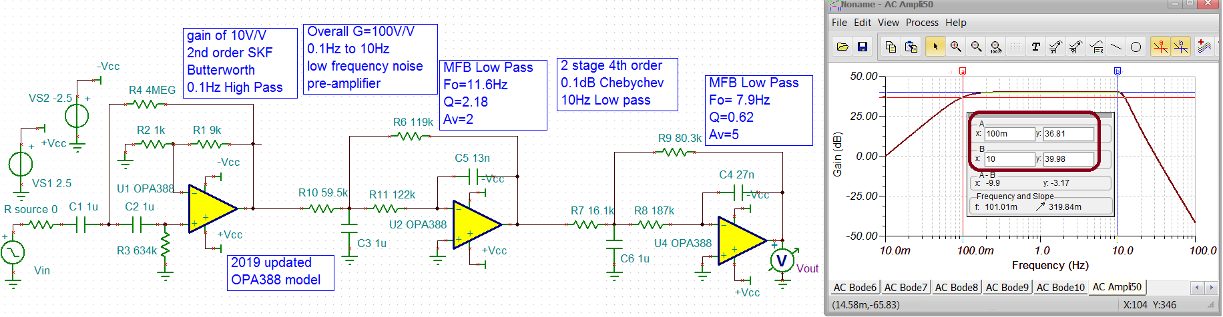

Figure 3. Updated gain of 100V/V 0.1Hz to 10Hz active filter for low frequency noise measurements.

Using this OPA388 chopper amp gives a lower integrated noise through the filter span for this noise preamp itself over earlier implementations. Running a broadband output integrated noise simulation yields only 21μVRMS. This input refers as only 210nVRMS. The DUT need only come in with at least 10X this level for this preamp to yield a good measurement. Going back to the OPA827 noise integration at a gain of 1 shows a 41nVRMS number in Figure 2. To exceed the noise preamp input integrated noise floor by 10X requires the DUT be set to a gain ≥51V/V. Adding that OPA827 at a gain of 51V/V in front of the noise preamp gives the total output integrated noise swept over a wider span shown in Figure 4. The integrated noise is going flat at a 215μVRMS level indicating the 4th order low pass filter is cutting off all higher frequency noise. That 215μVRMS input refers (divided by a gain of 5100V/V) to give 42nVRMS input referred– closely matching Figure 2. Using a 6X crest factor, that 215uVRMS noise out of the preamp will appear as approximately 1.3mVPP noise – easily measurable. Increasing the DUT gain will increase both the accuracy of the measurement and the measured VPP.

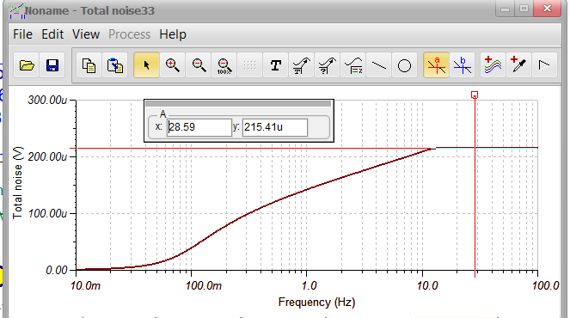

Figure 4. Integrated noise for the OPA827 set for gain of 51V/V followed by the OPA388 based gain of 100X active filter noise preamp.

**Want Butter with that Popcorn Noise?**

So popcorn noise was supposed to be an historical oddity – right? Well not so much – it still appears in many monolithic amplifiers – just at much lower levels than the early days that gave its’ name coming through speakers. While it may be at an imperceptible level on the speaker driver side, it could pose a limitation on very high dynamic range measurement mic digitizer channels. Where needed, this same low frequency active filter preamp is used to measure this effect. For FDA differential output popcorn noise, a low noise differential to single ended stage is first needed to get single ended into the noise preamp. Ideally that would be a wideband chopper based “Instrumentation Amplifier” (INA). There are a few low frequency ones, but the recent INA818 (non-chopper) appears to have suitably low 1/f corners (Figure 22, Reference 5) for this application. Just screen that particular INA818 for popcorn noise itself using the popcorn free preamp of Figure 3.

Recent high-speed amplifier developments have shown a low, but non-zero, incidence of popcorn noise in characterization. Each wafer has a variable incidence of popcorn noise where most sites are popcorn free. Those that are not show a surprising randomness in frequency, duration, and amplitude for these discrete steps in apparent input offset voltage (or current in some cases). Figure 5 shows a particularly virulent case of popcorn noise in a returned THS4531A low power FDA (Reference 7). This input referred plot shows the relatively low (10’s of μV) level for these input offset voltage shifts.

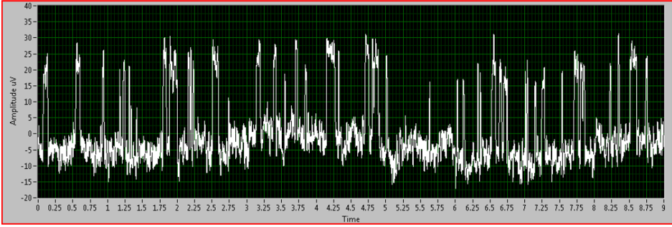

Figure 5. Representative popcorn noise in a returned THS4531A.

Using the low noise, high gain active filter, preamp of Figure 3, it is possible, but time consuming, to screen these outliers out. Some production test flows add a 2 second screen for this issue. While helpful, any device with a >2sec pop period might be a test escape. This phenomenon is not limited to TI amplifiers but appears as well across a range of bipolar input amplifiers in the industry. Use the low frequency noise preamp described here to perform your own validation testing (ideally across multiple units and wafer lots).

References

1. “Low Noise, High Precision, JFET-Input Operational Amplifier”, Texas Instruments OPA827 Datasheet, revised July 2016, <http://www.ti.com/lit/ds/symlink/opa827.pdf>
2. “Noise Analysis for High Speed Op Amps, Burr Brown application note, Michael Steffes, Oct. 1996, <http://www.ti.com/lit/an/sboa066a/sboa066a.pdf>
3. “0.1Hz to 10Hz Noise Filter”, TI Designs, Art Kay, June 2013, <http://www.ti.com/lit/ug/slau522/slau522.pdf>
4. “Precision, Zero-Drift, Zero-Crossover, True Rail to Rail I/O Operational Amplifiers”, Texas Instruments OPA388 Datasheet, revised May 2019, <http://www.ti.com/lit/ds/symlink/opa388.pdf>
5. “35μV Offset, 8-nV/√Hz Noise, Low-Power, Instrumentation Amplifier”, Texas Instruments INA818 Datasheet, revised June 2019, <http://www.ti.com/lit/ds/sbos894a/sbos894a.pdf>
6. “Ultra Low-Power, Rail to Rail Output, Fully Differential Amplifier”, Texas Instruments THS4531A datasheet, revised March 2020, <http://www.ti.com/lit/ds/symlink/ths4531a.pdf>
7. TI online support site, e2e, THS4531A popcorn noise thread, <https://e2e.ti.com/support/amplifiers/f/14/t/505185>