Power tree:

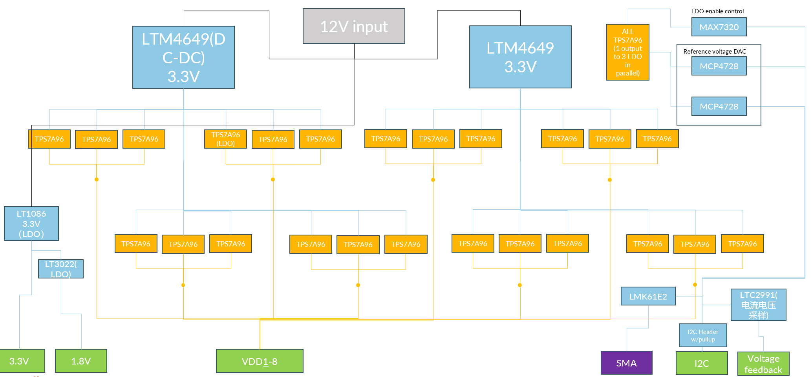

Detail:

Q1: For the INA3221, we want to check whether we can use the ballast resistor to do the current sensing? We have 4mOhm ballast resistor on all the LDO to balance the current between 3LDO -> 1 output power supply now, but we would the reading is not accurate

