Hello,
Good morning.
We have used the MSP430F67641IPN as a 3-phase 4-wire application(see below picture), but we are looking for a solution or refer design for a 3-phase 3-wire application (see below picture),whether have you this solution? whether may use this IC,how modify for this application?

- Phase 4-wire application:

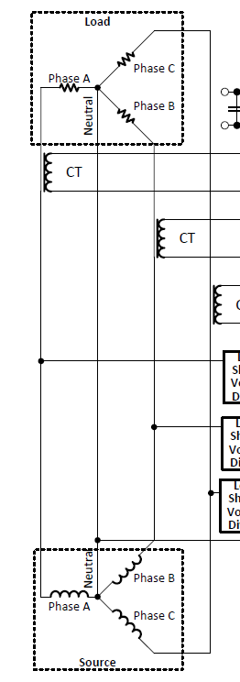

3-phase 3-wire application
