ADS1263 test
Input a sine signal with a peak-to-peak value of 1V at 1Hz
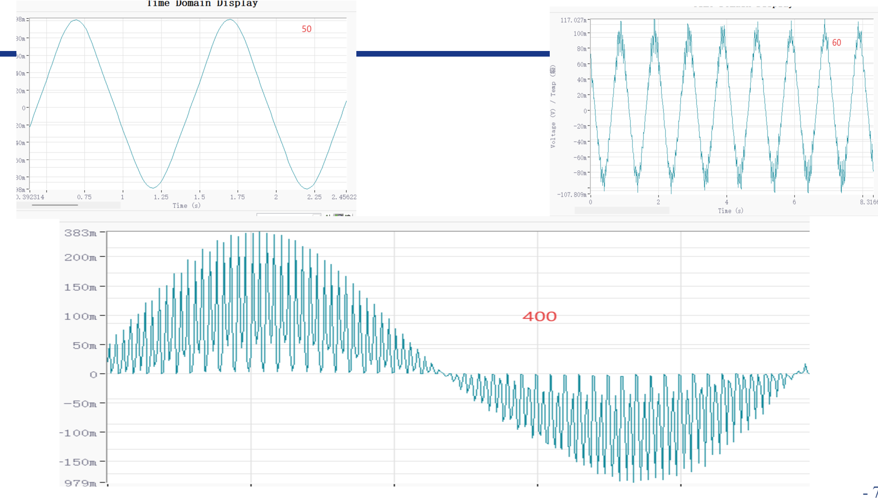
SINC1-5SPS-1Hz1Vpp sine wave
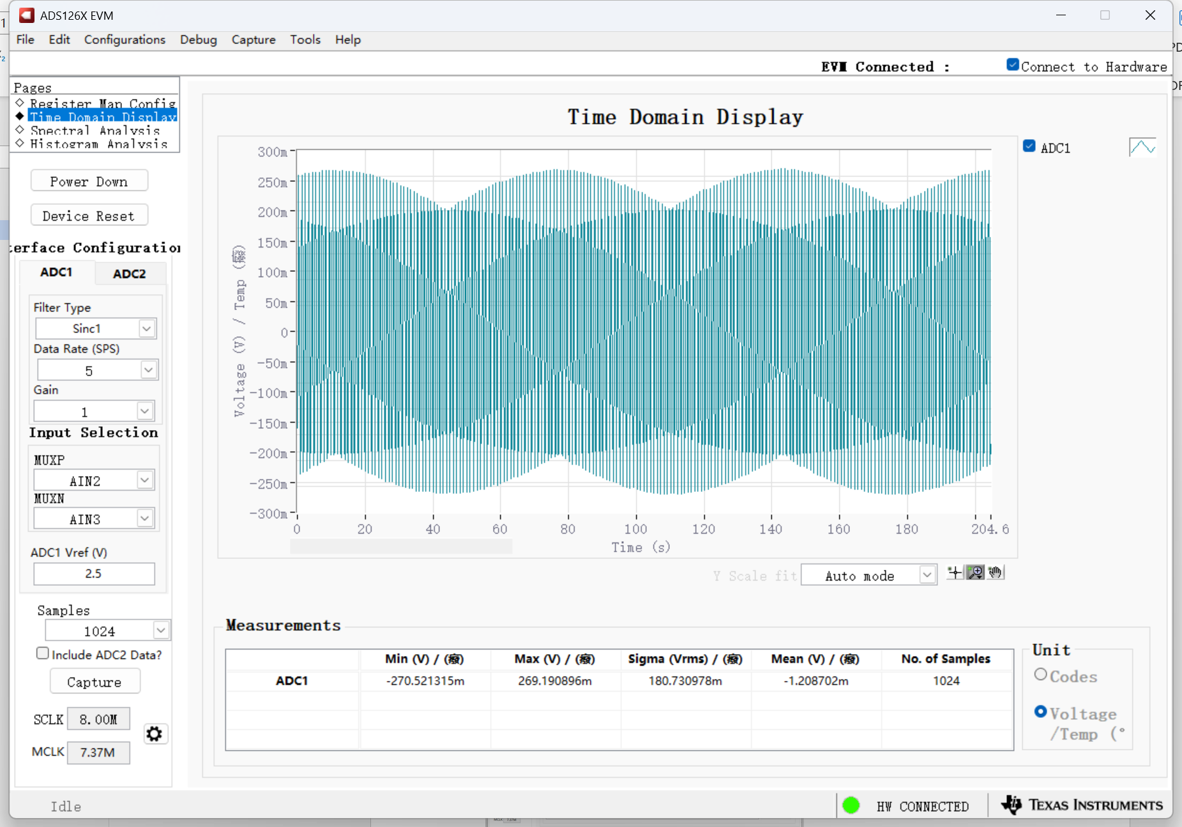
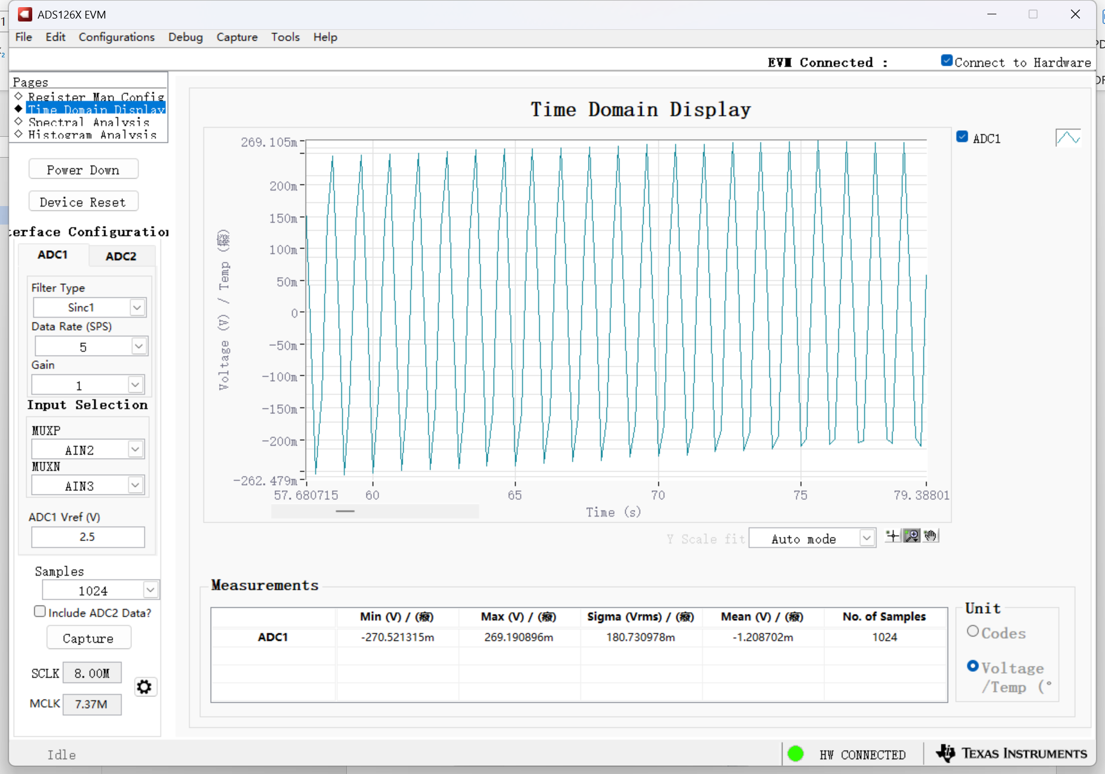
SINC1-10SPS-1Hz1Vpp sine wave
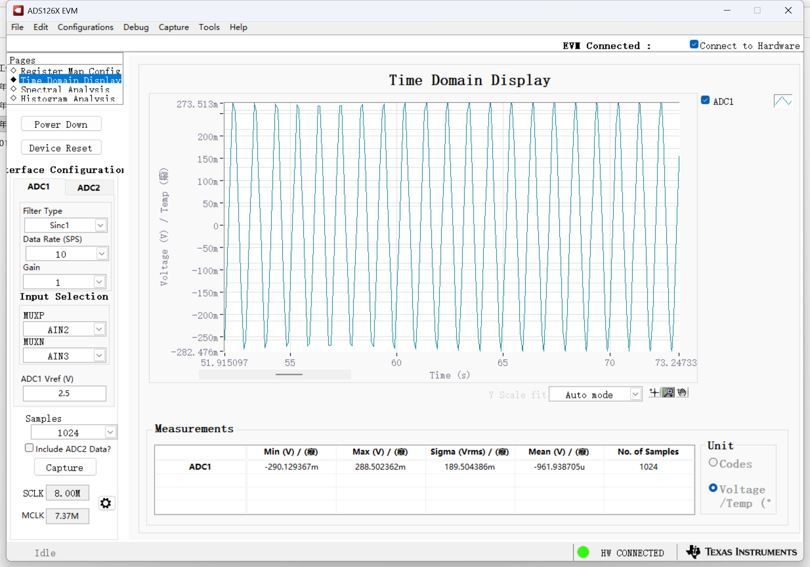
SINC1-20SPS-1Hz1Vpp sine wave
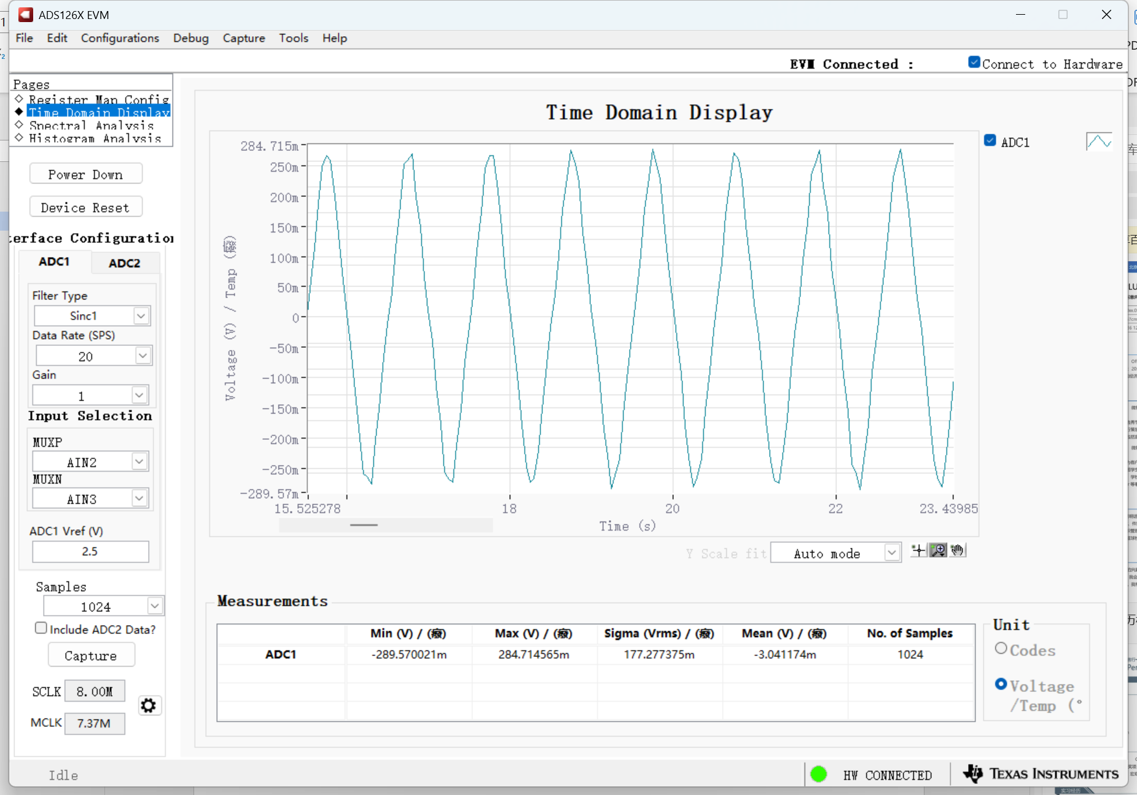
SINC1-50SPS-1Hz1Vpp sine wave
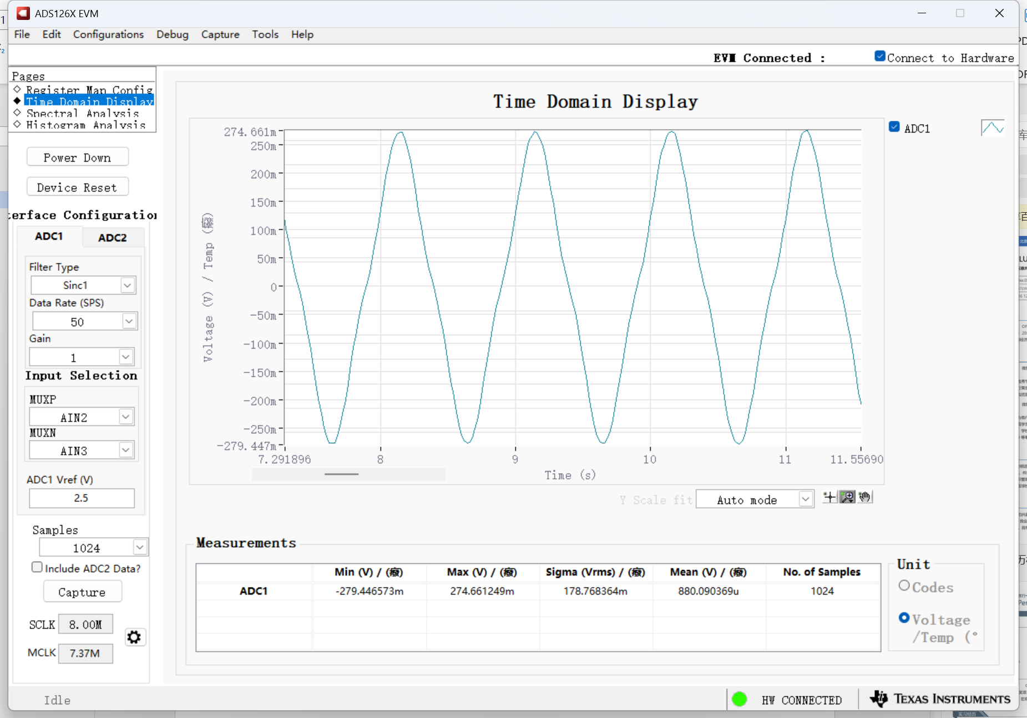
SINC1-60SPS-1Hz1Vpp sine wave
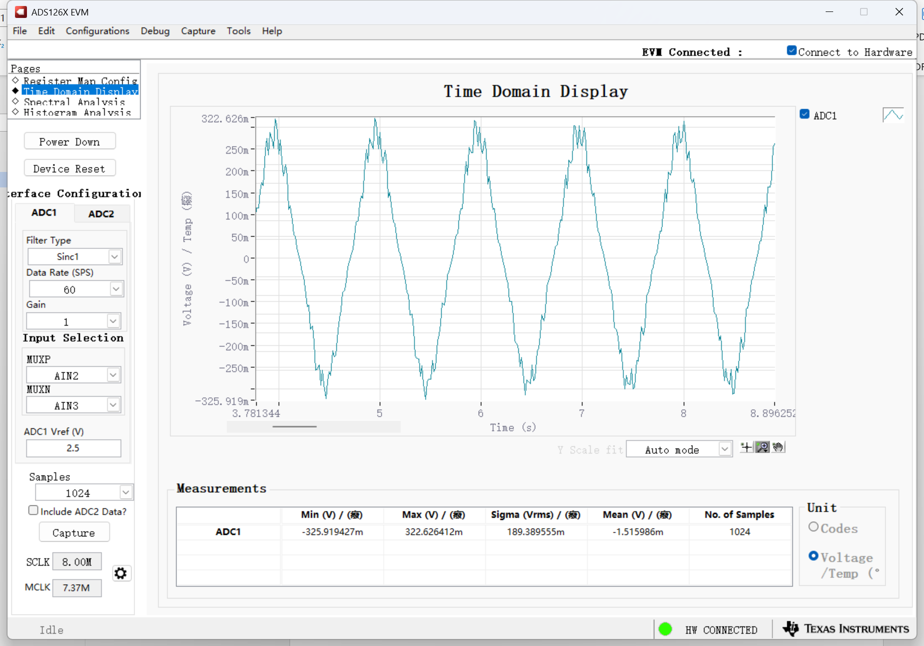
SINC1-60SPS-10Hz1Vpp sine wave
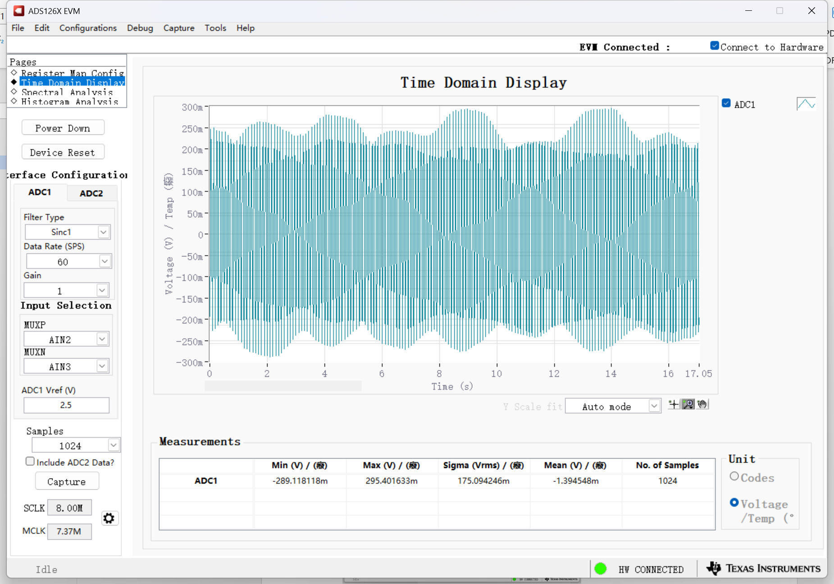
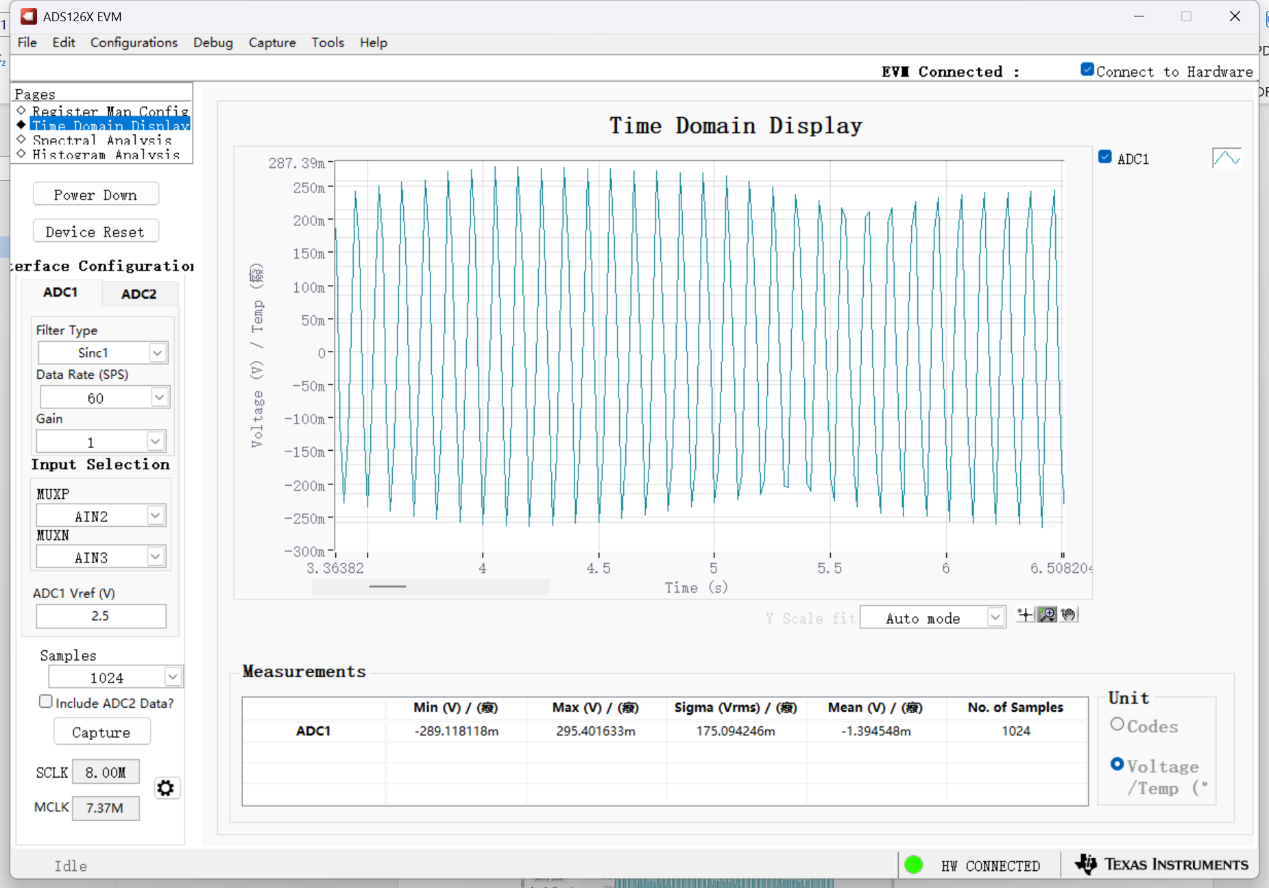
SINC1-60SPS-20Hz1Vpp sine wave
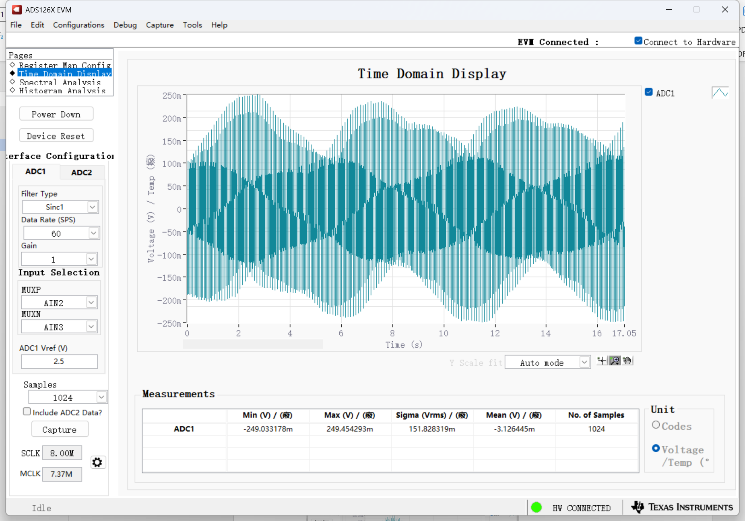
SINC1-400SPS-1Hz1Vpp sine wave
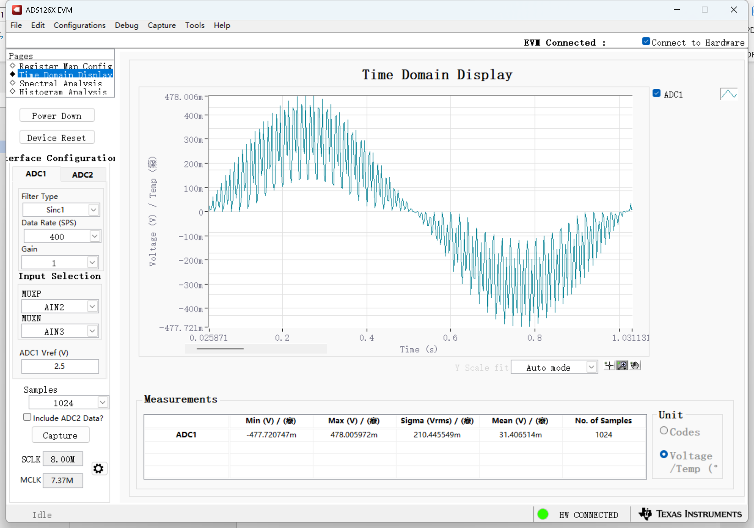
SINC1-2400SPS-1kHz1Vpp sine wave
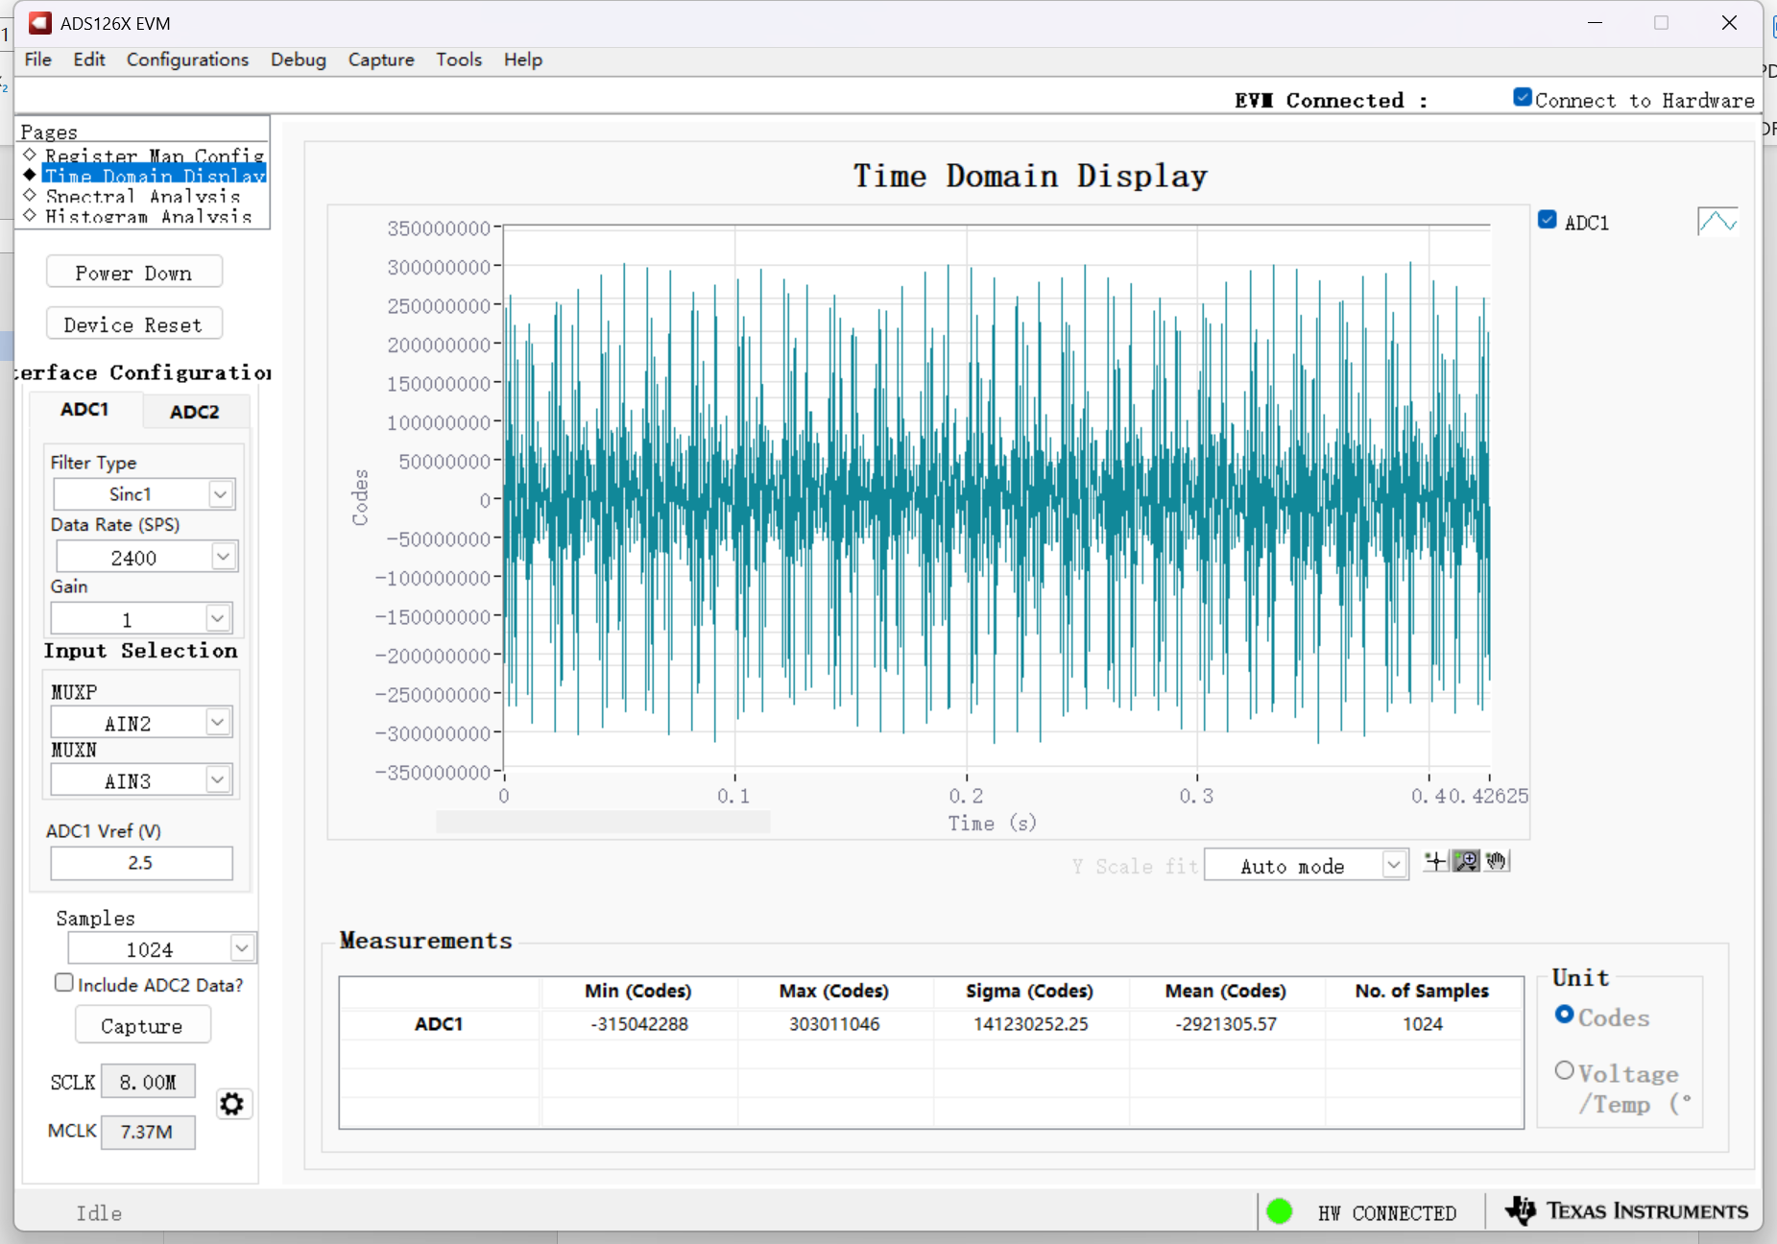
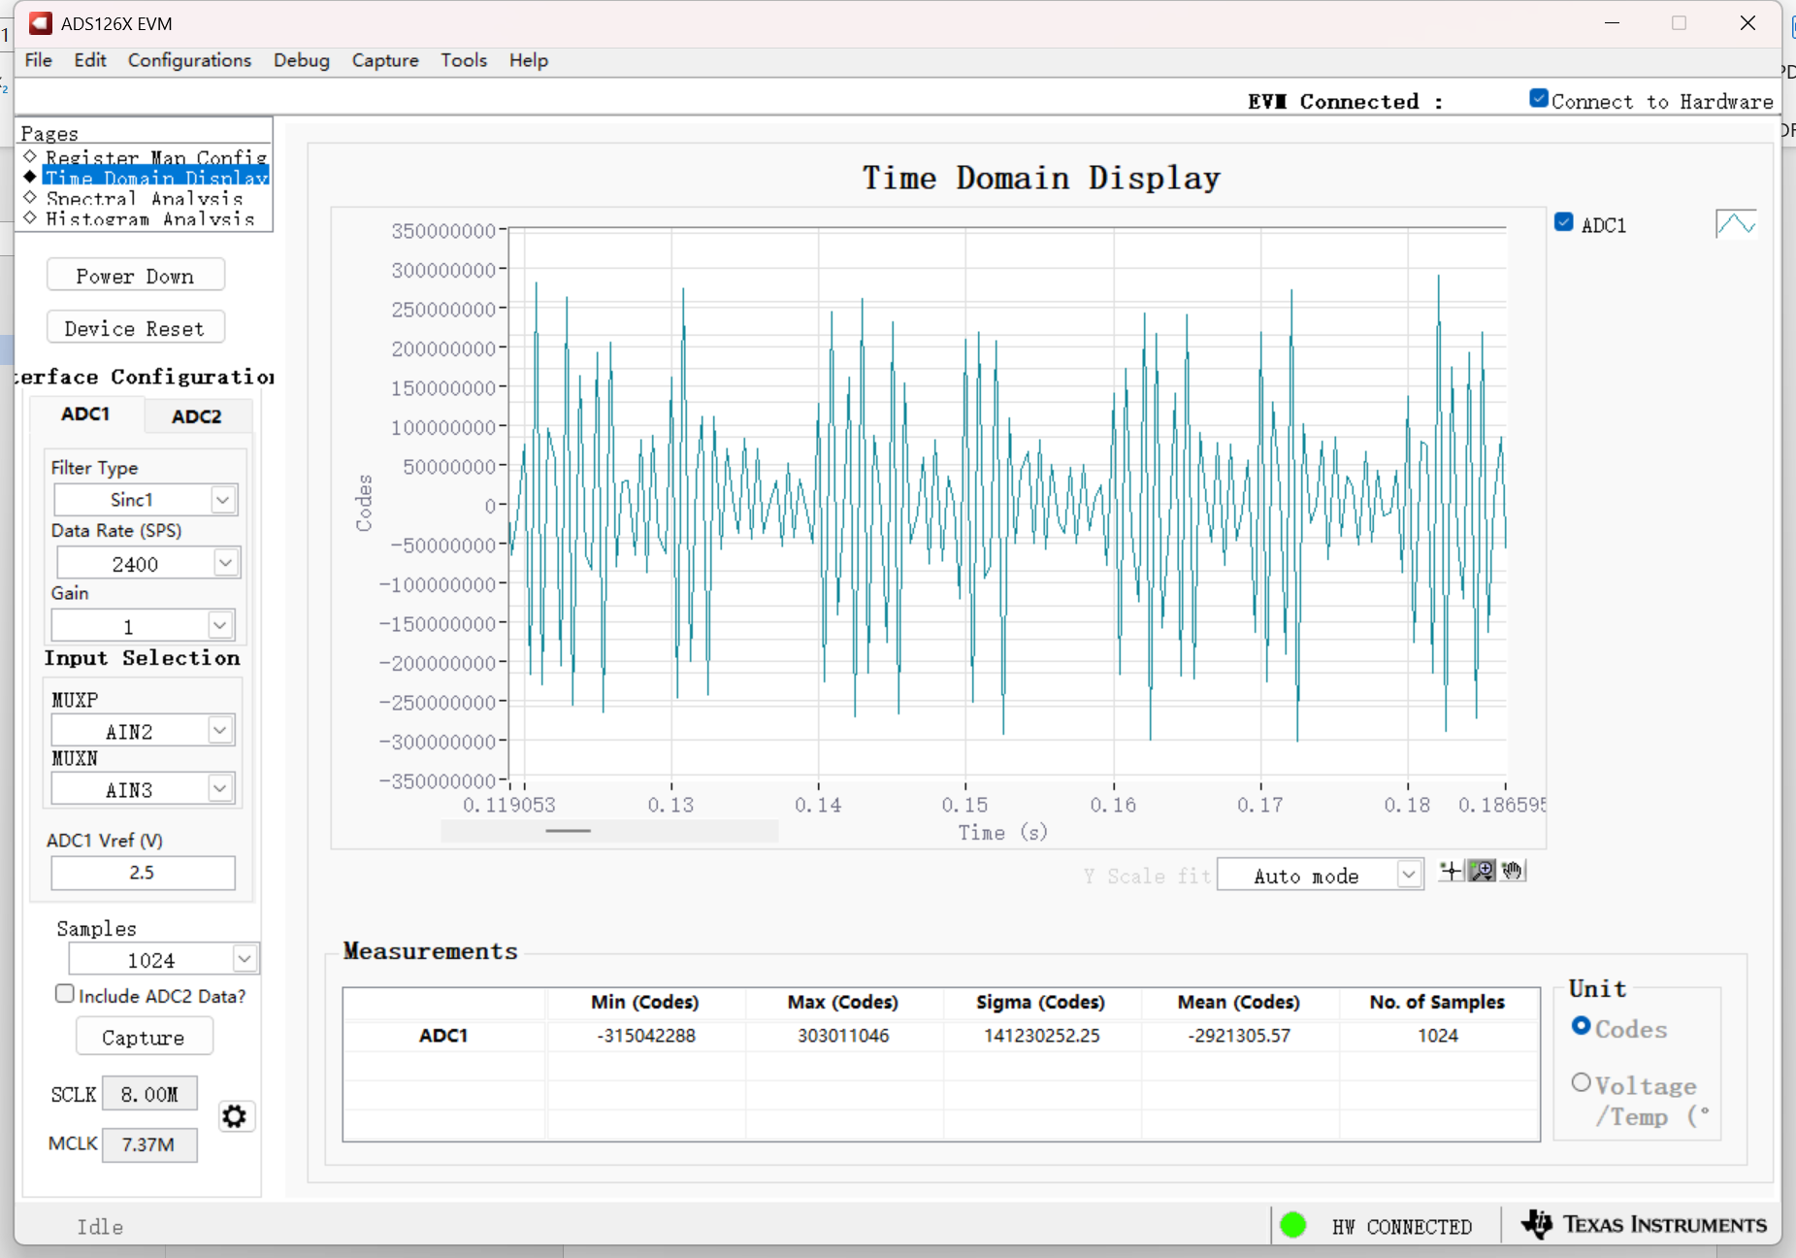
SINC1-4800SPS-1kHz1Vpp sine wave
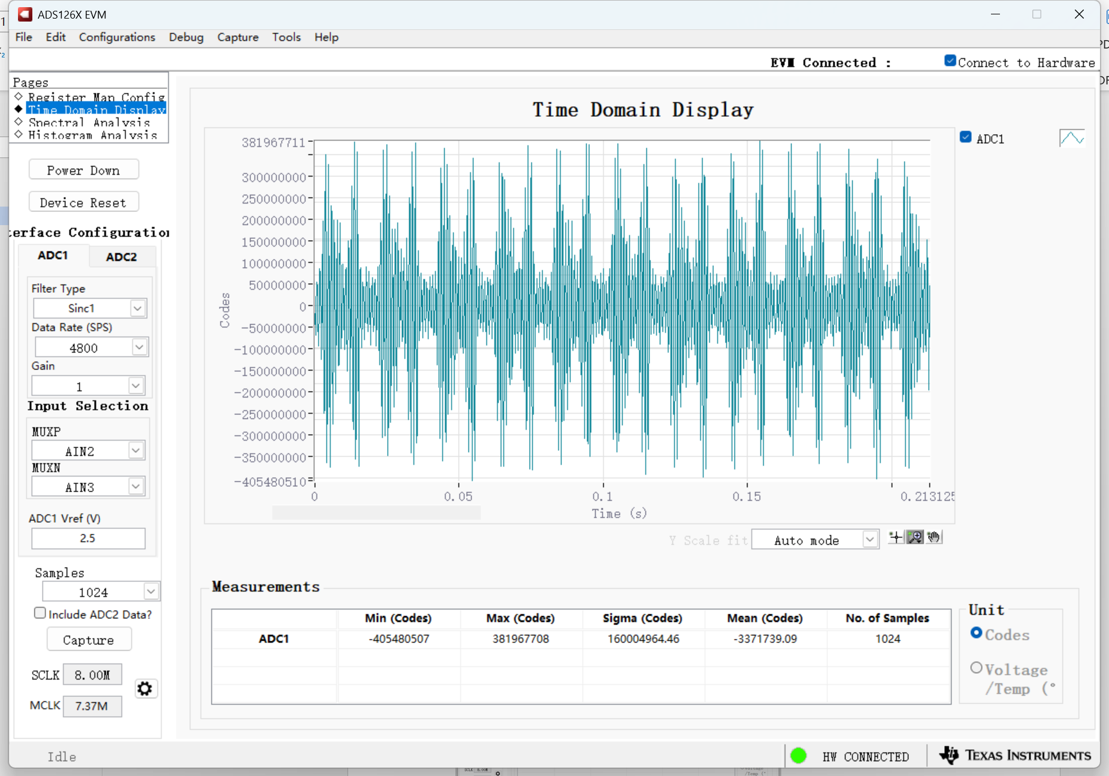
SINC1-7200SPS-1kHz1Vpp sine wave
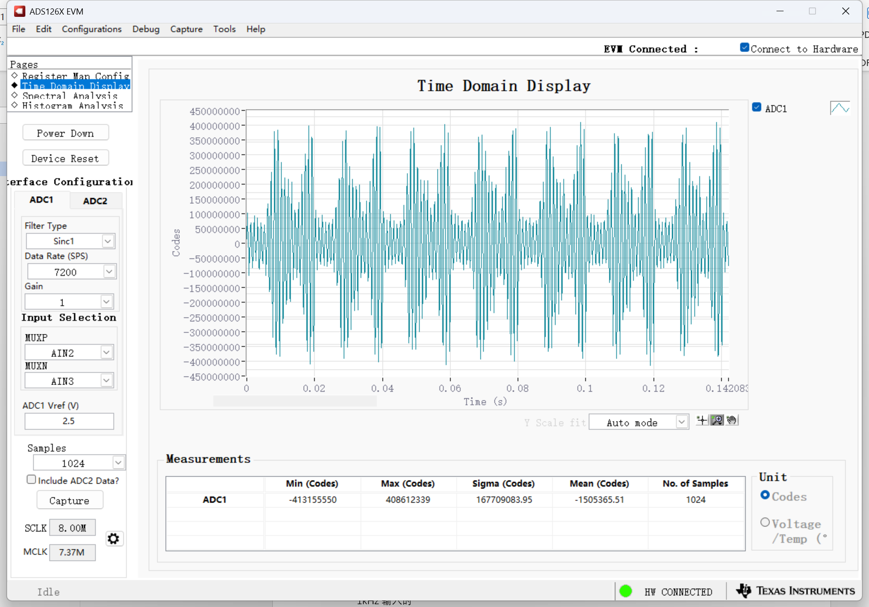
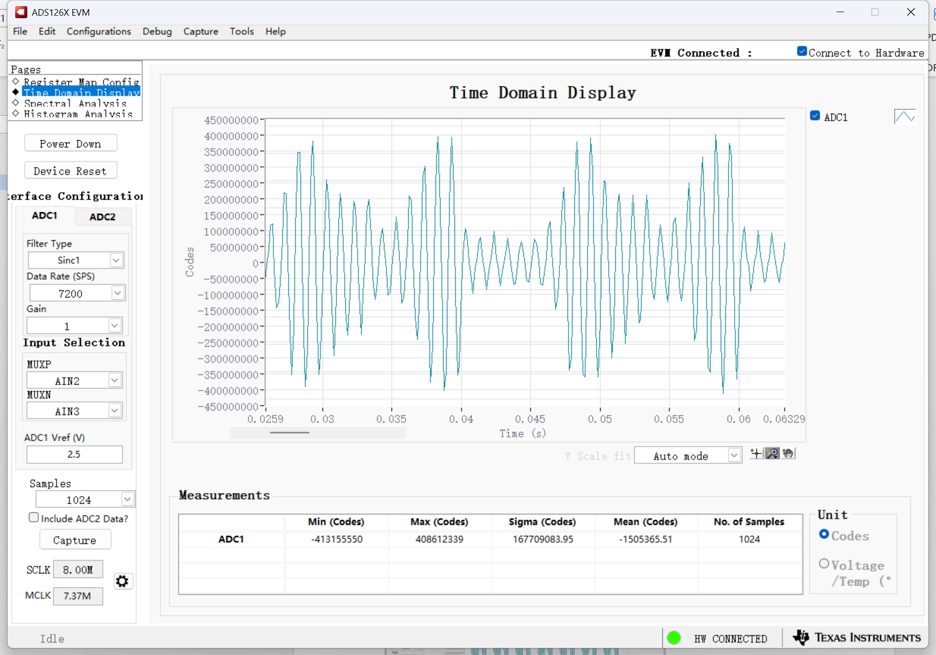
SINC1-14400SPS-1kHz1Vpp sine wave
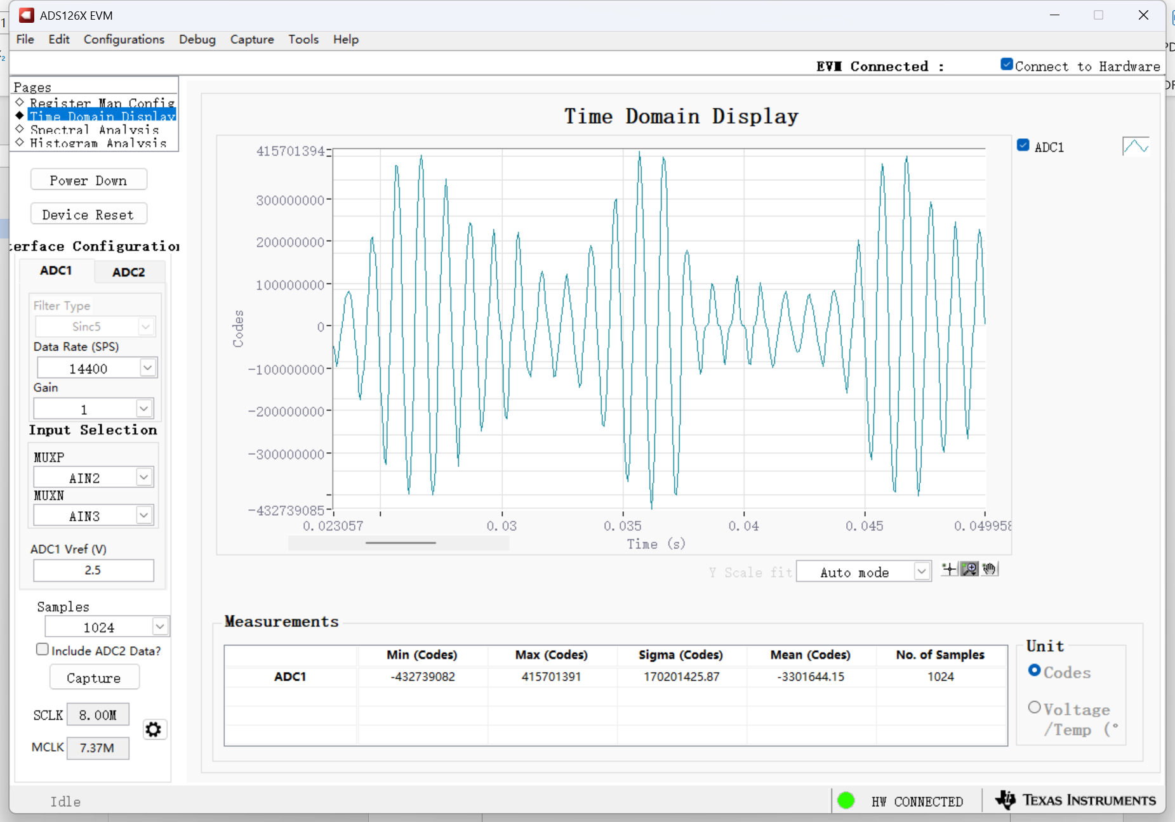
SINC4-2400SPS-1kHz1Vpp
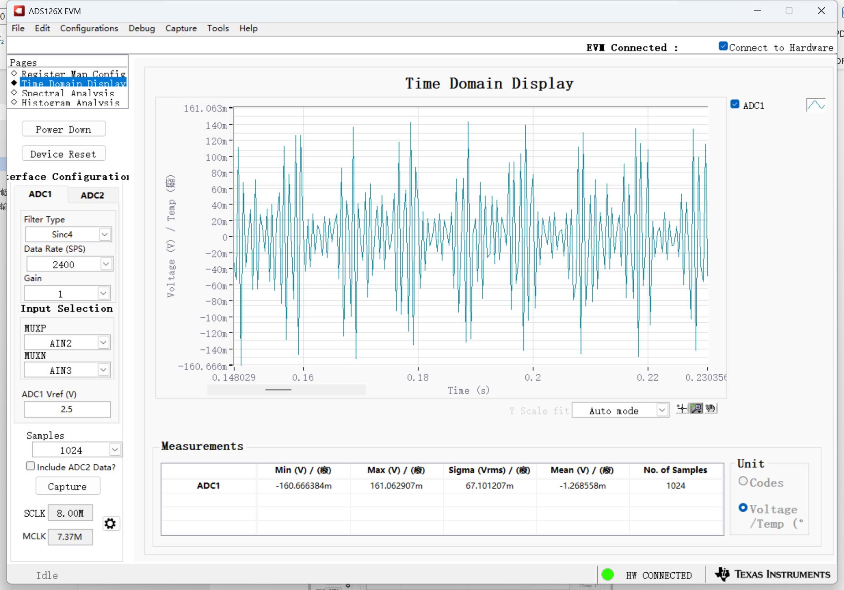
SINC4-4800SPS-1kHz1Vpp
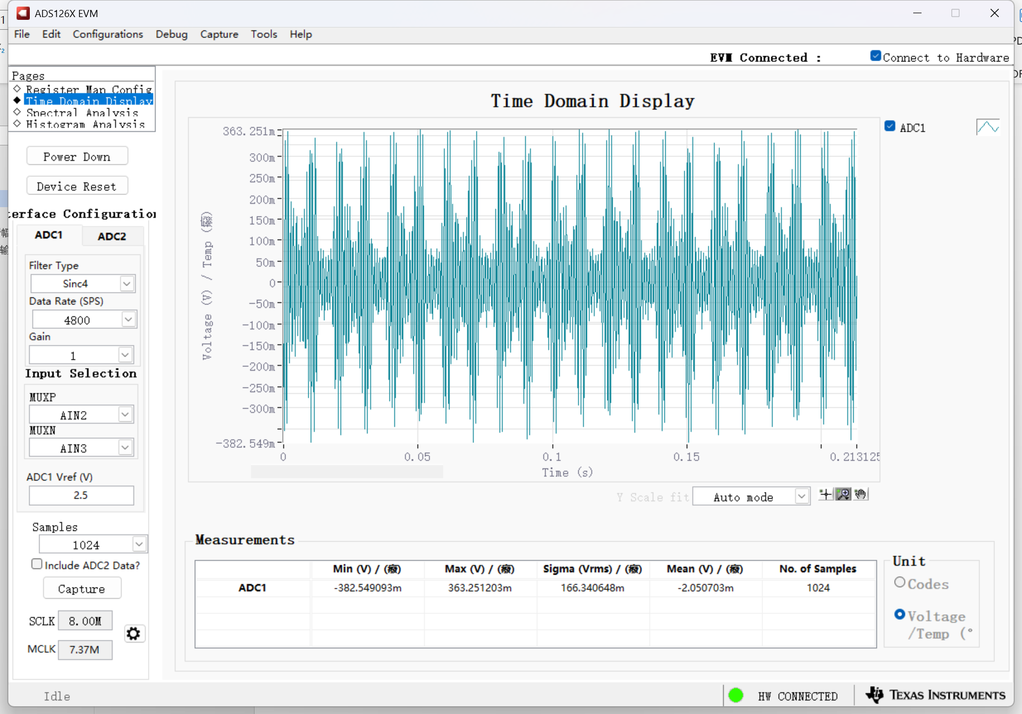
SINC4-7200SPS-1kHz1Vpp
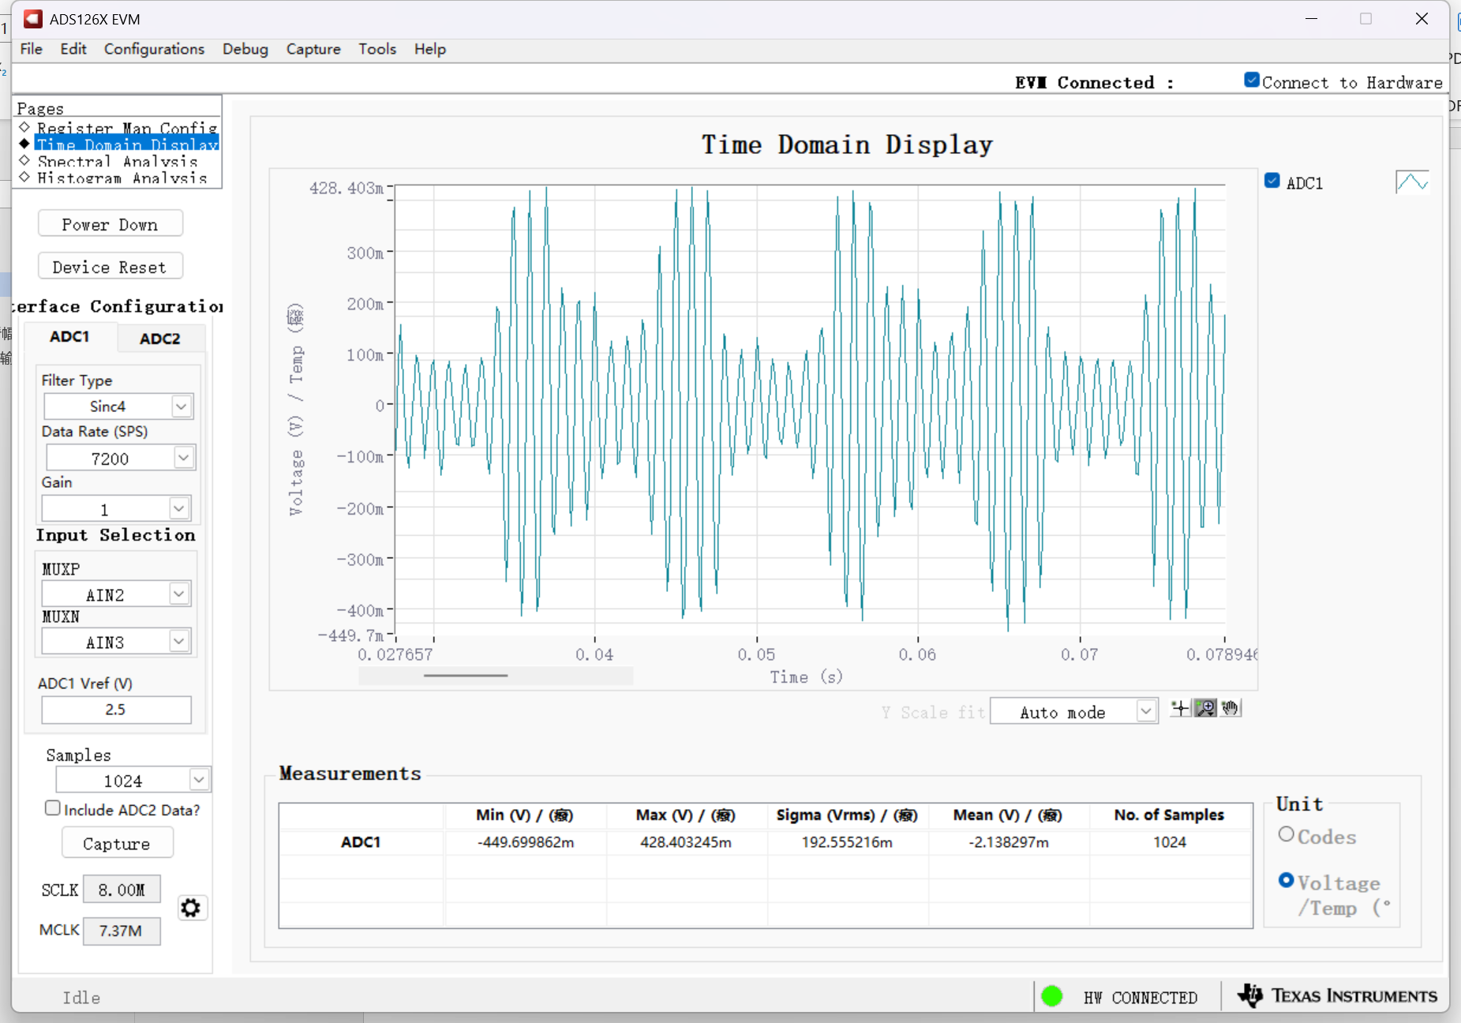
SINC4-14400SPS-1kHz1Vpp
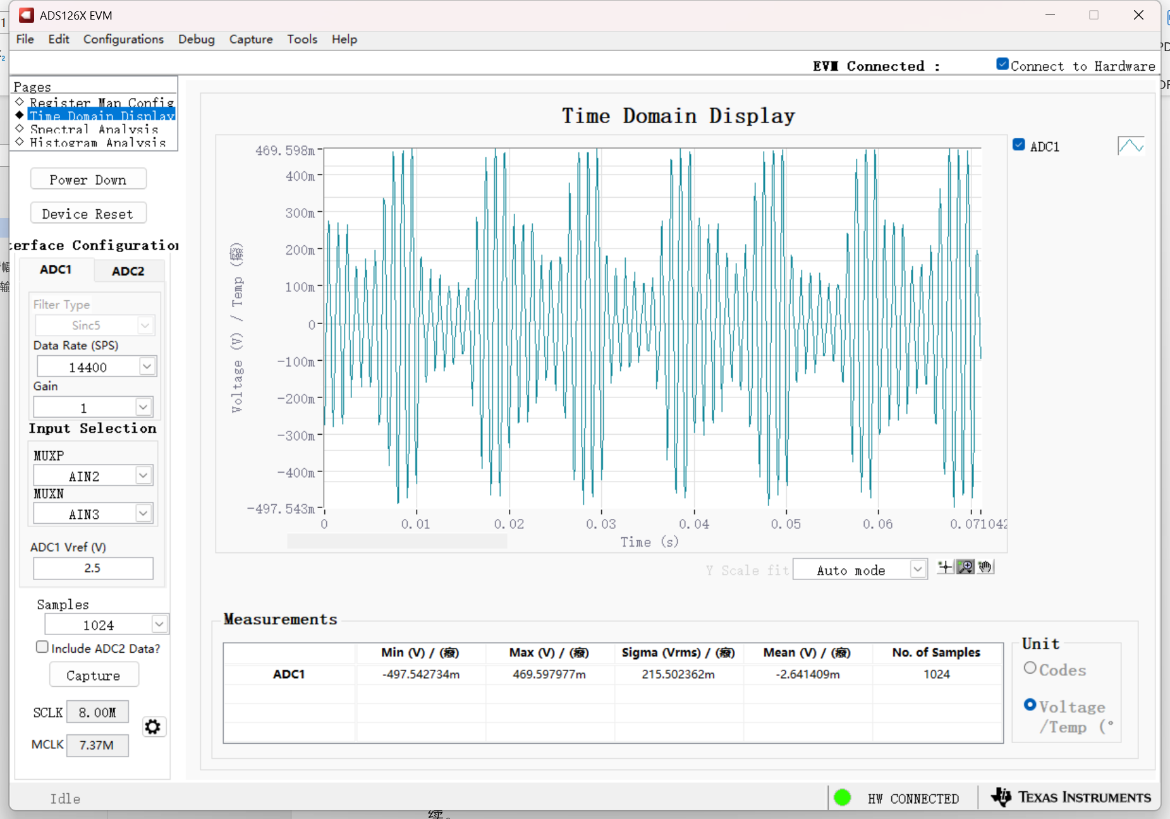

When the 1Hz1Vpp sine wave is input, the waveform discontinuity will occur when the SPS acquisition above 50 is used. But when the 10Hz1Vpp sine wave is collected with 60SPS, the signal appears to be continuous. The sampling rate setting is very important. At present, it is more appropriate to set the 1 setting at 5 to 10 times the input signal frequency.
When using a high-frequency signal input such as 1kHz1Vpp, the sampling rate is selected, and the acquired waveform feels discontinuous.

