General Guidelines for Current Sinking DAC interface with an FDA
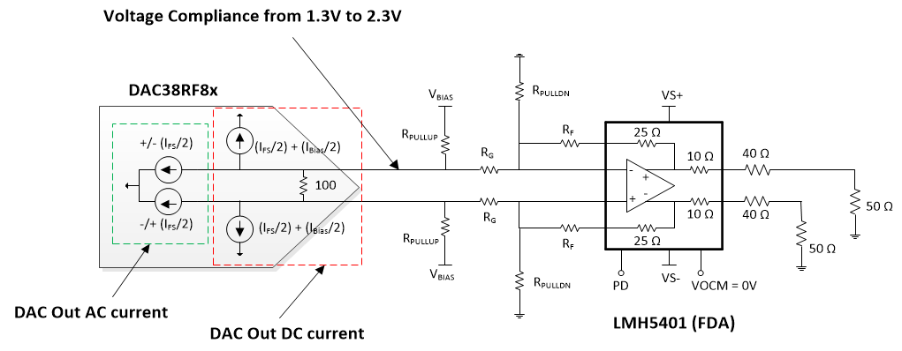
Figure 1. Current Sinking DAC interface with an FDA
For interfacing a current sinking DAC (say DAC38RF8x) with an FDA (say LMH5401) in DC coupled application, we need to know the below three parameters.
- DAC Full scale output current (I_{FS}) & Bias current (I_{BIAS})
- DAC output compliance voltage range
- External interface DC common-mode voltage
Let us assume that the DAC38RF8x output full scale current (I_{FS}) is set to 30mA. Based on the below table from the DAC datasheet, the I_{BIAS} is set to 6 mA. In differential output operation of the DAC, the I_{BIAS} is split equally between the two complementary outputs resulting in (I_{BIAS}/2) = 3mA on each side. Also, the DAC full scale output current (I_{FS}) flows on top of I_{BIAS} from 0 to 30mA on one output while giving complementary current on the other output from 30mA to 0mA.
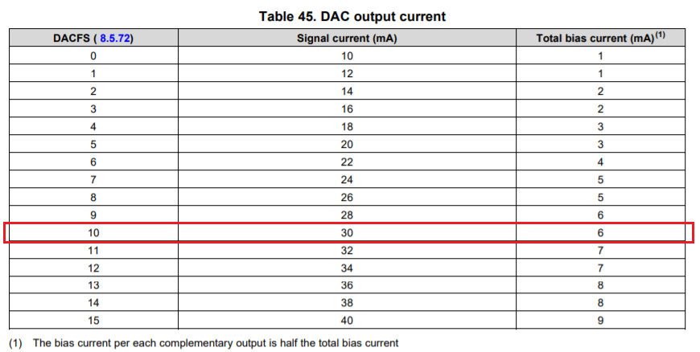
Due to the symmetric differential action of the output current, the I_{FS} can be treated as having “dc” bias current of (I_{FS}/2) on each output while having an “ac” current of +/- I_{FS}/2 current on one output (and vice versa of complementary current -/+ I_{FS}/2 on the other output). This operation results in the DAC output current being treated as AC current and DC current, as shown in Figure 1.
For current sinking DACs, the output CM voltage is typically set to its supply voltage and the DAC voltage swing occurs with respect to this output CM voltage. In-order to prevent or exceed the max voltage rating of the DAC output differential pair, an output voltage compliance range is generally specified in the DAC datasheet. For the DAC38RF8x outputs, this happens to be 1.3V to 2.3V on each output with its output CM set to 1.8V (or mid-point of single-ended output range).
Most DC coupled systems require interface to the external world with respect to GND or 0V. This means that the FDA output should be set to 0V using its output CM voltage pin, while level shifting the DAC output CM voltage from 1.8V down to 0V. In the process, care should to be taken to avoid violating the input CM voltage of the FDA. For the LMH5401, the typical input CM voltage spans from (VS+) – 1.2V down to VS- from the datasheet.
For 0V output CM at the LMH5401 and maximum output swing at the FDA, the ideal supply for the device is then +/-2.5V. This means that the input CM voltage for the LMH5401 will be from 1.3V down to -2.5V.
DC Analysis:
In-order to level shift the DAC output CM from say 1.8V down to 0V, we need to perform DC analysis of the Figure 1. An R_{PULLUP} resistor with V_{BIAS} voltage is included in-order to pull up the DAC output CM up to 1.8V. Similarly, an R_{PULLDN} resistor is included at the FDA input in-order to pull down the FDA input CM voltage within compliance.
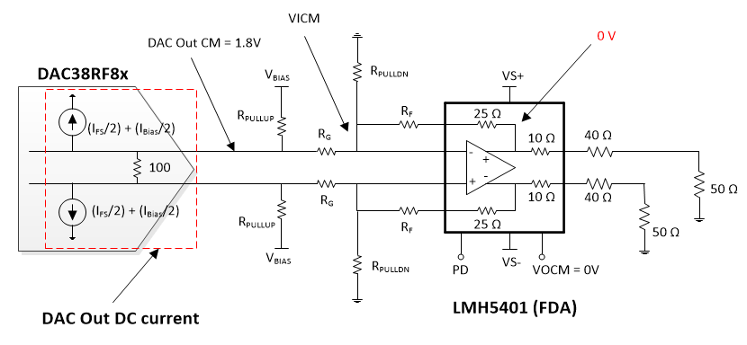
Figure 2. DC analysis of the Interface
Treating the DAC outputs and FDA inputs as virtual short at DC, we can simplify the Figure 2 to solve for the KCL equation as shown in Figure 3.
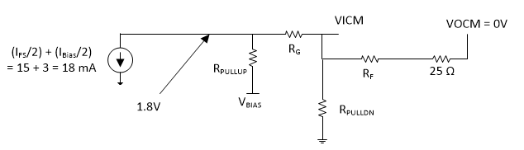
Figure 3. Simplified DC analysis circuit
Equation 1. KCL Applied at the DAC output of 1.8V
$$- I_{DAC\left(DC\right)} +\frac{V_{BIAS}-1.8V}{R_{PULLUP}}+\frac{\left(VICM-1.8V\right)}{R_{G}}= 0$$
Equation 2. KCL Applied at the FDA input or the VICM node
$$\frac{(1.8-VICM)}{R_{G}}+ \frac{(0-VICM)}{R_{PULLDN}}+ \frac{(0-VICM)}{R_{F}+25}=0$$
The V_{BIAS} voltage should be selected higher than the target DAC output CM voltage, to say 5V, in-order to give positive value for the resistors.
AC Analysis:
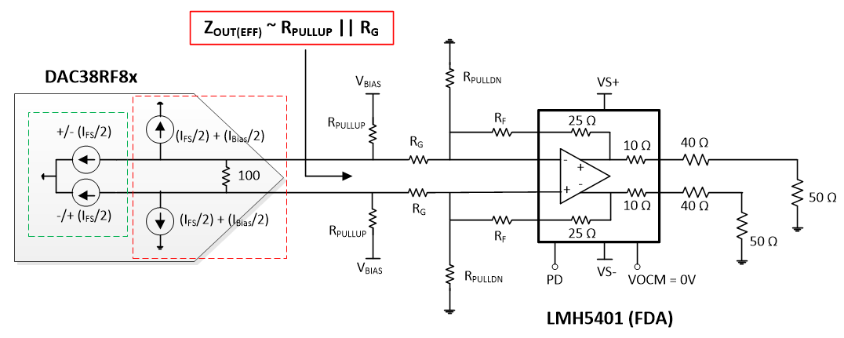
Figure 4. AC analysis of the interface
The AC analysis is used to determine the effective output impedance at the DAC output, which is then used to appropriately set the R_{PULLUP} and R_{G} resistors. As we noticed in the DC analysis, the right value of R_{PULLUP} and R_{G} is needed in-order to set the DAC output CM to 1.8V. In a similar fashion, the compliance voltage range of the DAC is determined by these resistors for a set DAC output current.
For DAC38RF8x, the voltage compliance range on each output is 1.3 to 2.3V. So, this translates to V_{DAC(OUT)_SE} = 1Vpp swing on each output. The DAC full scale current (I_{FS}) is set to 30mA. So, the effective impedance looking at the DAC output in-order to be within its voltage compliance then becomes 1Vpp/30mA ~ 33.33 ohms.
The DAC already has internal 100-ohms differential impedance, or 50-ohms single ended output impedance (R_{DAC(INT)}) based on differential symmetry. So, the effective impedance (Z_{OUT(EFF)}) required externally to be within compliance can then be calculated using Equation 3. The Z_{OUT(EFF)} will be 100ohms for the internal DAC impedance of 50-ohms with 1Vpp swing on I_{FS} = 30mA.
Equation 3. Required DAC effective output impedance
$$Z_{OUT(EFF)}=\frac{\left(\frac{V_{DAC(OUT)_SE}}{I_{FS}}\right)*R_{DAC(INT)} }{R_{DAC(INT)}- \left(\frac{V_{DAC(OUT)_SE}}{I_{FS}}\right)}$$
This effective output impedance (Z_{OUT(EFF)}) is set by the parallel combination of R_{PULLUP} and R_{G,} as shown in Figure 4. The R_{PULLDN} does not come into play here for the Z_{OUT(EFF)} since the FDA input is fully differential resulting in the input CM being virtual short to AC GND. As a result, the Z_{OUT(EFF)} = R_{PULLUP} || R_{G}. Calculating for R_{G} as a function of R_{PULLUP}, we then have Equation 4.
Equation 4. R_{G} expressed as a function of R_{PULLUP}
$$R_{G}=\frac{Z_{OUT(EFF)}*R_{PULLUP}}{(R_{PULLUP}- Z_{OUT\left(EFF\right)})}$$
Substituting the value for R_{G} from Equation 4 into Equation 1, and then solving for R_{PULLUP} gives the Equation 5.
Equation 5. R_{PULLUP} calculation
$$R_{PULLUP}= \frac{Z_{OUT(EFF)}*(V_{BIAS}-VICM)}{[\left(Z_{OUT\left(EFF\right)}*I_{DAC\left(DC\right)}\right)+1.8-VICM]}$$
From the R_{PULLUP} calculation in Equation 5, calculate the R_{G} resistor.
Depending upon the output voltage swing requirement at the FDA, the voltage gain (A_{V}) in the FDA needs to be set which is given as Av = R_{F}/R_{G.} Since R_{G} and R_{F} resistor are now known, you can use Equation 2 to calculate for the R_{PULLDN} resistor.
Few things to keep in mind while calculating for R_{PULLUP.} (Continue reading below)
- Make sure the R_{PULLUP} resistor does not come out to be negative. If it does, then make sure the V_{BIAS} selected is greater than VICM
- If the R_{PULLUP} resistor evaluates out to be approximately close to Z_{OUT(EFF)}, then the R_{G} resistor will be extremely large. This presents a problem while setting the gain of the FDA. This is because the R_{F} resistor will now need to be Av times R_{G} to set the gain, and will severely affect the signal chain BW performance. In such a situation, you need to reduce the Z_{OUT(EFF)}.
Example: Interface DAC38RF8x with the LMH5401 for DAC FS = 30mA and 0V output CM at the FDA
Let us assume the interface circuit looks like Figure 1, where the VBIAS selected is 5V which is higher than DAC output CM of 1.8V. Also, let us assume the LMH5401 FDA input CM voltage (VICM) needs to be set to 0.6V for the amplifier to be in linear operation.
For DAC output compliance range of 1.3V to 2.3V with internal differential 100-ohm termination, the effective output impedance Z_{OUT(EFF)} for DAC FS current (I_{FS}) of 30mA is ~ 100 ohms. Also, the DAC DC bias current – I_{DAC(DC)} consists of I_{FS}/2 + I_{BIAS}/2 = 18mA.
Using Equation 5, the R_{PULLUP} resistor evaluates to ~ 145 ohms. Now, this R_{PULLUP} value results in an R_{G} of ~ 314-ohms which is kind of on a higher value side.
Instead, reduce the Z_{OUT(EFF)} from 100ohms to one half the original value of say 50-ohms. This results in the DAC single ended output swing to ~ 30mA*(50||50) = 30mA*25ohms = 0.75 V_{PP(SE)}. If we re-evaluate for R_{PULLUP} using the new Z_{OUT(DIFF)}, this results in R_{PULLUP} = 104.76-ohms and a subsequent R_{G} value of 95.65-ohms.
For the LMH5401 output, the max single ended output swing is ~ 2.7V_{PP}. This translates to the gain required in the FDA to ~ 2.7V_{PP} / 0.75V_{PP} = 3.6 V/V. Since we now have the R_{G} = 95.65-ohms, the desired R_{F} value will now be ~ 344-ohms. (Remember that the external R_{F} needed for the LMH5401 will be 319-ohms, since the device has internal 25-ohms feedback resistor). This value of R_{F} is within acceptable range for the LMH5401 where the BW is not comprised to less than 1GHz.
The R_{PULLDN} calculated from Equation 2 results in the value of ~ 55.54-ohms. Below is the finalized circuit with the resistor values shown in Figure 5. Lastly, make sure to optimize the circuit with 1% standard resistor values for better DC accuracy.
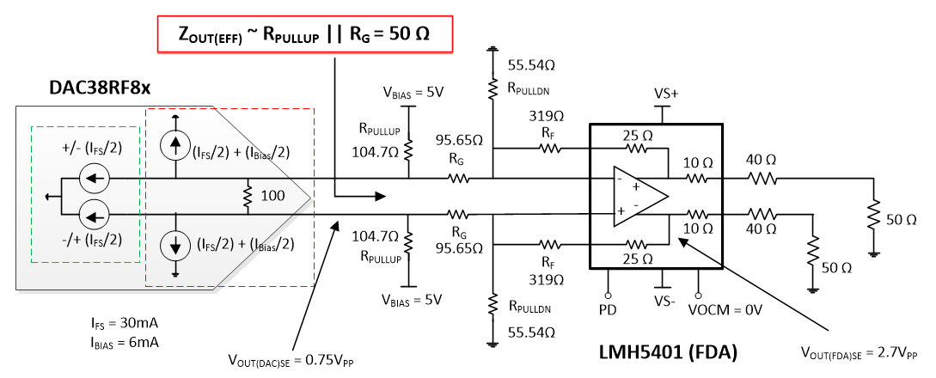
Figure 5. Example interface of DAC38RF8x with the LMH5401

