Click [here](https://ftdichip.com/wp-content/uploads/2023/01/FT_Prog_v3.12.31.639-Installer.exe_.zip) to download the FT Prog and [here](https://ftdichip.com/wp-content/uploads/2020/07/AN_124_User_Guide_For_FT_PROG.pdf) for the user guide.

Open the FTProg and click Scan & Parse. All the FTDI devices will be listed here. Among the listed ones, check for the TSW1400 board (here, I have ADS54J40 connected).

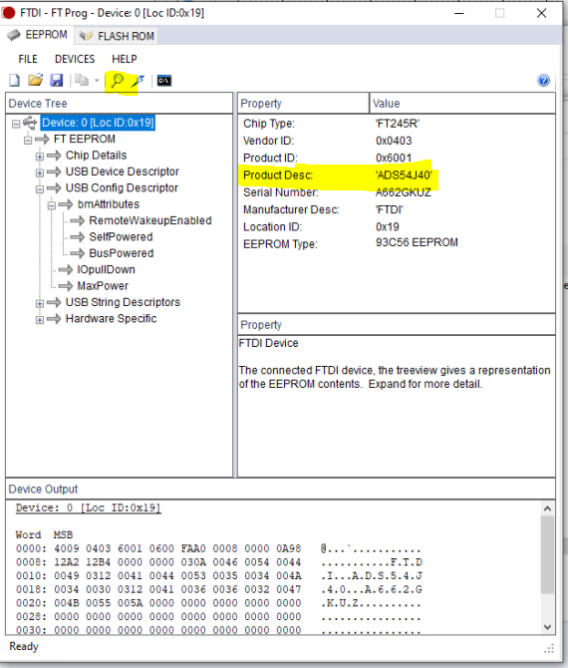

Under the device, click on USB Config Descriptor, you will find an option to updated the Max Bus Power.

