The error 1379 may arise due to some issue in the LabVIEW drivers. Please uninstall both HSDC Pro and LabVIEW runtime engine and then install HSDC Pro and try the C example (Please find the steps for uninstalling the LabVIEW runtime and HSDC Pro mentioned below).

**Steps to follow for complete uninstallation of HSDC Pro with LabVIEW runtime engine:**

1. Open NI Package Manager. If not present, kindly install it from the NI website. The offline installer is present at the following location.

“\\ent.ti.com\data\HSC_DC\HSDCPRO_DEPOT\Softwares\NIPM”

1. Go to Installed tab(When opening NI Package Manager, an error saying failed to update all feeds may arise, please ignore it).

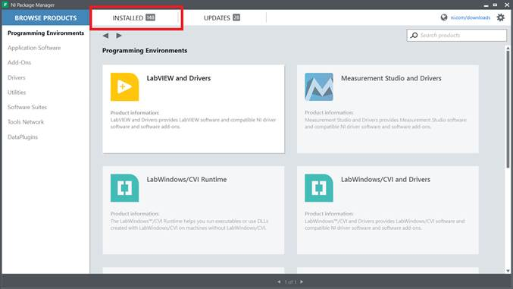

1. In Installed tab, Select **LabVIEW Runtime (32-bit)** of version **2014 SP1 f11** and click on **Remove** to uninstall.

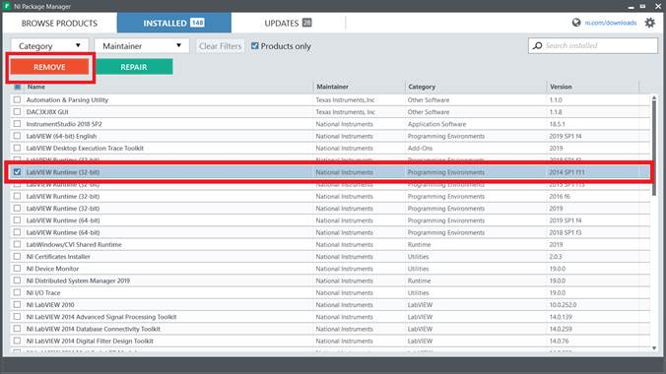

1. Uninstall **High Speed Data Converter Pro** from control panel. And delete the “High Speed Data Converter Pro” folder if present in the below 2 locations,

“C:\Program Files (x86)\Texas Instruments”

“C:\Users\Public\Documents\Texas Instruments”

1. Install **High Speed Data Converter Pro** and run the GUI.