At present, I have made a board with TMS320C6678，DDR is not used. When the GPIO port of DSP and FPGA is set to EMIF I / O, the connection is successful with CCS v5.5 test connection, but there will be error prompt pop-up device core was hung when debugging;
After clicking OK in the pop-up window, sometimes it will jump to the address of 0x7... And sometimes it will show that the device functional clock appears to be off.
Thanks
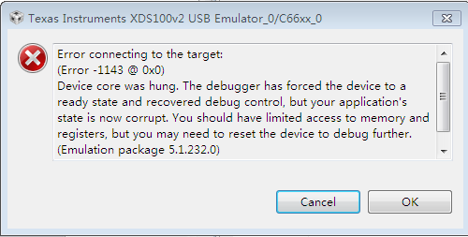

After clicking OK：
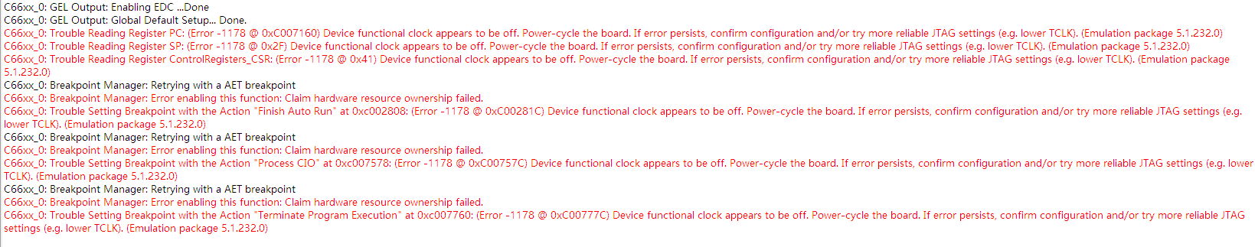

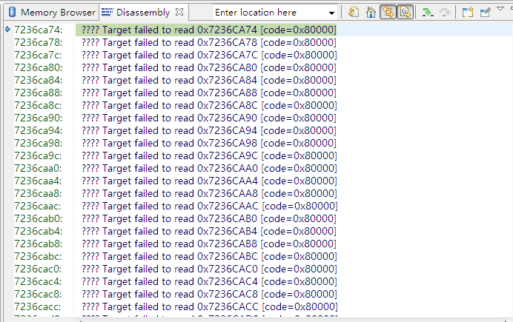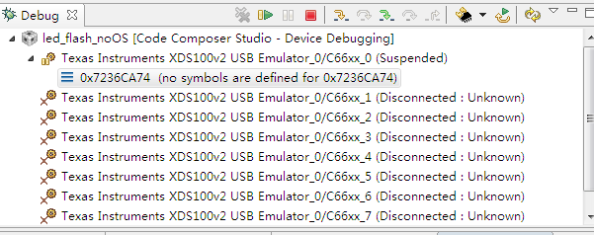

CMD：

