1、schematic
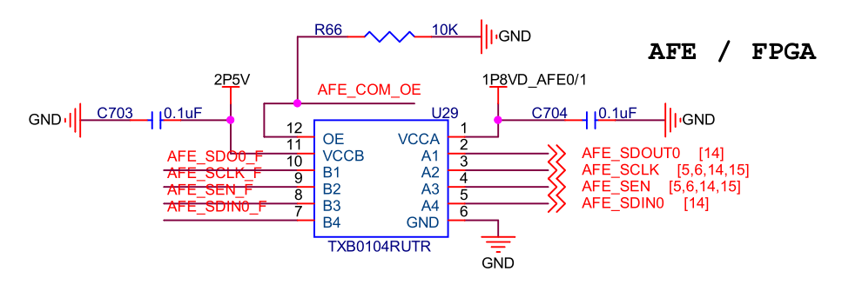
B1~B4, OE is connected to FPGA IOs(bank2.5V); A1~A4 is connected to AFE5818.
Signal direction:
A1—>B1; SDO
B2—>A2; Tsclk=160ns
B3—>A3; SEN
B4—>A4; SDIN

AFE5818 Pin Functions:
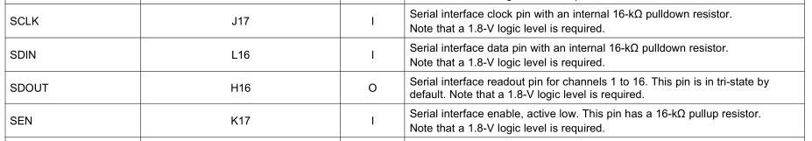
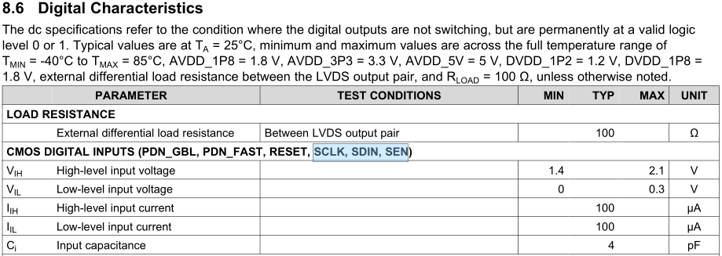

2、waveform
B2 wave | A2 wave
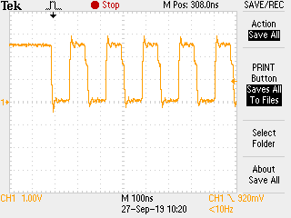 | 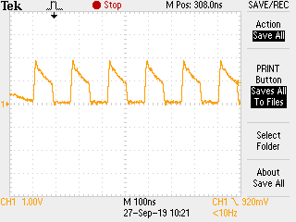

B3 wave | A3 wave
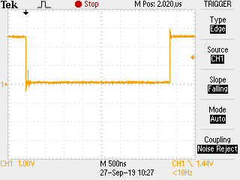 | 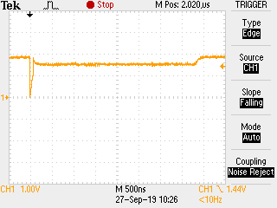

B4 wave | A4 wave
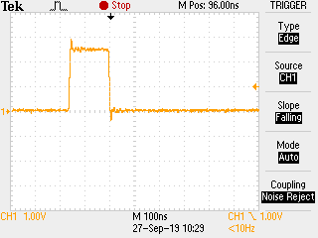 | 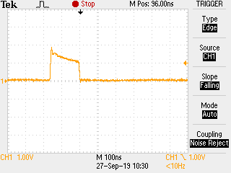

3、产生的根本原因是什么？哪颗料可替代TXB0104RUTR？

