AWR1642 Board Configuration Process

- When connecting the Board to the computer through USB for the first time, we can see the picture below from the Device Manager，it does not have a Port display, just show Stellaris Device Firmware Upgrade
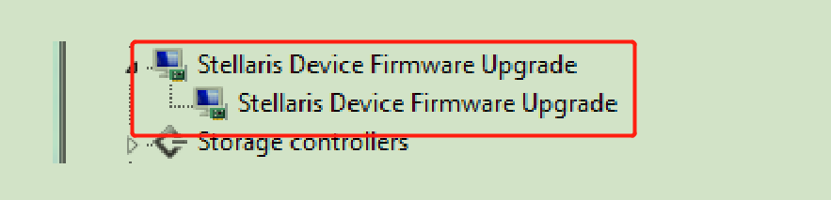
- We use LM Flash Programmer to solve this problem, the steps are as follows:
- Select the configuration as shown below in the tool
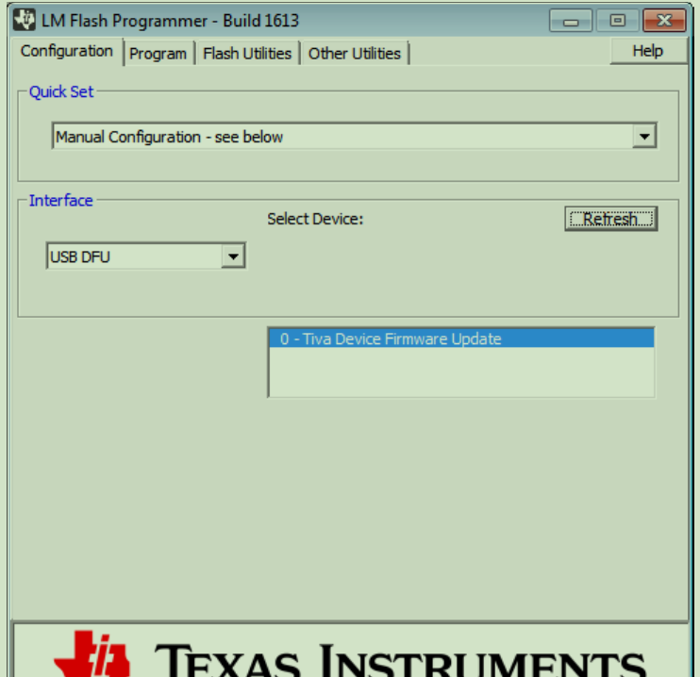

- Load the bootloader.bin with the address 0x0000
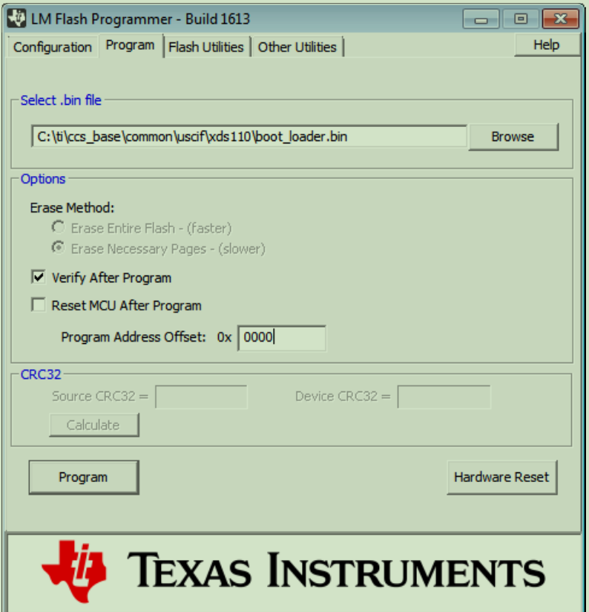
- Load the firmware.bin for XDS110 with the address 0x4000
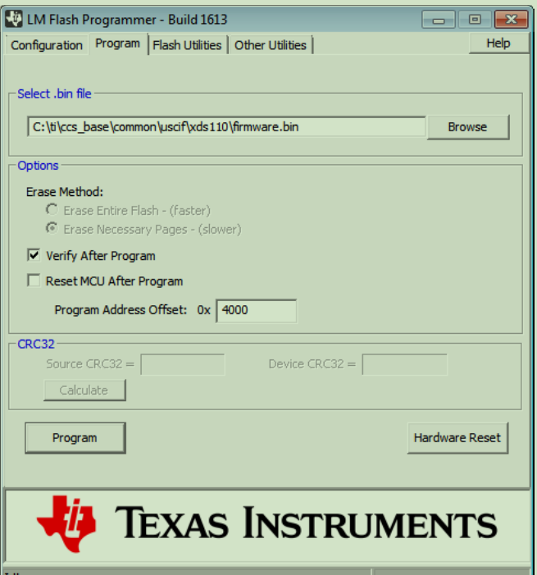
- Finally, the Port from the Device Manager appeared
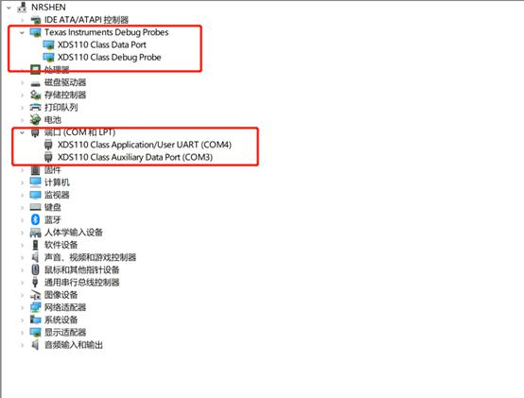

But we have a question, Whether these two files have an impact to the final problem? The first boot_loader.bin file is on my computer, maybe provided by CCS IDE
The second boot_loader.bin file provided by LM Flash Programmer.
We use the first one to configuration finally.
The firmware.bin file is also the same situation.
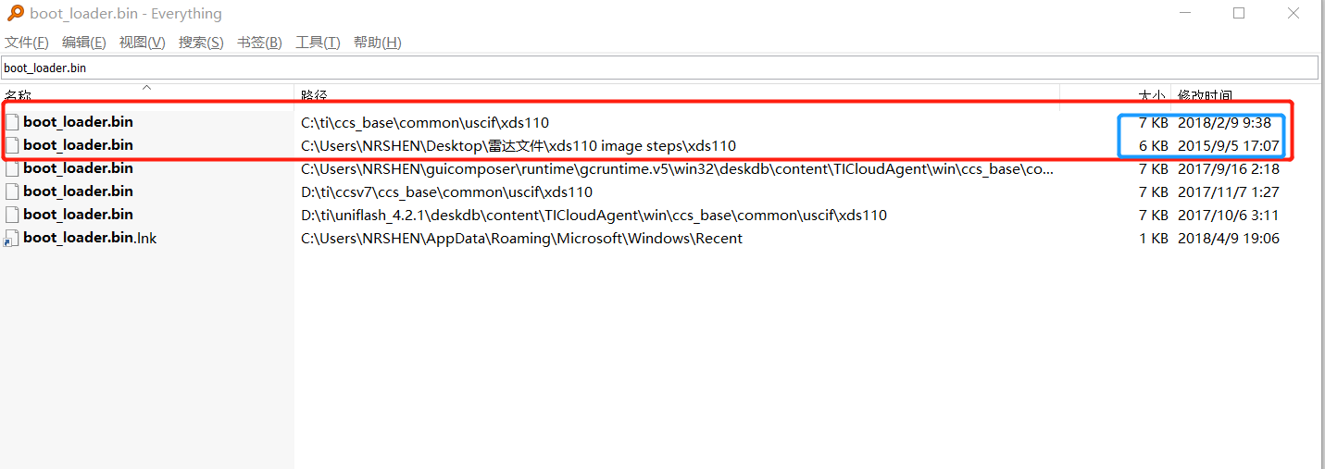

- We use Uniflash to connect AWR1642 EVM, the steps are as follows:
- We first set the AWR1642 Board SOP jumpers into 101.
- We choose the AWR1642 BoosterPack and click the start button.
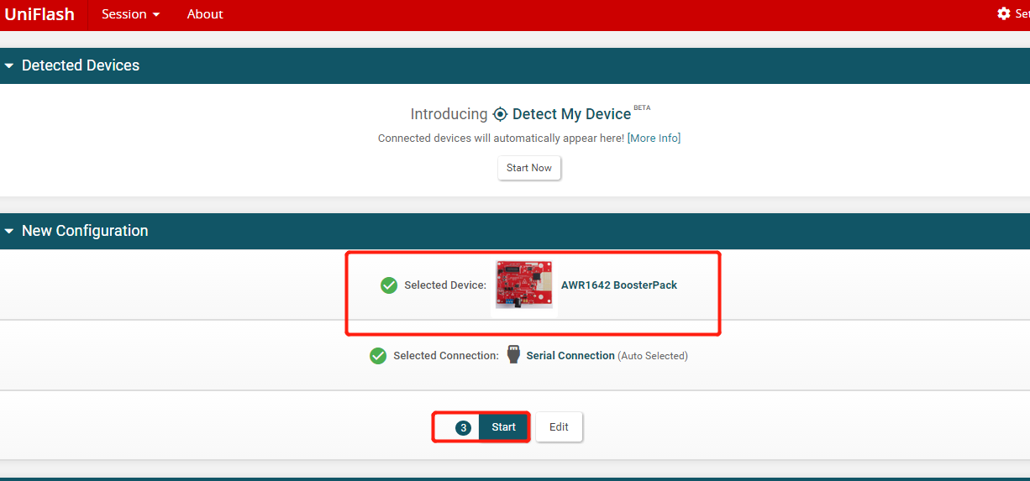
- We choose the Settings & Utilities from the left panel, modify the COM Port to COM4(Note: the User UART corresponds to my computer port is COM4)
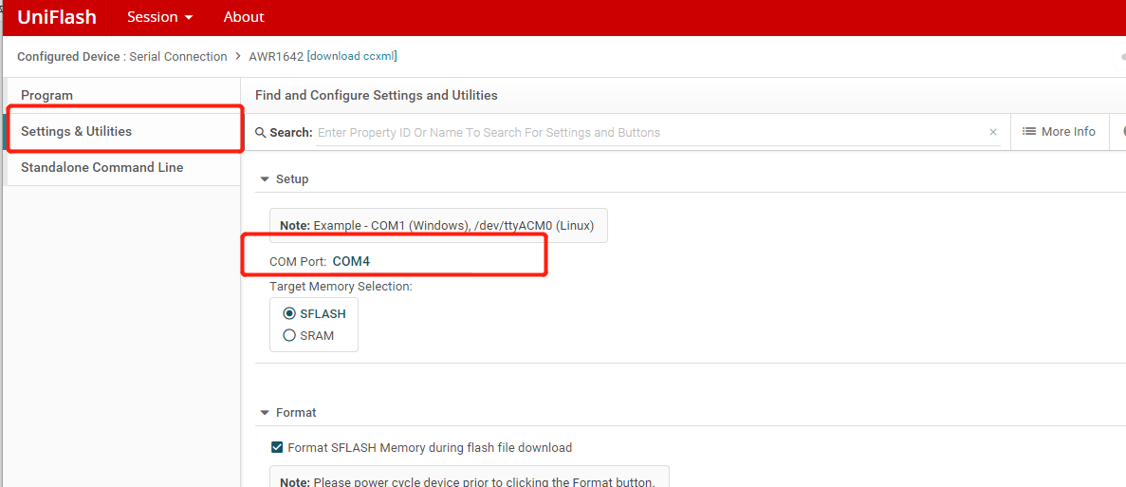
- We choose the Program and set the Meta Image 1 to xwr16xx_mmw_demo.bin and click the Load Image finally.
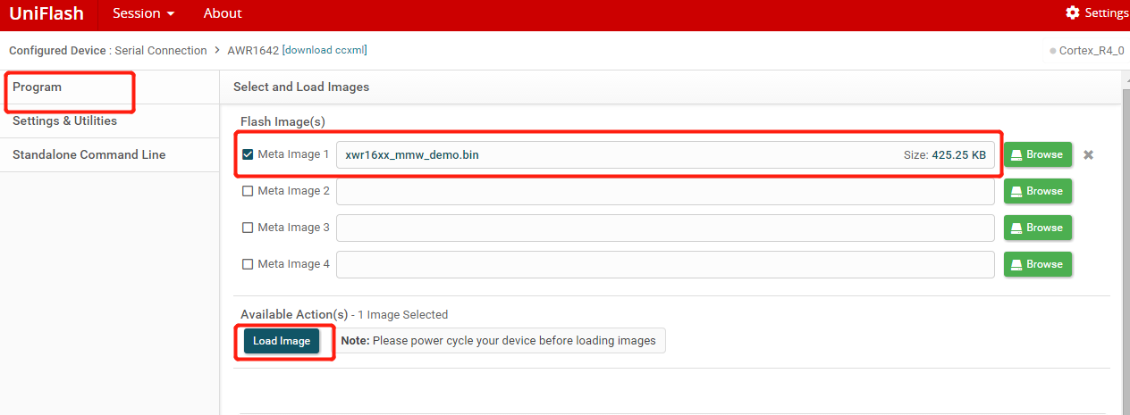

All configurations has been shown, the results show that Not able to connect to serial port...
