1. **Can you provides details about audio to vibration function?**

So far as I know, the [DRV2605](http://www.ti.com.cn/product/cn/DRV2605) has two modes. One is the open-loop driving through the use of internally-generated PWM. The other is the audio to vibe mode which convert an audio input signal to meaningful tactile effects.

The haptic feedback system theory is the codec process audio data to an continuous analog audio signal and then send to the IN/TRIG pin of haptic driver. What’s next?

**The analog audio signal goes in the haptic driver. First there is a pre amplifier to amplify the audio signal. Then a pwm modulator to transform the analog audio signal to a digital PWM signal. The information of analog audio signal is stored in the duty cycle of PWM signal.**

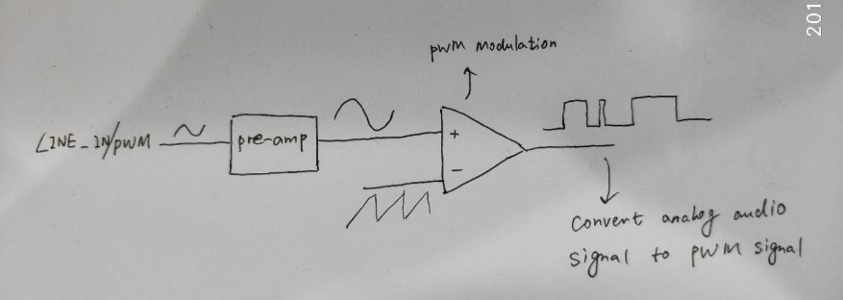

As the differential output amplitude of the haptic driver is Vout_diff=Vmax*(2D-1), thus the tone of analog audio signal is transformed into different Vout_diff which result in different vibration strength. Am I right?

Note: D is the duty cycle of PWM signal.