
JIANGMEN GLORY FAITH PCB COMPANY LIMITED

Information Clarification Sheet
Tel:0750-3868888 Fax：0750-3868800 CR-PE(MI)-008

Cust. name：PST791 Cust. P/N：70661340R2F GF P/N： 6791139A0
To: MKT Date: 2011-9-13 Page: 1 of 2
From: GF PE Dept. Prepared By: YYM Reviewed by： WZH
Question (1)
Question description: Please refer to the enclosed picture, We can’t control impedance 50 ohm +/-10%, because the space of trace is too small (only 4mil). If we will insure impedance value , so the space of trace have only 1.6mil after compensated .
GF Suggestion : In order to meet our company production, please allow to increase impedance value to build, L1/L6 :55 ohm+/-10%, L3: 60 ohm+/-10%.
Customer Reply: □ Accept □ Further advice
Remark:
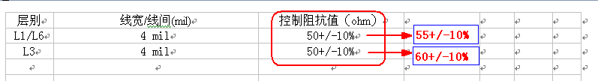
Question (2)
Question description: If customer accept suggestion of question(1), so we will control trace width tolerance as +/-30% to insure 4mil impedance value.
GF Suggestion : please kindly confirm.
Customer Reply: □ Accept □ Further advice
Remark:
Question (3)
Question description: Please refer to the enclosed picture, we don’t have this material in warehouse per your drawing provided last time .
GF Suggestion : Ignore it, we would like to use common KB material as FR-4 to build. Please kindly confirm.
Customer Reply: □ Accept □ Further advice
Remark:
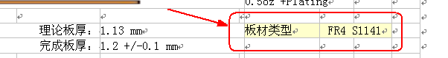
Question (4)
Question description: Please refer to the enclosed picture, for customer layer stack-up, we can’t insure finished thickness 1.2+/-0.12mm, and we also haven’t core of 3mil in warehouse.
GF Suggestion : Ignore them, we would like to follow below “A” picture to build, please kindly confirm.
Customer Reply: □ Accept □ Further advice
Remark:
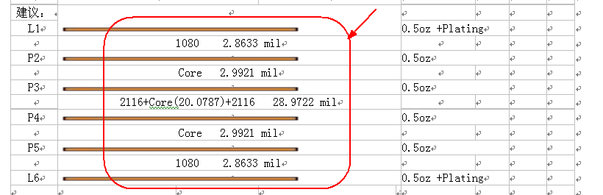
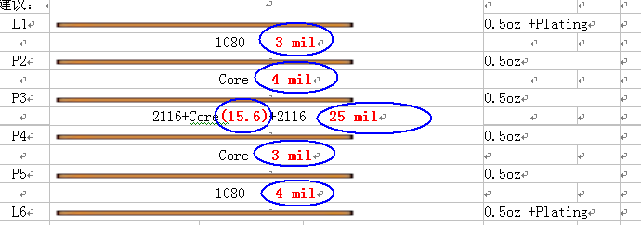
A

Thanks and best regards!

