1.XDC(Express DSP Component)是TI提供的一个命令行工具,它可以生成并使用实时软件组件包。
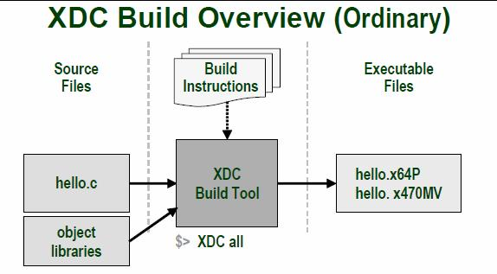
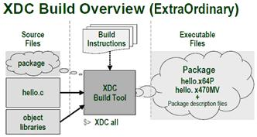
2.以上两图说明了XDC的工作方式：通过相关文件设定操作指令，读入源码、库文件以及已经存在的组件包最终生成可执行文件。
3.Package------XDC工作的基本单元。包括有：源码、库文件以及元数据；元数据这包含有该包的版本信息和依赖信息，以及模块（Module）信息。
4.XDC使用方法：
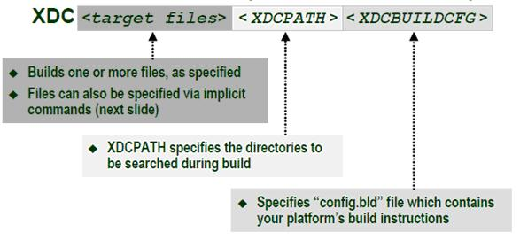
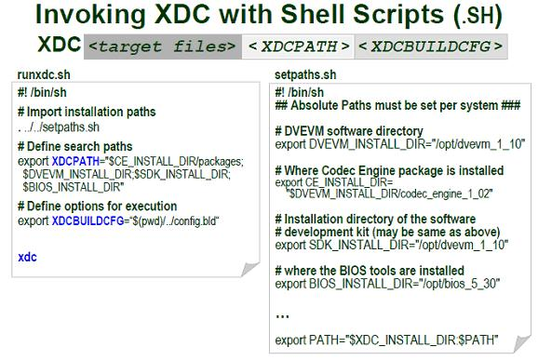
5.XDC需要的文件：config.bld package.bld package.xdc
Package.xdc -------------描述该包的名称，版本信息，依赖文件，模块信息等
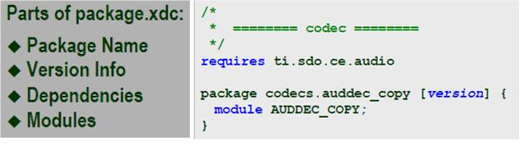
Config.bld --------------描述XDC要使用的编译工具的相关信息，如不同CPU所使用的编译工具目录，每种编译工具的编译选项，连接选项等基本信息；
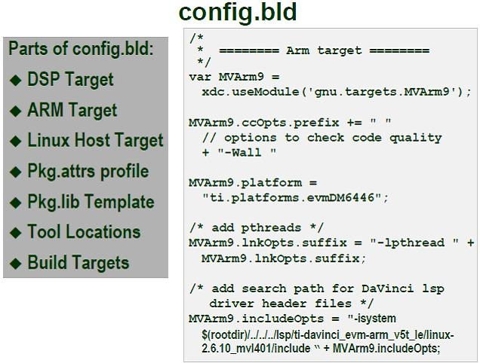
Package.bld -------------------描述对于该包需要生成的平台，profile（debug，release）。通过Javascript脚本添加源码到生成执行文件的信息中。
Package.mak-------------------由XDC生成的文件，用于最终编译可执行文件。
6.XDC工作流程：
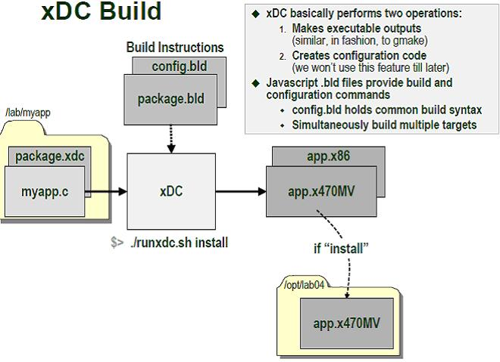
7.使用XDC所需的文件：源码、package.bld、package.xdc、config.bld。同时需要通过shell脚本将DVEVM的安装位置导出为环境变量。
各代码如下：
Config.bld样本代码:
+ expand sourceview plaincopy to clipboardprint?
var MVArm9 = xdc.useModule("gnu.targets.MVArm9");
MVArm9.rootDir = "/opt/DVS357/mv_pro_4.0/montavista/pro/devkit/arm/v5t_le";
MVArm9.lnkOpts.suffix = "-lpthread " + MVArm9.lnkOpts.suffix;
var Linux86=xdc.useModule("gnu.targets.Linux86");
Linux86.rootDir = "/usr";
Linux86.lnkOpts.suffix = "-lpthread " + Linux86.lnkOpts.suffix;
Build.targets = [ Linux86,MVArm9,];
var MVArm9 = xdc.useModule("gnu.targets.MVArm9");
MVArm9.rootDir = "/opt/DVS357/mv_pro_4.0/montavista/pro/devkit/arm/v5t_le";
MVArm9.lnkOpts.suffix = "-lpthread " + MVArm9.lnkOpts.suffix;
var Linux86=xdc.useModule("gnu.targets.Linux86");
Linux86.rootDir = "/usr";
Linux86.lnkOpts.suffix = "-lpthread " + Linux86.lnkOpts.suffix;
Build.targets = [ Linux86,MVArm9,];
Runxdc.sh样本代码:
view plaincopy to clipboardprint?
#! /bin/sh
# import install paths
# putting the first period before the shell invokation keeps the changes
# to environment variables set here. Otherwise, changes to environment
# are only within the context of the executed script
./setpaths.sh
# Define search paths for included packages
export XDCPATH="$CE_INSTALL_DIR/packages"
# Define options for execution
export XDCBUILDCFG=$(pwd)"/config.bld
# Execute xdc command to make all packages
/opt/DVS357/dvevm_1_20/xdc_2_94/xdc $@ -P *
#! /bin/sh
# import install paths
# putting the first period before the shell invokation keeps the changes
# to environment variables set here. Otherwise, changes to environment
# are only within the context of the executed script
./setpaths.sh
# Define search paths for included packages
export XDCPATH="$CE_INSTALL_DIR/packages"
# Define options for execution
export XDCBUILDCFG=$(pwd)"/config.bld
# Execute xdc command to make all packages
/opt/DVS357/dvevm_1_20/xdc_2_94/xdc $@ -P *
Setpaths.sh样本代码:
#!/bin/sh
export DVEVM_INSTALL_DIR="/opt/DVS357/dvevm_1_20/"
export BIOS_INSTALL_DIR=$DVEVM_INSTALL_DIR/bios_5_31_01
export CG_INSTALL_DIR=$DVEVM_INSTALL_DIR/cg6x_6_0_14
export CMEM_INSTALL_DIR=$DVEVM_INSTALL_DIR/cmem_1_02
export CE_INSTALL_DIR=$DVEVM_INSTALL_DIR/codec_engine_1_10_01
export CS_INSTALL_DIR=$DVEVM_INSTALL_DIR/codec_servers_1_23
export DSPLINK_INSTALL_DIR=$DVEVM_INSTALL_DIR/dsplink_1_30_08_02
export FMWK_INSTALL_DIR=$DVEVM_INSTALL_DIR/framework_components_1_10_04
export XDAIS_INSTALL_DIR=$DVEVM_INSTALL_DIR/xdais_5_10
export XDC_INSTALL_DIR=$DVEVM_INSTALL_DIR/xdc_2_94
export PATH=$XDC_INSTALL_DIR:$PATH
#!/bin/sh
export DVEVM_INSTALL_DIR="/opt/DVS357/dvevm_1_20/"
export BIOS_INSTALL_DIR=$DVEVM_INSTALL_DIR/bios_5_31_01
export CG_INSTALL_DIR=$DVEVM_INSTALL_DIR/cg6x_6_0_14
export CMEM_INSTALL_DIR=$DVEVM_INSTALL_DIR/cmem_1_02
export CE_INSTALL_DIR=$DVEVM_INSTALL_DIR/codec_engine_1_10_01
export CS_INSTALL_DIR=$DVEVM_INSTALL_DIR/codec_servers_1_23
export DSPLINK_INSTALL_DIR=$DVEVM_INSTALL_DIR/dsplink_1_30_08_02
export FMWK_INSTALL_DIR=$DVEVM_INSTALL_DIR/framework_components_1_10_04
export XDAIS_INSTALL_DIR=$DVEVM_INSTALL_DIR/xdais_5_10
export XDC_INSTALL_DIR=$DVEVM_INSTALL_DIR/xdc_2_94
export PATH=$XDC_INSTALL_DIR:$PATH
package.bld样本代码:
+ expand sourceview plaincopy to clipboardprint?
var targs = [MVArm9, Linux86];
var profiles = ["debug", "release"];
// Define the base name for the executable(s) built
var basename = "app";
// The following code uses the java.io.File.list() method to generate an array
// of all files in the current directory ('.') and then sorts out .c files
var sources = java.io.File('.').list();
var csources = [];
for (var i = 0; i < sources.length; i++){
if(String(sources[i]).match(/.*\.c$/))
csources.push(sources[i]);
}
// The build phase cycles through the arrays of build targets and profiles
// and adds an executable for each combination
for (var i = 0; i < targs.length; i++) {
for(var j = 0; j < profiles.length; j++){
Pkg.addExecutable( basename + "_" + profiles[j], targs[i],
targs[i].platform, {
cfgScript: null,
profile: profiles[j],
}
).addObjects( csources );
}
}
var targs = [MVArm9, Linux86];
var profiles = ["debug", "release"];
// Define the base name for the executable(s) built
var basename = "app";
// The following code uses the java.io.File.list() method to generate an array
// of all files in the current directory ('.') and then sorts out .c files
var sources = java.io.File('.').list();
var csources = [];
for (var i = 0; i < sources.length; i++){
if(String(sources[i]).match(/.*\.c$/))
csources.push(sources[i]);
}
// The build phase cycles through the arrays of build targets and profiles
// and adds an executable for each combination
for (var i = 0; i < targs.length; i++) {
for(var j = 0; j < profiles.length; j++){
Pkg.addExecutable( basename + "_" + profiles[j], targs[i],
targs[i].platform, {
cfgScript: null,
profile: profiles[j],
}
).addObjects( csources );
}
}
PS: 在 VIM中，给新的文件类型添加已知文件类型的语法高亮的方法是------在“/usr/share/vim/vimfiles/after”路径中添加一个文件“filetype.vim”（FC10系统下）,在其中添加如下代码：
augroup filetypedetect
au BufNewFile,BufRead *.bld setf javascript
augroup END
原文地址 http://www.61ic.com/Article/DaVinci/DM64X/201004/25466.html

