一共设计了基于DM8148的两块电路板。
第一块电路板参考DM8148评估板的设计，采用了8片MT41J128M8JP-125（8bit数据总线宽度）， 电路板运行正常。
第二块电路板为了减小电路板面积，将8片MT41J128M8JP-125改为4片MT41J128M16-125，并参考相关文档，对DDR3接口的寄存器参数进行了调整，但是始终不能正常访问DDR3。
测试程序是TI提供的BB_021_DDR3_TEST.out，GEL文件是DM814x_PG2.x.gel，文件中相关的DDR3寄存器配置宏定义，已根据MT41J128M16-125的时序特点进行了修改。
以下是DDR3相关的软硬件设计，寄存器修改，以及问题的详细描述。
如有描述不明的地方，请联系frank201105.li@gmail.com

DDR3 接口相关原理图
共有两个DDR3接口，以DDR0接口为例，如图所示
注意：为了PCB布线方便，在字节范围之内，对数据线进行了调整，具体参考相应的原理图。
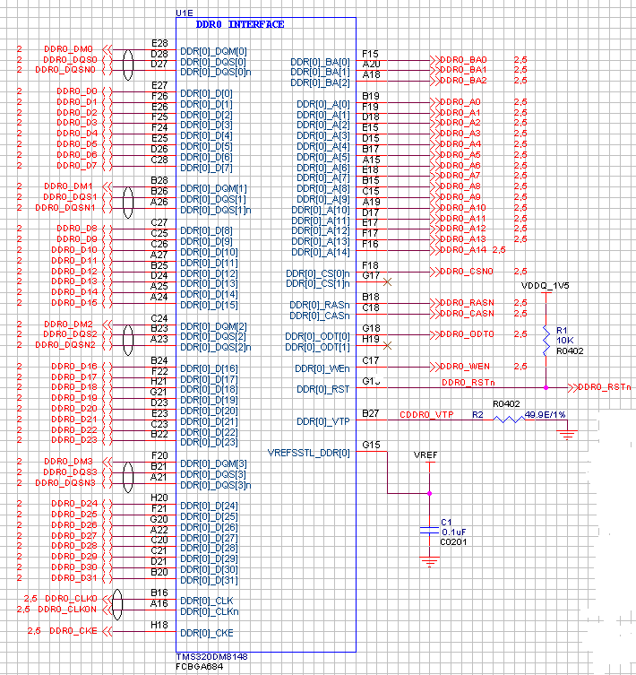

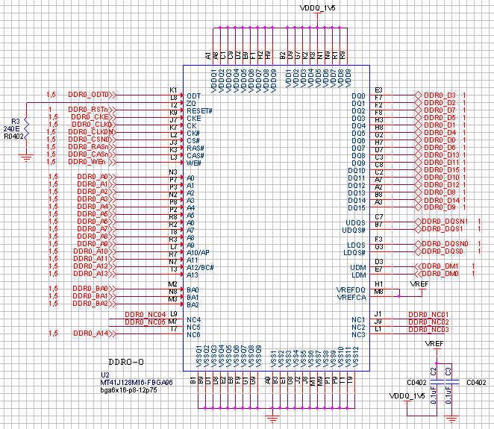

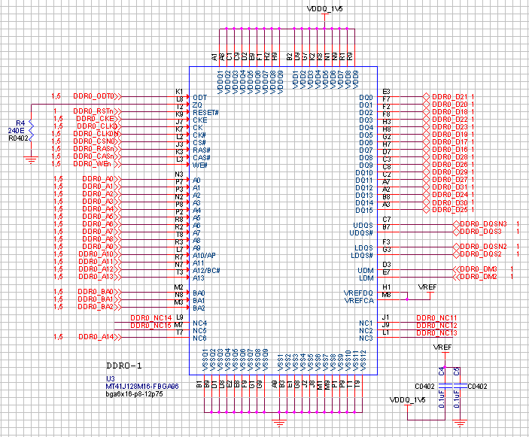

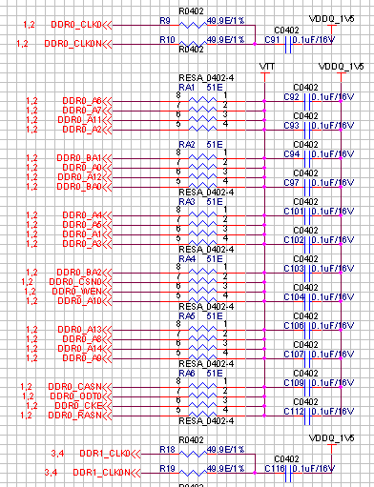

DDR3 接口相关PCB图
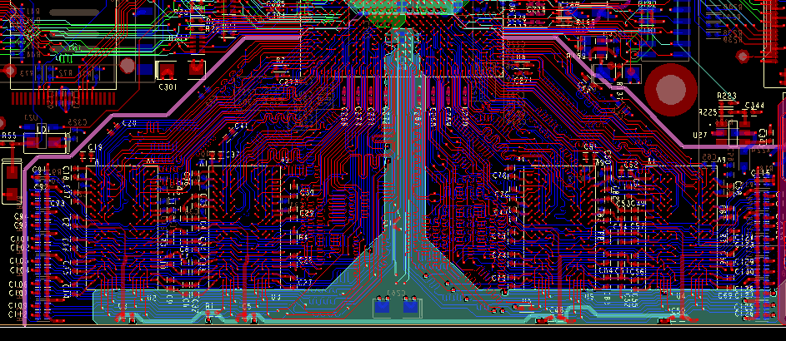
设计为8层电路板，电路板叠层如下
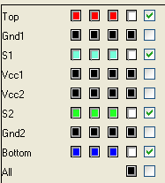
DDR3相关的走线都在top（红色）和bottom（蓝色）层，差分信号线4.5/6MIL，阻抗设计要求为100欧姆；单端走线4mil宽度，要求50欧姆阻抗。

DDR3信号走线长度

时钟/地址/控制
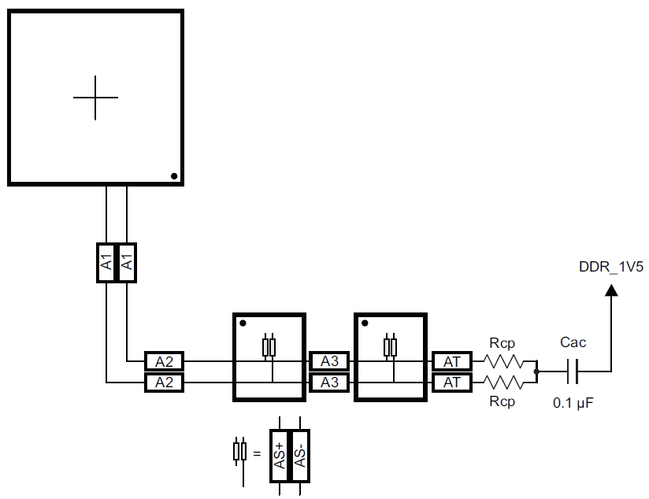

以DDR0为例，布线时的约束为
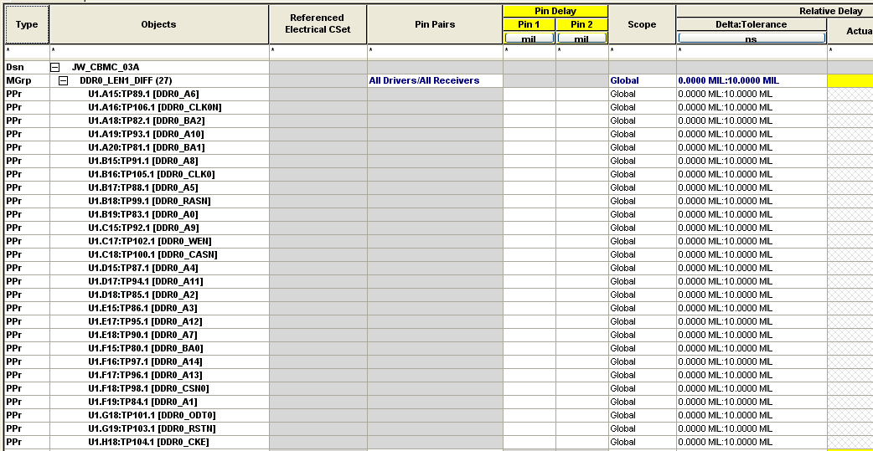
图中，从U1的PIN较到tp[80…106]的走线对应的是拓扑图中A1+A2

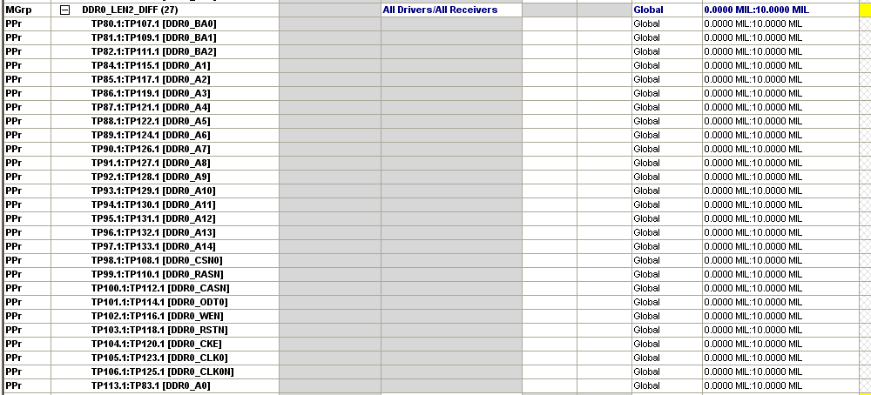
图中，从tp[80…106]到tp[107…125]的走线对应的是拓扑图中A3

DDR0_CLK0实际走线长度
A1+A2：1841.393 MIL
A3： 580.2965 MIL
合计2421.6895MIL
时钟/地址/控制信号中的其他信号，布线长度与DDR0_CLK0的长度差为10mil

数据
以DDR0为例，布线时的约束为
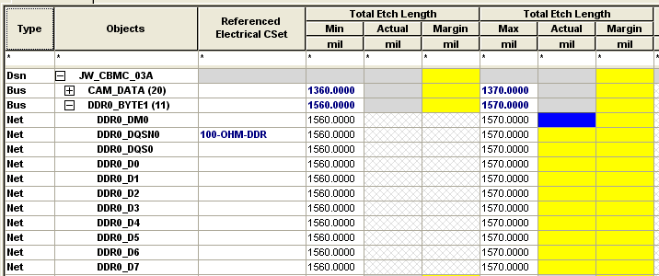
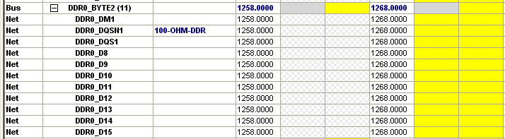
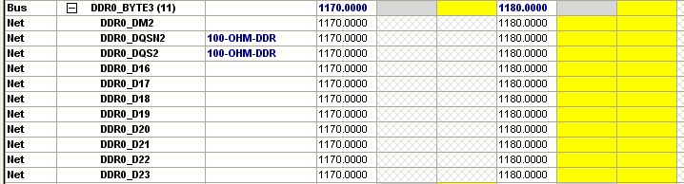
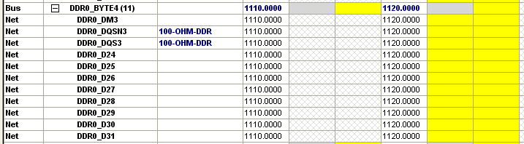

实际长度
DDR0_DQS3 1116.6585 MIL
DDR0_DQS2 1176.2937 MIL
DDR0_DQS1 1267.6483 MIL
DDR0_DQS0 1567.8758 MIL

寄存器配置

Ti工具计算
DM814x_DDR_Controller_Register_Configuration_spreadsheet_v1.0.xlsx
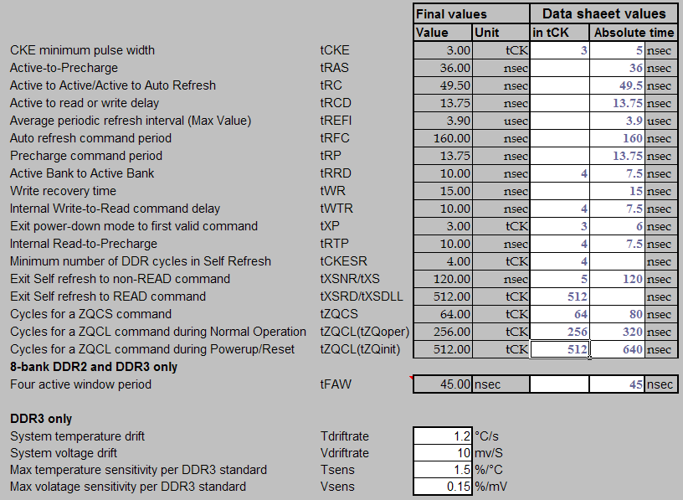

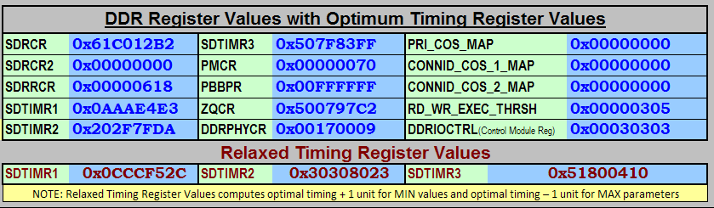

参考datasheet计算

DDR0/1 MMR

DDRPHYCR(0x00170009)
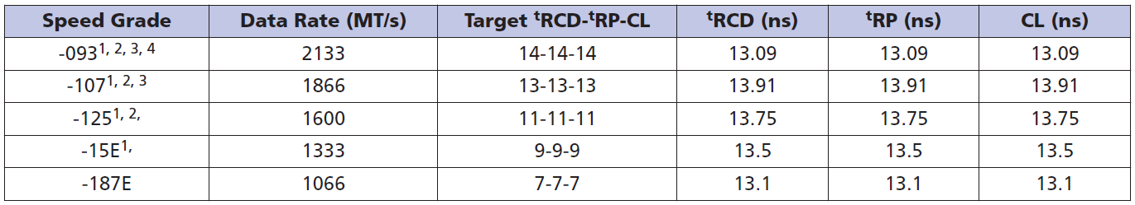
对于MT41J128M16-125，CAS latency为13.75/2.5 = 5.5，取值为6，所以确定寄存器中READ_LATENCY为9
Bit | 位域 | 值
20 | DYN_PWRDN_EN | 1h | Enables dynamically powering down the IO Receiver when not performing a read.  This will help in reducing DDR IO power. It is recommended to set this bit to '1' always.
18 | RDEYE_LVL_DIS | 1h | When set to 1, read eye auto-leveling is disabled. This is applicable only for DDR3
17 | GATE_LVL_DIS | 1h | When set to 1, read gate auto-leveling is disabled. This is applicable only for DDR3
16 | WR_LVL_DIS | 1h | When set to 1, write auto-leveling is disabled. This is applicable only for DDR3
15 | PHY_RST | 0h | When set to 1, DDR PHY is reset .Both data and command macros will be reset
13-12 | IDLE_LOCAL_ODT | 0h | This bit fields specify the ODT selection on the DDR Controller side when the breceiver is powered down. IDLE_LOCAL_ODT is applicable only when DYN_PWRDN_EN is set to '1'. Please refer to Table1-16 for the supported ODT termination values.  Recommended value is 0x0 [ODT OFF]
4-0 | RD_LOCAL_ODT | 0h | This bit fields specifies the ODT selection on the DDR PHY side during READ. To control the ODT on the DDR device side, refer to the SDRCR register details. Please refer to Table1-16 for the supported ODT termination values.  Recommended value is 0x2 [50 Ohms termination]
4-0 | READ_LATENCY | 9h | Defines the latency for read data from DDR SDRAM in number of 1x cycles. The value applied should be equal to the required value minus one. The maximum read latency supported by the DDR PHY is equal to CAS latency plus 7 clock cycles. The minimum read latency must be equal to CAS latency plus 1 clock cycles.

写入EMIF4_0_DDR_PHY_CTRL_1，EMIF4_1_DDR_PHY_CTRL_1寄存器的值为0x00170209

SDRTIM1(0x0AAAE4E3)
对于MT41J128M16-125
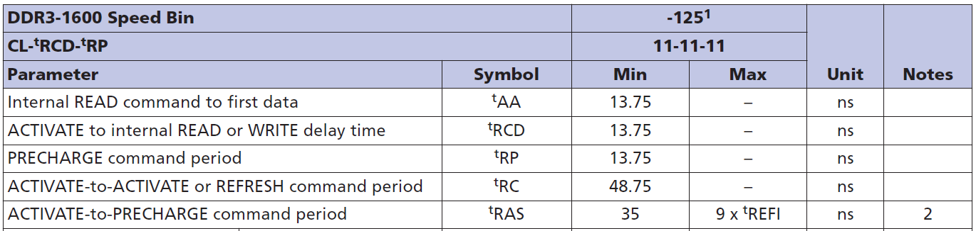
T_RP = (13.75ns/2.5ns)-1 = 4.5，取值为5
T_RCD = (13.75ns/2.5ns)-1 = 4.5，取值为5
最小的T_WR = (15ns/2.5ns)-1 = 5
最小的T_RAS = (35ns/2.5ns)-1 = 13，取值为14
最小的T_RC= (48.75ns/2.5ns)-1 = 18.5，取值19
最小的T_RRD = 4
最小的T_WTR = 4-1 = 3，取值为5
Bit | 位域 | 值
28-25 | T_RP | 5h | T_RP=(tRP/DDR[X]_CLK period)-1
24-21 | T_RCD | 5h | T_RCD=(tRCD/DDR[X]_CLK period)-1
20-17 | T_WR | 5h | T_WR=(tWR/DDR[X]_CLK period)-1
16-12 | T_RAS | 0eh | T_RAS=(tRAS/DDR[X]_CLK period)-1
11-6 | T_RC | 13h | T_RC=(tRC/DDR[X]_CLK period)-1
5-3 | T_RRD | 4h | T_RRD=(tRRD/DDR[X]_CLK period)-1  ((tFAW/(4*DDR[X]_CLK))-1)
2-0 | T_WTR | 3h | T_WTR=(tWTR/DDR[X]_CLK period)-1
所以寄存器EMIF4_0_SDRAM_TIM_1，EMIF4_1_SDRAM_TIM_1的值为0x0AAAE4E3

SDRTIM2(0x202F7FDA)
对于MT41J128M16-125
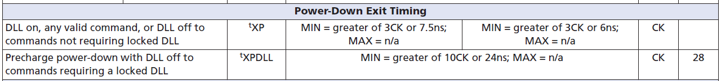
T_XP =3-1 = 2
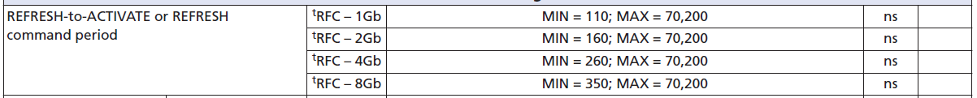
T_XSNR = (160ns+10ns)/2.5ns -1 = 67 = 0x43

T_XSRD = 512-1 =511
T_RTP = 4-1 =3
T_CKE = 3-1=2
Bit | 位域 | 值
30-28 | T_XP | 2h | from power down exit to any other command except read command, minus 1.
24-16 | T_XSNR | 2fh | from a self-refresh exit to any other command except a read command, minus 1. Corresponds to tXSNR/tXS AC timing parameter in the DDR2/DDR3 data sheet.  Calculated by T_XSNR=(tXSNR/DDR[X]_CLK period)-1
15-6 | T_XSRD | 1ffh | from a self-refresh exit to a read command, minus 1.  Corresponds to tXSRD/tXSDLL AC timing parameter in the DDR2/DDR3 data sheet.  Calculated by T_XSRD=(tXSRD or tXSDLL)-1
5-3 | T_RTP | 3h | from a last read command to a precharge command, minus 1.  Corresponds to tRTP AC timing parameter in the DDR2/DDR3 data sheet.  Calculated by T_RTP=(tRTP/DDR[X]_CLK period)-1
2-0 | T_CKE | 2h | between transitions on the DDR[X]_CKE[X] pin, minus 1.  Corresponds to the tCKE AC timing parameter in the DDR2 data sheet.  Calculated by T_CKE=(tCKE/DDR[X]_CLK period)-1
写入寄存器的值为0x202F7FDA

SDRTIM3(0x507F83FF)
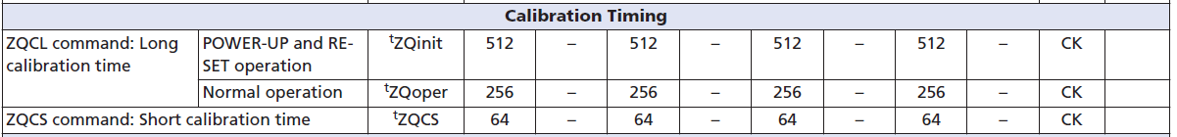
TZQCS = 64-1=63
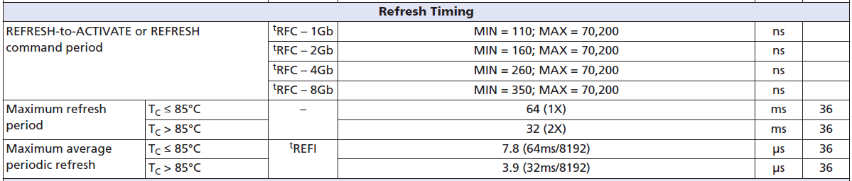
T_RFC =160/2.5 -1= 64 -1 =63

Bit | 位域 | 值
31-28 | T_PDLL_UL | 5h | This field must be written with a value of 5.
27-24 | T_CSTA | 0h | between write-to-write or read-to-read data phases to different chip selects, minus one.  This is a don't care when only only one chip select is being used.
20-15 | T_ZQCS | 3fh | TZQCS=(tZQCS-1)
14-13 | Reserved | 0h
12-4 | T_RFC | 3fh | from Refresh or Load Mode to Refresh or Activate, minus one.  Calculated by T_RFC=(tRFC/DDR[x]_CLK period)-1
3-0 | T_RAS_MAX | fh | Specifies the maximum number of refresh rate intervals from Active to Precharge command.  This field must be programmed to Fh for DDR2/DDR3 SDRAM types.
写入寄存器的值为0x507F83FF

SDRCR(0x61C012B2)
对于MT41J128M16-125
CAS Latency是13.75ns，CLK频率为400MHz（2.5ns），13.75/2.5 = 5.5，因此确定CAS latency为6。
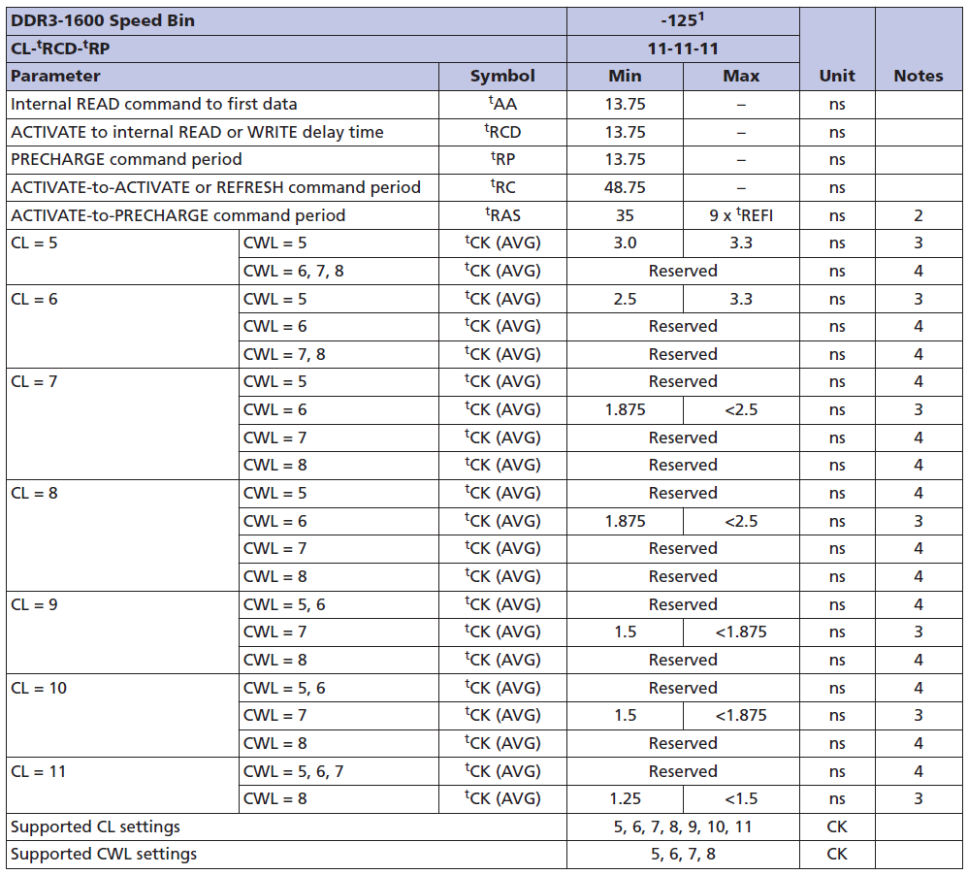
在CAS latency为6的情况下，CAS Write Latency: CWL确定为5。
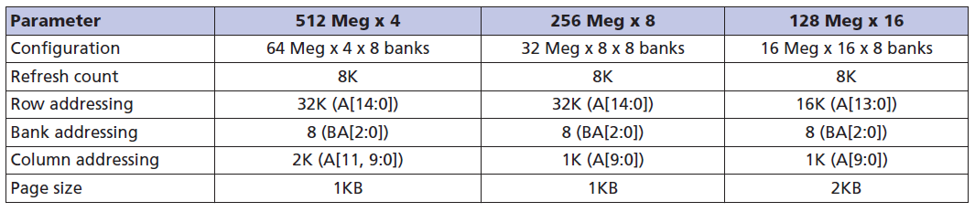
Row addressing为A[13:0]，14bit
Bit | 位域 | 值
31-29 | SDRAM_TYPE | 3h | DDR3
28-27 | IBANK_POS | 0h
26-24 | DDR_TERM | 1h | RZQ/4 (Recommended value of external resistor RZQ is 240 ohm)
23 | DDR2_DDQS | 1h | Differential Ended DQS
22-21 | DYN_ODT | 2h | RZQ/2 (Recommended value of external resistor RZQ is 240 ohm)
20 | DDR_DISABLE_DLL | 0h | Enable DLL for Normal Operation. This bit must be set to low for normal operation.
19-18 | SDRAM_DRIVE | 0h | RZQ/6 drive strength
17-16 | CWL | 0h | DDR3 CAS Write Latency: CWL of 5
15-14 | NARROW_MODE | 0h | 32 bits
13-10 | CL | 4h | CAS latency of 6
9-7 | ROWSIZE | 5h | Don't care if both EBANK_POS and IBANK_POS are 0.  14 Rows bits
6-4 | IBANK | 3h | 8 Banks
3 | EBANK | 0h | CS0 only
2-0 | PAGESIZE | 2h | 1024 word page requiring 10 column address bits
写入寄存器的值为0x61C012B2

SDRRCR(0x00000C30)
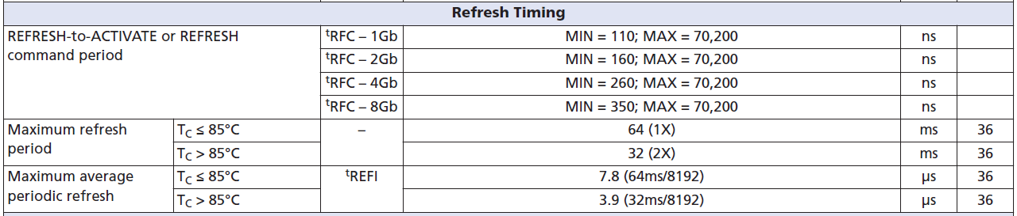
Refresh_Rate = DDR2/DDR3 clock frequency (in MHz) x DDR2/DDR3 fresh rate (in μs)
400MHzx7.8us =3120 = C30H
400MHzx3.9us =1560 = 618H

Bit | 位域 | 值
31 | INITREF_DIS | 0 | Enable SDRAM Initialization and Refreshes
29 | SRT | 0 | Normal Operating Temperature range  For DDR3, this bit must be set to '0' if ASR is set to 1. A write to this field will cause the  DDR2/DDR3 to start the initialization sequence
28 | ASR | 0 | Auto Self Refresh Enable  Manual Self Refresh reference indicated by SRT field
26-24 | PASR | 0h | Partial Array Self Refresh.  Full Array
15-0 | REFRESH_RATE | C30h | Refresh rate.
写入寄存器的值为0x00000C30

ZQCR(0x50074BE1)
#define DDR3_EMIF_SDRAM_ZQCR
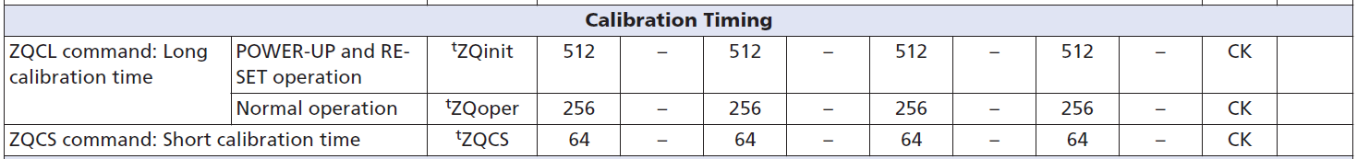
256/64 -1 = 3，512/256 -1 = 1
ZQ_REFINTERVAL = 0.5%/((TsensxTdriftrate)+(VsensxVdriftrate)) = 5/33S
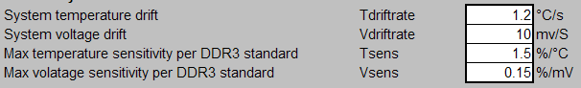
(5/33)x1000000us/7.8us = 38850=0x4BE1
Bit | 位域 | 值
31 | ZQ_CS1EN | 0 | Writing a 1 enables ZQ calibration for CS1
30 | ZQ_CS0EN | 1 | Writing a 1 enables ZQ calibration for CS0
29 | ZQ_DUALCALEN | 0 | Allows both ranks (chip selects) to be ZQ calibrated simultaneously.  Setting this bit requires both chip selects to have a separate calibration resistor per  device.
28 | ZQ_SFEXITEN | 1 | Writing a 1 enables the issuing of ZQCL on Self-Refresh, Active Power-Down and  Precharge Power Down exit
19-18 | ZQ_ZQINIT_MULT | 1h | Indicates number of ZQCL intervals that make up a ZQINIT interval, minus 1
17-16 | ZQ_ZQCL_MULT | 3h | Indicates number of ZQCS intervals that make up a ZQCL interval, minus 1
15-0 | ZQ_REFINTERVAL | 97c2h | Number of refresh periods between ZQCS commands. Supports between one refresh period to 256 ms between ZQCS calibration commands.  Refresh period is defined by REFRESH_RATE field in SDRAM Refresh Control Register.
写入寄存器的值为
3.9us：0x500797c2
7.8us：0x50074BE1

DMM的DMM_LISA_MAP
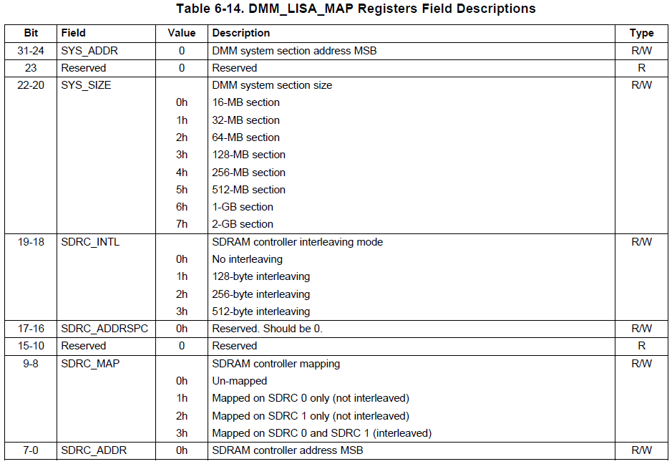

Bit | 位域 | 值
31-24 | SYS_ADDR | 80h | DMM system section address MSB
22-20 | SYS_SIZE | 6h | DMM system section size  1-GB section
19-18 | SDRC_INTL | 0h | SDRAM controller interleaving mode  No interleaving
17-16 | SDRC_ADDRSPC | 0h | Reserved. Should be 0
9-8 | SDRC_MAP | 1h | SDRAM controller mapping  Mapped on SDRC 0 only (not interleaved)
7-0 | SDRC_ADDR | 00h | SDRAM controller address MSB
写入 DMM_LISA_MAP__0和DMM_LISA_MAP__1的值是0x80600100

Bit | 位域 | 值
31-24 | SYS_ADDR | C0h | DMM system section address MSB
22-20 | SYS_SIZE | 6h | DMM system section size  1-GB section
19-18 | SDRC_INTL | 0h | SDRAM controller interleaving mode  No interleaving
17-16 | SDRC_ADDRSPC | 0h | Reserved. Should be 0
9-8 | SDRC_MAP | 2h | SDRAM controller mapping  Mapped on SDRC 1 only (not interleaved)
7-0 | SDRC_ADDR | 00h | SDRAM controller address MSB
写入 DMM_LISA_MAP__2和DMM_LISA_MAP__3的值是0xC0600200

与原DM8148评估板的寄存器值保持一致

DDR0/1 PHY寄存器
DDR0_CLK0 1841.393 MIL+ 580.2965 MIL = 2421.6895MIL
DDR0_DQS2 1176.2937 MIL
DDR0_DQS3 1116.6585 MIL
DDR0_DQS0 1567.8758 MIL
DDR0_DQS1 1267.6483 MIL
使用RatioSeed_TI814x.xls计算
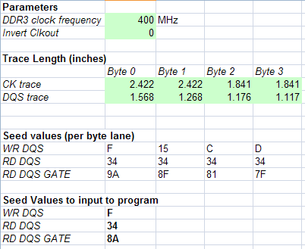
参考文档TI814x-DDR3-Init-U-Boot Wordwise SWleveling.pdf
修改TI814x_ddr3.gel中的寄存器配置值后，运行后DDR3_SlaveRatio_ByteWiseSearch_TI814x.out
提示无法获取

写入文件Ti814x_Ratio_values中的值都是0
*********************************************************
Byte level Slave Ratio Search Program Values
*********************************************************
BYTE3 BYTE2 BYTE1 BYTE0
*********************************************************
Read DQS MAX 0 0 0 0
Read DQS MIN 0 0 0 0
Read DQS OPT 0 0 0 0
*********************************************************
Read DQS GATE MAX 0 0 0 0
Read DQS GATE MIN 0 0 0 0
Read DQS GATE OPT 0 0 0 0
*********************************************************
Write DQS MAX 0 0 0 0
Write DQS MIN 0 0 0 0
Write DQS OPT 0 0 0 0
*********************************************************
Write DATA MAX 0 0 0 0
Write DATA MIN 0 0 0 0
Write DATA OPT 0 0 0 0

问题
问题主要有两个：
第一个是在获取DDR3的软件均衡相关寄存器值的时候，
修改TI814x_ddr3.gel中的控制寄存器配置值后，
按照文档TI814x-DDR3-Init-U-Boot Wordwise SWleveling.pdf中所述的步骤，
运行后DDR3_SlaveRatio_ByteWiseSearch_TI814x.out
提示无法获取相应的值

第二个问题是在仿真器（seed_xds560v2）连接的情况下，运行BB_021_DDR3_TEST.out，DDR3时钟无法正确访问。

问题现场记录
2014．09．24日的记录如下
使用的Gel文件是DM814x_PG2.x.gel，文件中寄存器配置的相关宏定义修改如下
#define DDR_FREQ 800

//DDR3 400 MHz - CL=6,CWL=5
#define DDR3_EMIF_TIM1_DEFINE_400 0x0AAAE4E3
#define DDR3_EMIF_TIM2_DEFINE_400 0x202F7FDA
#define DDR3_EMIF_TIM3_DEFINE_400 0x507F83FF
#define DDR3_EMIF_REF_CTRL_DEFINE2_400 0x00000C30
#define DDR3_EMIF_SDRAM_CONFIG_DEFINE_400 0x61C012B2
#define DDR3_EMIF_DDRPHYCR_DEFINE_400 0x00070209

#define DDR3_EMIF_SDRAM_ZQCR_DEFINE 0x50074BE1

理论写入值
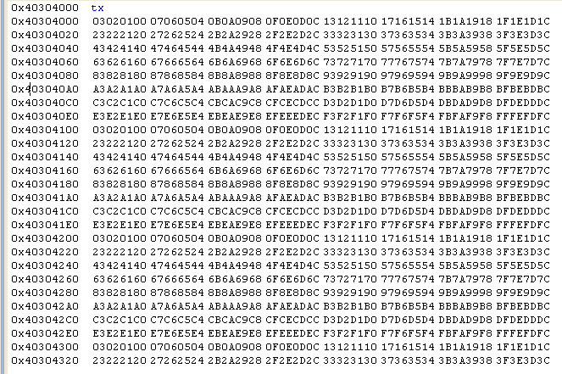
这是通过仿真器连接，读取DM8148的片内RAM得到的值

DDR3_PHY寄存器配置1
#define DDR3_EMIF_SDRAM_ZQCR_DEFINE 0x50074BE1
#define DDR3_EMIF_TIM1_DEFINE_400 0x0AAAE4E3
#define DDR3_EMIF_TIM2_DEFINE_400 0x202F7FDA
#define DDR3_EMIF_TIM3_DEFINE_400 0x507F83FF
#define DDR3_EMIF_REF_CTRL_DEFINE2_400 0x00000C30
#define DDR3_EMIF_SDRAM_CONFIG_DEFINE_400 0x61C012B2
#define DDR3_EMIF_DDRPHYCR_DEFINE_400 0x00070009

#define DDR3_PHY_RD_DQS_CS0_DEFINE 0x34
#define DDR3_PHY_WR_DQS_CS0_DEFINE 0xA
#define DDR3_PHY_FIFO_WE_CS0_DEFINE 0xB4
#define DDR3_PHY_WR_DATA_CS0_DEFINE 0x4A

通过仿真器，查看memory空间0x80000000（DDR0起始地址）的数据如下
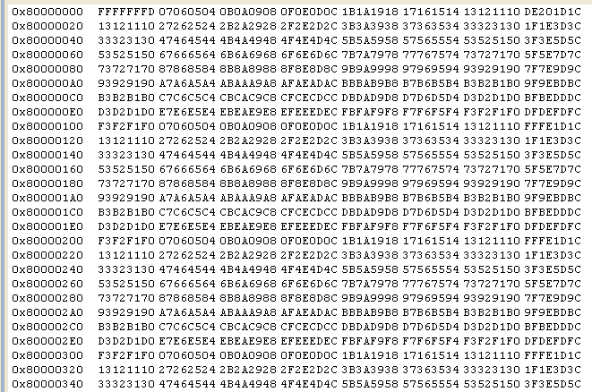
数据与理论写入值的偏差有
- memory brower窗口的第一个数据为0xFFFFFFFD，改变memory brower窗口初始地址后，还是这个数值。感觉读取的是在DDR3器件的data还没有正常输出时，读取数据总线上的值。
- 每行8个数据，data[0:7]，从data3到data6出现在memory brower中的次序颠倒了，实在是很困惑。
- 每行的最后一个数据像是随机值，但是更改memory brower窗口初始地址后，值却保持不变。

初步估计这种异常现象应该与软件读写均衡有关，于是更改相关寄存器的配置如下：

DDR3_PHY寄存器配置2

#define DDR3_PHY_RD_DQS_CS0_DEFINE 0x14
#define DDR3_PHY_WR_DQS_CS0_DEFINE 0x0f
#define DDR3_PHY_FIFO_WE_CS0_DEFINE 0x69
#define DDR3_PHY_WR_DATA_CS0_DEFINE 0x23

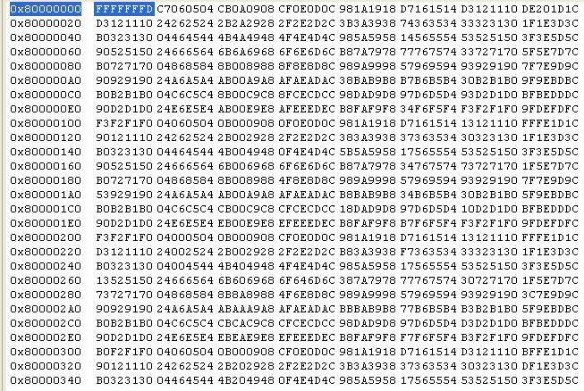
发现没有一个32bit数据是正确的

疑问
从DDR3_PHY寄存器配置1的情况看，与DDR3时序相关的寄存器配置应该是正确的，请FAE帮忙确认。
PCB中，DDR3所有信号走线的约束都很严格，硬件设计还没有发现问题。但从memory brower窗口中读取的数据却十分怪异。初步判断是读写均衡的问题，即宏定义
DDR3_PHY_RD_DQS_CS0_DEFINE
DDR3_PHY_WR_DQS_CS0_DEFINE
DDR3_PHY_FIFO_WE_CS0_DEFINE
DDR3_PHY_WR_DATA_CS0_DEFINE
的配置问题。可是按照文档TI814x-DDR3-Init-U-Boot Wordwise SWleveling所叙述的方法，得到的数值还是满足不了要求，也无法获取更加准确的配置值
DDR3_PHY0_RD_DQS_CS0_BYTE0
DDR3_PHY0_RD_DQS_CS0_BYTE1
DDR3_PHY0_RD_DQS_CS0_BYTE2
DDR3_PHY0_RD_DQS_CS0_BYTE3

DDR3_PHY0_WR_DQS_CS0_BYTE0
DDR3_PHY0_WR_DQS_CS0_BYTE1
DDR3_PHY0_WR_DQS_CS0_BYTE2
DDR3_PHY0_WR_DQS_CS0_BYTE3

DDR3_PHY0_RD_DQS_GATE_CS0_BYTE0
DDR3_PHY0_RD_DQS_GATE_CS0_BYTE1
DDR3_PHY0_RD_DQS_GATE_CS0_BYTE2
DDR3_PHY0_RD_DQS_GATE_CS0_BYTE3

DDR3_PHY0_WR_DATA_CS0_BYTE0
DDR3_PHY0_WR_DATA_CS0_BYTE1
DDR3_PHY0_WR_DATA_CS0_BYTE2
DDR3_PHY0_WR_DATA_CS0_BYTE3

而且excel工具RatioSeed_TI814x.xls中的
RD DQS
固定为0x34，原因是什么？

