网口反复up和down导致不通的问题

1、问题描述
dual mac模式下，网口在使用过程中出现概率性不通的情况；后经过不断的up、down、ping的测试，也会出现网口不通。
SDK版本：ti-processor-sdk-linux-am335x-evm-08.00.00.00-Linux-x86-Install.bin
硬件描述：使用双网卡模式，port1(eth0)与电脑通信，port2(eth1)与fpga通信，原理图见附件

2、已做过的相关操作
2.1 在板上am3352端抓包同时也在PC端抓包，发现PC端能抓到对应的ARP包，am3352端抓不到数据，也就是接收不了。将phy配置成loopback模式，网口仍然接收不了数据
2.2 将内核换成最新的SDK里的内核，问题并没有解决，最新SDK版本如下 ti-processor-sdk-linux-am335x-evm-03.03.00.04-Linux-x86-Install
2.3 在phy_device.c中将genphy_suspend和genphy_resume的功能注释掉，在网口up和down的过程中不进行电源操作，重新挂机测试，现象依旧。
2.4 使用ifconifg eth0 promisc指令，让ALE进入bypass模式，没有效果。
2.5 将eth0、eth1都down掉，然后在将eth0 up，网口可以ping通，单单将eth0 down掉再up没有效果
2.6 网口出现不通是，cpsw SL1寄存器MACCONTROL指示该控制器一直是非空闲状态，复位cpsw SL1也没有效果。

3、网口相关配置

3.1设备树的相关配置
mac: ethernet@4a100000 {
compatible = "ti,cpsw";
ti,hwmods = "cpgmac0";
clocks = <&cpsw_125mhz_gclk>, <&cpsw_cpts_rft_clk>;
clock-names = "fck", "cpts";
cpdma_channels = <8>;
ale_entries = <1024>;
bd_ram_size = <0x2000>;
dual_emac = <1>; //xiaoxi add
no_bd_ram = <0>;
rx_descs = <64>;
mac_control = <0x20>;
slaves = <2>;
active_slave = <0>;
cpts_clock_mult = <0x80000000>;
cpts_clock_shift = <29>;
reg = <0x4a100000 0x800
0x4a101200 0x100>;
#address-cells = <1>;
#size-cells = <1>;
interrupt-parent = <&intc>;
/*
* c0_rx_thresh_pend
* c0_rx_pend
* c0_tx_pend
* c0_misc_pend
*/
interrupts = <40 41 42 43>;
ranges;

davinci_mdio: mdio@4a101000 {
compatible = "ti,davinci_mdio";
#address-cells = <1>;
#size-cells = <0>;
ti,hwmods = "davinci_mdio";
bus_freq = <1000000>;
reg = <0x4a101000 0x100>;
};
cpsw_emac0: slave@4a100200 {
/* Filled in by U-Boot */
mac-address = [ 00 00 00 00 00 00 ];
};
cpsw_emac1: slave@4a100300 {
/* Filled in by U-Boot */
mac-address = [ 00 00 00 00 00 00 ];
};

phy_sel: cpsw-phy-sel@44e10650 {
compatible = "ti,am3352-cpsw-phy-sel";
reg= <0x44e10650 0x4>;
reg-names = "gmii-sel";
};
/***********************************************************************/
&davinci_mdio {
pinctrl-names = "default", "sleep";
pinctrl-0 = <&my_mdio_1_pins_default>;
};

&cpsw_emac0 {
phy_id = <&davinci_mdio>,<3>;
phy-mode = "mii";
};

&cpsw_emac1 {
phy_id = <&am335x_mdio>,<1>;
phy-mode = "mii";
};

&mac {
pinctrl-names = "default", "sleep";
pinctrl-0 = <&my_mii_1_pins_default>;

};
3.2 内核的相关配置
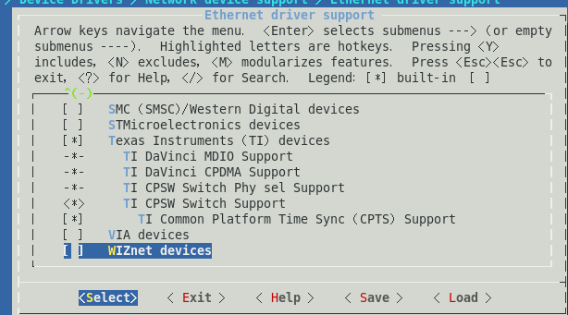

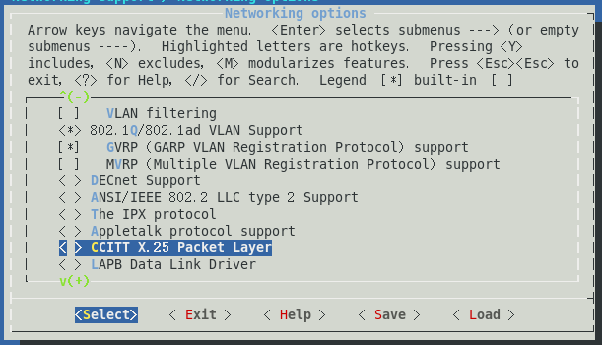

4、网口不通时，cpsw所有寄存器的状态见附件

