需要文件(以SPI flash启动为例)：
- ubl-spi_ais.bin(通过AISgen for D800K008工具进行格式转换)
- u-boot.bin

在windows下
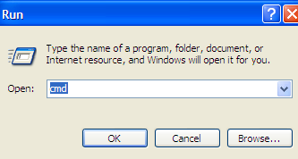
运行 command prompt
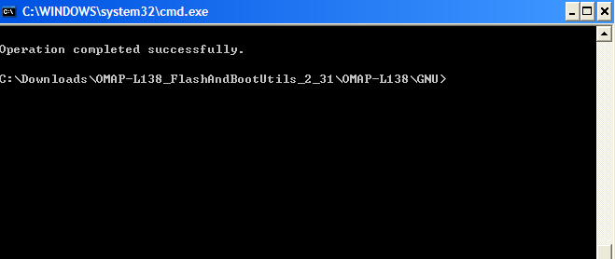
进入sfh_OMAP-L138.exe所在的文件目录

设置S7管脚如下
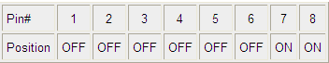
- Erase the target flash type - This will erase the entire contents of the flash.
  - sfh_OMAP-L138.exe -erase
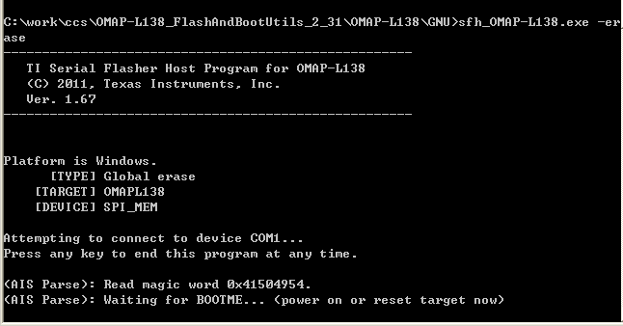
在按下板子reset键后
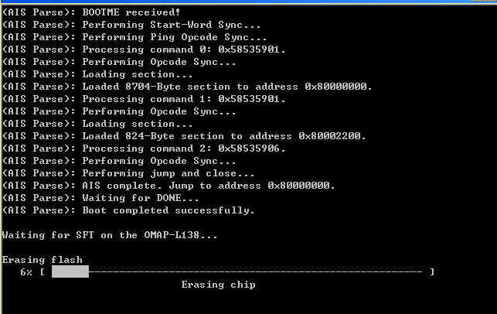

- Flash the memory with a single application image - This will place an application image at address 0x0 of the flash. This must be an AIS format binary, which can be created with the AISgen utilities bundled with the Bootloader User Guide.
  - sfh_OMAP-L138.exe -flash_noubl <binary application file>
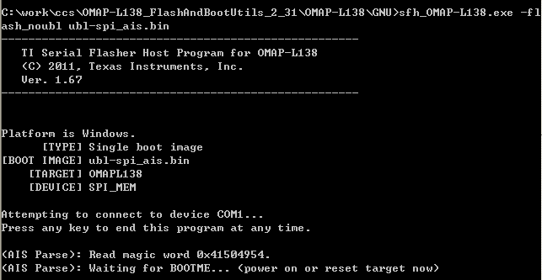
在按下板子reset键后
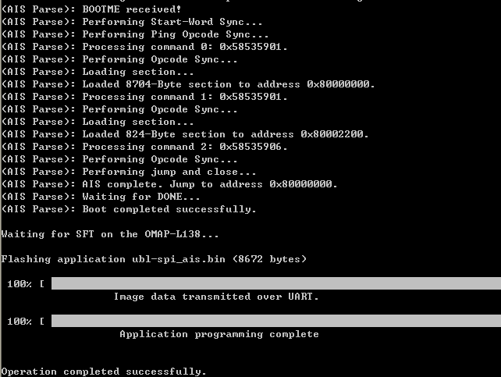

- Flash the memory with a UBL and application image - This will place a UBL at address 0x0 of the flash and an application image, such as u-boot, at address 0x10000. In general, a UBL is not required, and this mode is only used when restoring the default flash contents, as explained in the following section.
  - ..\sfh_OMAP-L138.exe -flash <UBL binary file> <binary application file>
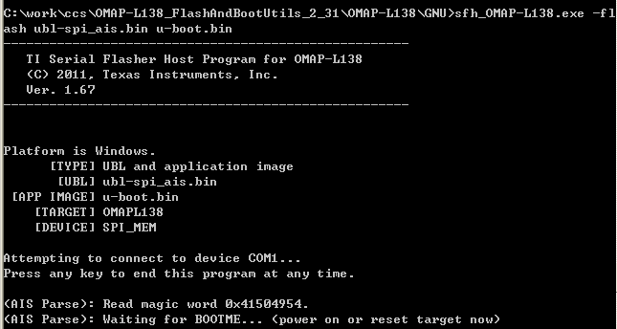
按下板子reset后
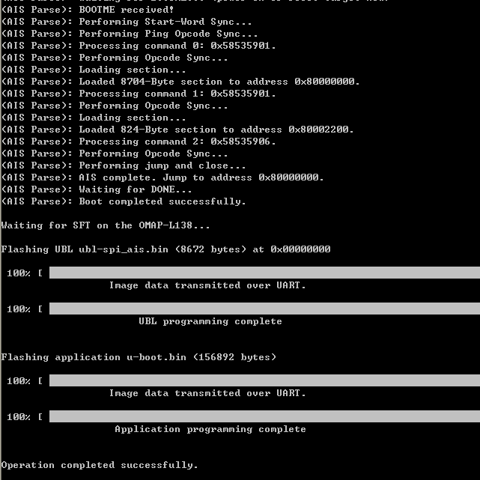
Ubl和uboot烧写完后，需要将S7开关设置为如下
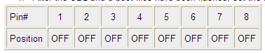
然后重新reset，则打开Hyper terminal，可见
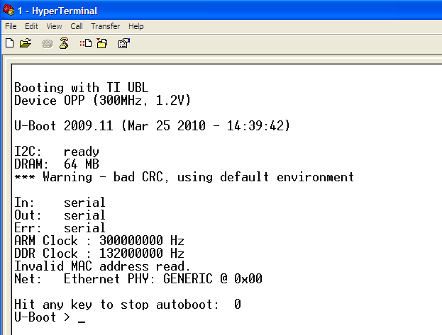
表示下载成功，uboot可以成功启动

注：
http://processors.wiki.ti.com/index.php/Serial_Boot_and_Flash_Loading_Utility_for_OMAP-L138

Help：sfh_OMAP-L138.exe 的命令格式
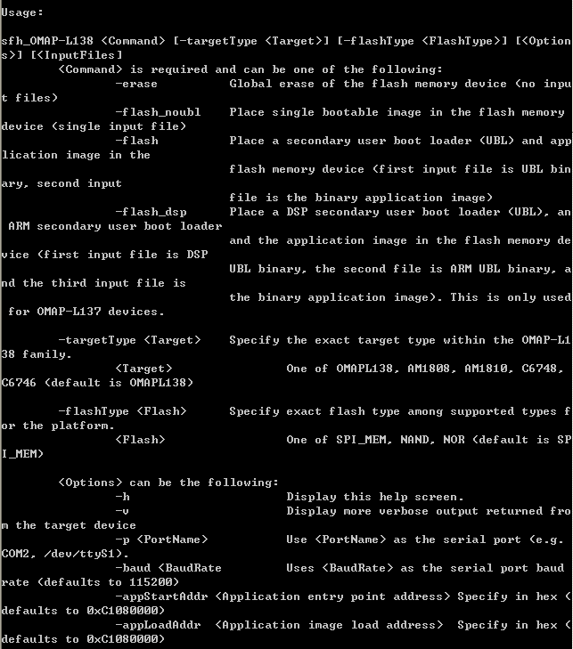

编译UBL:
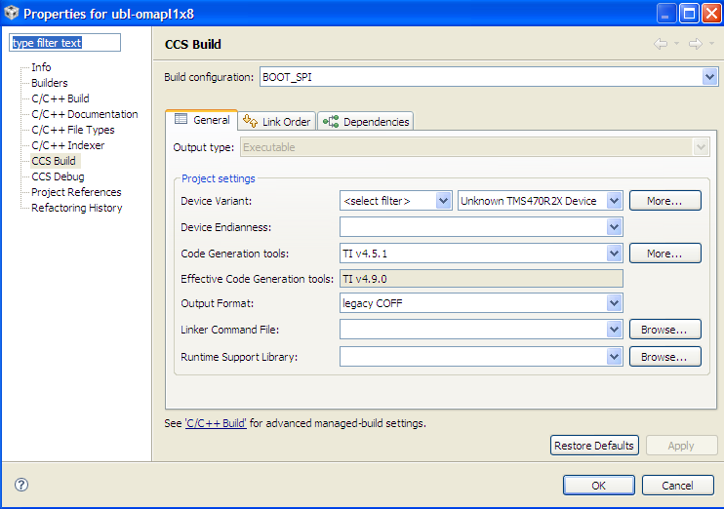
生产ubl-spi.bin和ubl-spi.out

只有ubl启动（或uboot不能正确启动），串口显示如下：
Booting with TI UBL
Device OPP (300MHz, 1.2V)

