Change compiler in CCS3.3
- CCS menu Help->About
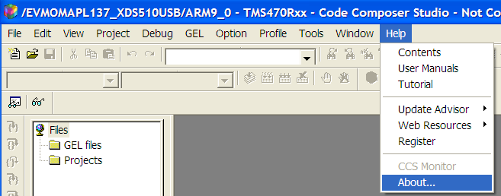
- Click Component Manager
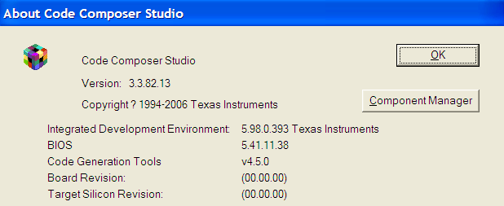
- From Build tools select the compiler version for your target CPU type. TMS470R2X is ARM9.
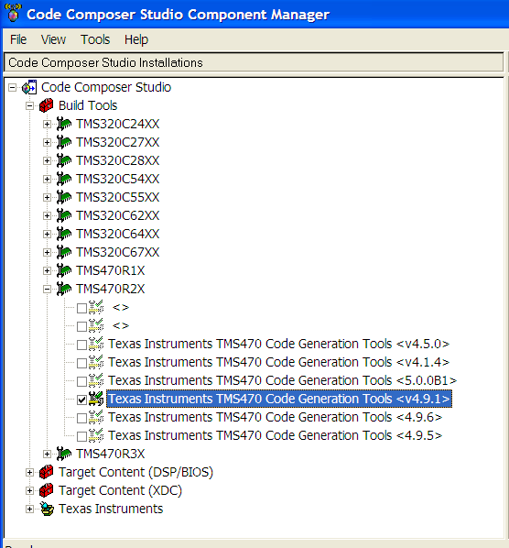
- Notice you to restart CCS to make changes valid.
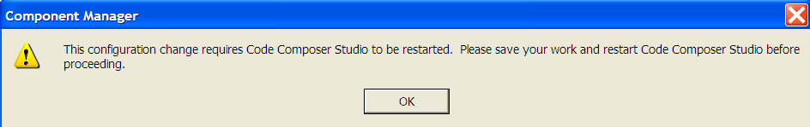
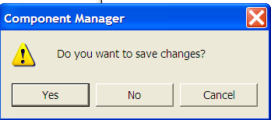
Similar step to change BIOS version.

