刚开始学习mcsdk_video_2_2_0_23这个库，准备试验一下Under <MCSDK video install diretory>\examples\transcode directory这个例程，但是运行出现这个错误
[C66xx_0] Read tftp config file
[C66xx_0]
[C66xx_0] Starting TFTP Get for airshow_p1280x720.264... Error receive from server!
[C66xx_0]
[C66xx_0] Creating Decoder Algorithm Instance...Num. buffs requested = 23
[C66xx_0] algAlloc req. Buffer 0: space = 17, size = 4840
[C66xx_0] algAlloc req. Buffer 1: space = 0, size = 8840
[C66xx_0] algAlloc req. Buffer 2: space = 0, size = 78184
[C66xx_0] algAlloc req. Buffer 3: space = 0, size = 8992
[C66xx_0] algAlloc req. Buffer 4: space = 17, size = 8664
[C66xx_0] algAlloc req. Buffer 5: space = 17, size = 176
[C66xx_0] algAlloc req. Buffer 6: space = 17, size = 144
[C66xx_0] algAlloc req. Buffer 7: space = 17, size = 4420
[C66xx_0] algAlloc req. Buffer 8: space = 17, size = 24
[C66xx_0] algAlloc req. Buffer 9: space = 17, size = 1860480
[C66xx_0] algAlloc req. Buffer 10: space = 17, size = 15079680
[C66xx_0] algAlloc req. Buffer 11: space = 17, size = 1966080
[C66xx_0] algAlloc req. Buffer 12: space = 17, size = 136
[C66xx_0] algAlloc req. Buffer 13: space = 17, size = 144
[C66xx_0] algAlloc req. Buffer 14: space = 17, size = 8840
[C66xx_0] algAlloc req. Buffer 15: space = 17, size = 544
[C66xx_0] algAlloc req. Buffer 16: space = 17, size = 540
[C66xx_0] algAlloc req. Buffer 17: space = 17, size = 264
[C66xx_0] algAlloc req. Buffer 18: space = 17, size = 12672
[C66xx_0] algAlloc req. Buffer 19: space = 17, size = 74880
[C66xx_0] algAlloc req. Buffer 20: space = 17, size = 110592
[C66xx_0] algAlloc req. Buffer 21: space = 17, size = 8160
[C66xx_0] algAlloc req. Buffer 22: space = 17, size = 116
[C66xx_0]
[C66xx_0] Algorithm Instance Creation Done...
[C66xx_0] Num. buffs requested = 13
[C66xx_0] algAlloc req. Buffer 0: space = 17, size = 1664
[C66xx_0] algAlloc req. Buffer 1: space = 0, size = 261376
[C66xx_0] algAlloc req. Buffer 2: space = 17, size = 327680
[C66xx_0] algAlloc req. Buffer 3: space = 17, size = 4480
[C66xx_0] algAlloc req. Buffer 4: space = 17, size = 5888
[C66xx_0] algAlloc req. Buffer 5: space = 17, size = 6144
[C66xx_0] algAlloc req. Buffer 6: space = 17, size = 8192
[C66xx_0] algAlloc req. Buffer 7: space = 17, size = 65536
[C66xx_0] algAlloc req. Buffer 8: space = 17, size = 8448
[C66xx_0] algAlloc req. Buffer 9: space = 17, size = 6983680
[C66xx_0] algAlloc req. Buffer 10: space = 17, size = 554880
[C66xx_0] algAlloc req. Buffer 11: space = 17, size = 142848
[C66xx_0] algAlloc req. Buffer 12: space = 17, size = 32640
[C66xx_0]
[C66xx_0] Encoder Algorithm Instance Creation Done...
[C66xx_0]
[C66xx_0] Bitstream Ended...
[C66xx_0] TFTP Get stopped.
[C66xx_0] TFTP Statistics-------------------+
[C66xx_0] | RX Bytes : 0 |
[C66xx_0] | TX Bytes : 0 |
[C66xx_0] | Valid Packets : 0 |
[C66xx_0] | Duplicate Packets : 0 |
[C66xx_0] | Error Packets : 0 |
[C66xx_0] +---------------------------------+
[C66xx_0]
[C66xx_0] TFTP Put stopped.
[C66xx_0] TFTP Statistics-------------------+
[C66xx_0] | RX Bytes : 0 |
[C66xx_0] | TX Bytes : 0 |
[C66xx_0] | Valid Packets : 0 |
[C66xx_0] | Duplicate Packets : 0 |
[C66xx_0] | Error Packets : 0 |
[C66xx_0] +---------------------------------+
[C66xx_0]
[C66xx_0] -------------- SUMMARY --------------------
[C66xx_0] Total number of Frames = 1
[C66xx_0] Decoder Bit Rate at 30 frames/Sec = 0 Kbps
[C66xx_0] Encoder Bit Rate at 30 frames/Sec = 0 Kbps
[C66xx_0] -------------- END --------------------
[C66xx_0]
[C66xx_0] End of execution
[C66xx_0] End of Program
出现这个问题，这肯定是服务器出问题了。
1、按照

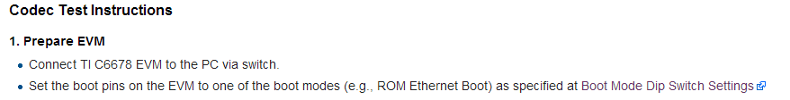
首先我用网线把电脑和6678EVM连接起来，模式也设为ROM Ethernet Boot,
我想问问这个Load的是不是videoTranscode.out文件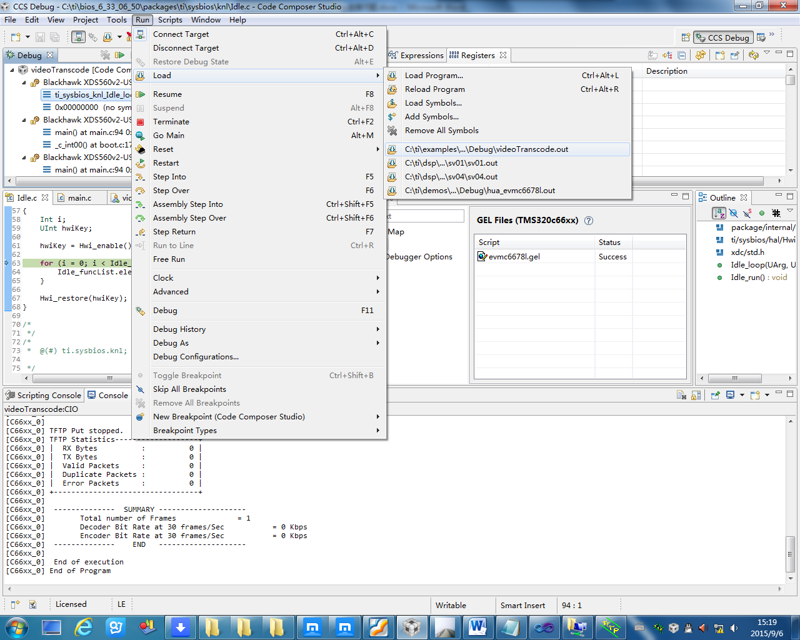
这个是我下载程序时的截图,我就加载了一个核core 0
至于ccs和EVM的设置就是这些了，
2、下面是电脑端的配置
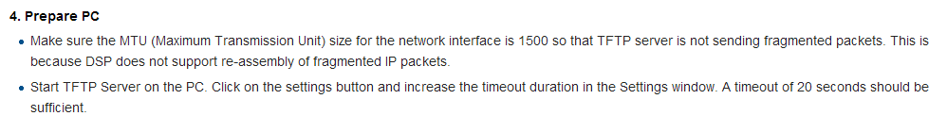
这个MTU我也已经改成了1500.
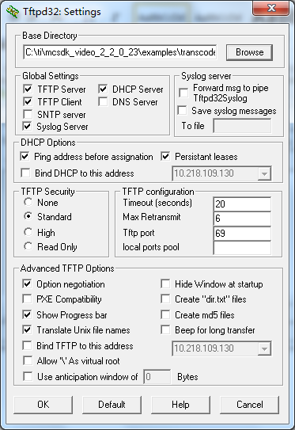
这是我的TFTP的设置
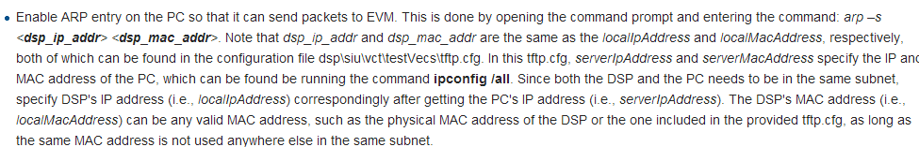
在我的这个tftp.cfg的文件中是
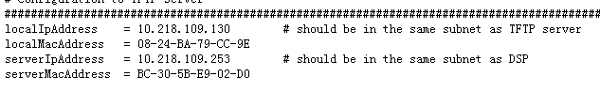
我想问问这个severIpAddress需不需要改成我本身电脑的Mac地址？
下面是arp –s命令结果
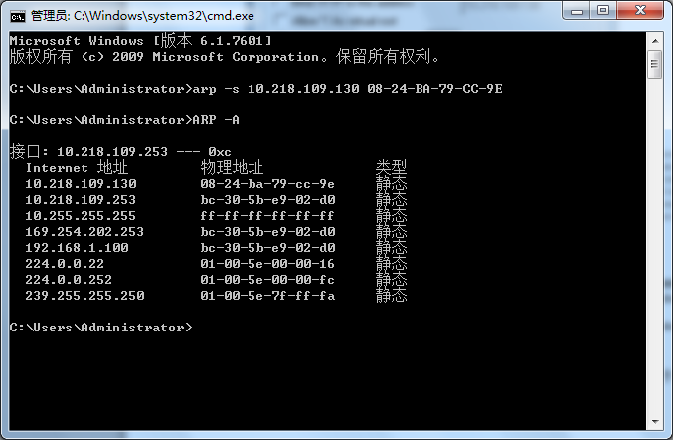
电脑设置的为静态IP
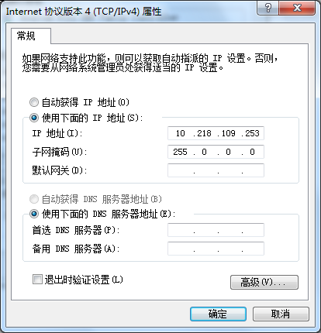
这样所有的都设置完成后，但ping不通啊，这是怎么回事？而且电脑显示是这样的，我想是不是连接的问题所有出现编译出错？
Ping的结果
