sysBios Exception module process
To use the exception, it is need to add the exception in the cfg or using xmc code as below. And it is recommended to configure in the bios cfg file.
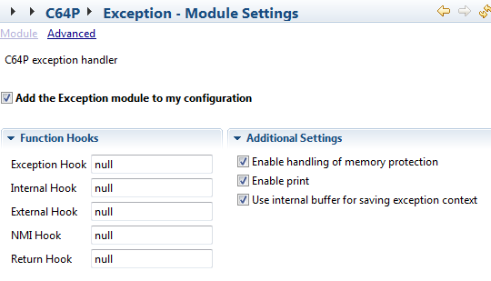
var Exception = xdc.useModule('ti.sysbios.family.c64p.Exception');
Exception.enablePrint = true;
Exception.internalHook = '&myExcHookFxn';
Exception source code location:
C:\ti\bios_6_35_04_50\packages\ti\sysbios\family\c64p
Exception_asm.s64P
Exception.c
Exception.h
Exception_asm.s64P:
Assemble function, exception ISR function entry, record the register in the sysbios variable “_ti_sysbios_family_c64p_Exception_Module__state__V”, and then call the function “_ti_sysbios_family_c64p_Exception_handler__I” defined in the exception.c “Exception_handler”.
Struct definition of variable type “_ti_sysbios_family_c64p_Exception_Module__state__V”:
struct ti_sysbios_family_c64p_Exception_Module_State {
xdc_Bits32 efr;
xdc_Bits32 nrp;
xdc_Bits32 ntsr;
xdc_Bits32 ierr;
ti_sysbios_family_c64p_Exception_FuncPtr returnHook;
ti_sysbios_family_c64p_Exception_Context* excContext; //Register record address
__TA_ti_sysbios_family_c64p_Exception_Module_State__scratch scratch;
xdc_Char* excPtr;
__TA_ti_sysbios_family_c64p_Exception_Module_State__contextBuf contextBuf;
};
Exception.c
C function, implement the exception process function Exception_handler, the corresponding exception hook function is called according to the error status bit. And several function hooks can be added.
Exception hook: called in the exception_handler function;
Internal hook: called for internal exception with EFR.IXF set;
External hook: called for external exception with EFR.EXF set;
NMI hook: called for external exception with EFR.NXF set;
Return hook: called when returning from the exception process;
Enable handling of memory protection:
Can route the memory protection event to the exception ISR, include the UMC/PMC/ /DMC_CMPA event.
UMC: L2 memory protection fault;
PMC: L1P memory protection fault;
DMC: L1D memory protection fault;
In the built map file we can find below corresponding symbol:
Variable:
ti_sysbios_family_c64p_Exception_Module__state__V: Variable used to store the exception context include the registers.
Useful function:
ti_sysbios_family_c64p_Exception_handler__I: key exception process function;
ti_sysbios_family_c64p_Exception_exceptionHook__C: hook pointer.
ti_sysbios_family_c64p_Exception_externalHook__C
ti_sysbios_family_c64p_Exception_internalHook__C
ti_sysbios_family_c64p_Exception_nmiHook__C

