b

Texas Instruments

PMP4390 Test Procedure

China Power Reference Design

REV A

12/09/2013

- GENERAL

  - PURPOSE
To provide detailed data for evaluating and verifying the PMP4390, which uses TI new Primary Side Controller UCC28713 and synchronous rectified controller UCC24610 for 5.5V3A adapter with size 44mmx35mmx15mm and can be placed into standard 10W England version shell. The below photo shows this demo board.
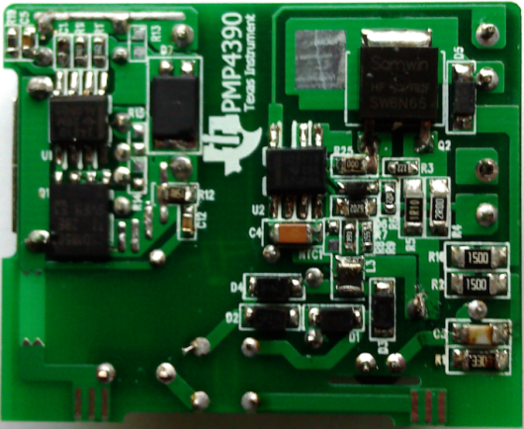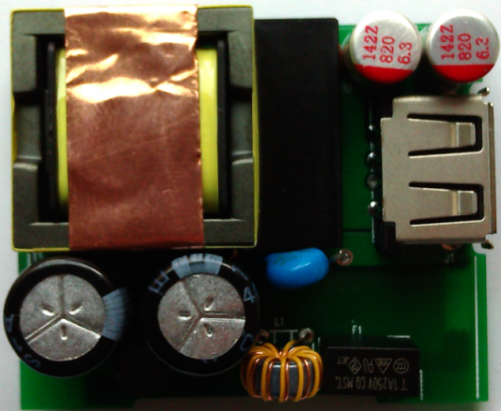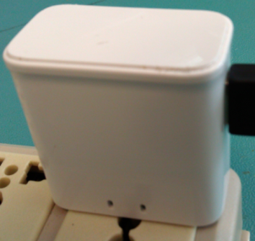

  - REFERENCE DOCUMENTATION
Schematic PMP4390_SCH.PDF
Assembly PMP4390_PCB.PDF
BOM
Gerber files
Promotion tools

  - TEST EQUIPMENTS
Power-meter: YOKOGAWA WT210
Multi-meter(current): Fluke 8845A
Multi-meter(voltage): Fluke 187
AC Source: Chroma 61530
Electronic load: Chroma 63105A module
Testing demoboard

- INPUT CHARACTERISTICS
Efficiency is tested on USB-end
Otherwise Specified, the test is under the condition with 100cm cable

  - STANDBY POWER

  - EFFICIENCY DATA
Notes: efficiency test is based on USB port
85v |  |  |  |  |  | 115v
Pi(w) | Io(A) |  | Vo(V) | efficiency |  | Pi(w) | Io(A) | Vo(V) | efficiency
1.025 | 0.15 |  | 5.197 | 0.761 |  | 1.038 | 0.15 | 5.195 | 0.751
1.902 | 0.3 |  | 5.206 | 0.821 |  | 1.925 | 0.3 | 5.203 | 0.811
2.339 | 0.375 |  | 5.211 | 0.835 |  | 2.361 | 0.375 | 5.209 | 0.827
4.604 | 0.75 |  | 5.246 | 0.855 |  | 4.598 | 0.75 | 5.243 | 0.855
6.9 | 1.125 |  | 5.276 | 0.86 |  | 6.882 | 1.125 | 5.279 | 0.863
9.28 | 1.5 |  | 5.311 | 0.858 |  | 9.219 | 1.5 | 5.31 | 0.864
11.74 | 1.875 |  | 5.35 | 0.854 |  | 11.62 | 1.875 | 5.353 | 0.864
14.25 | 2.25 |  | 5.402 | 0.853 |  | 14.05 | 2.25 | 5.394 | 0.864
16.81 | 2.625 |  | 5.442 | 0.85 |  | 16.53 | 2.625 | 5.436 | 0.863
19.35 | 3 |  | 5.476 | 0.849 |  | 18.99 | 3 | 5.461 | 0.863
132v |  |  |  |  |  | 150v
Pi(w) | Io(A) |  | Vo(V) | efficiency |  | Pi(w) | Io(A) | Vo(V) | efficiency
1.052 | 0.15 |  | 5.2 | 0.741 |  | 1.085 | 0.15 | 5.205 | 0.72
1.946 | 0.3 |  | 5.202 | 0.802 |  | 1.976 | 0.3 | 5.203 | 0.79
2.378 | 0.375 |  | 5.21 | 0.822 |  | 2.406 | 0.375 | 5.209 | 0.812
4.602 | 0.75 |  | 5.244 | 0.855 |  | 4.627 | 0.75 | 5.242 | 0.85
6.87 | 1.125 |  | 5.281 | 0.865 |  | 6.899 | 1.125 | 5.279 | 0.861
9.2 | 1.5 |  | 5.312 | 0.866 |  | 9.213 | 1.5 | 5.312 | 0.865
11.58 | 1.875 |  | 5.347 | 0.866 |  | 11.58 | 1.875 | 5.346 | 0.866
14 | 2.25 |  | 5.394 | 0.867 |  | 13.99 | 2.25 | 5.394 | 0.868
16.44 | 2.625 |  | 5.438 | 0.868 |  | 16.43 | 2.625 | 5.434 | 0.868
18.86 | 3 |  | 5.463 | 0.869 |  | 18.88 | 3 | 5.465 | 0.868
180v
Pi(w) |  | Io(A) | Vo(V) | efficiency
1.133 |  | 0.15 | 5.203 | 0.689
2.026 |  | 0.3 | 5.202 | 0.77
2.455 |  | 0.375 | 5.209 | 0.796
4.665 |  | 0.75 | 5.242 | 0.843
6.916 |  | 1.125 | 5.28 | 0.859
9.25 |  | 1.5 | 5.315 | 0.862
11.62 |  | 1.875 | 5.348 | 0.863
13.99 |  | 2.25 | 5.395 | 0.868
16.46 |  | 2.625 | 5.434 | 0.867
18.93 |  | 3 | 5.467 | 0.866
230v |  |  |  |  |  | 264v
Pi(w) | Io(A) |  | Vo(V) | efficiency |  | Pi(w) | Io(A) | Vo(V) | efficiency
1.27 | 0.15 |  | 5.193 | 0.613 |  | 1.345 | 0.15 | 5.192 | 0.579
2.14 | 0.3 |  | 5.2 | 0.729 |  | 2.219 | 0.3 | 5.2 | 0.703
2.57 | 0.375 |  | 5.206 | 0.76 |  | 2.654 | 0.375 | 5.207 | 0.736
4.766 | 0.75 |  | 5.236 | 0.824 |  | 4.846 | 0.75 | 5.237 | 0.811
7.027 | 1.125 |  | 5.275 | 0.845 |  | 7.099 | 1.125 | 5.274 | 0.836
9.328 | 1.5 |  | 5.312 | 0.854 |  | 9.388 | 1.5 | 5.312 | 0.849
11.66 | 1.875 |  | 5.348 | 0.86 |  | 11.73 | 1.875 | 5.348 | 0.855
14.05 | 2.25 |  | 5.383 | 0.862 |  | 14.14 | 2.25 | 5.383 | 0.857
16.54 | 2.625 |  | 5.433 | 0.862 |  | 16.62 | 2.625 | 5.432 | 0.858
19 | 3 |  | 5.448 | 0.86 |  | 19.1 | 3 | 5.469 | 0.859

2.2.1 Load and input voltage Vs efficiency curve tested at USB-end

2.2.2 efficiency curve at 5% and 10% of full load

2.2.3 Average efficiency curve at 0.75A,1.5A,2.25A,3A

2.2.5 Efficiency Vs load curve

  - INPUT CURRENT

Vin(Vac) | Freq(Hz) | Iin(Arms) | Pass/Fail
85 | 60 | 0.36

  - INPUT INRUSH CURRENT

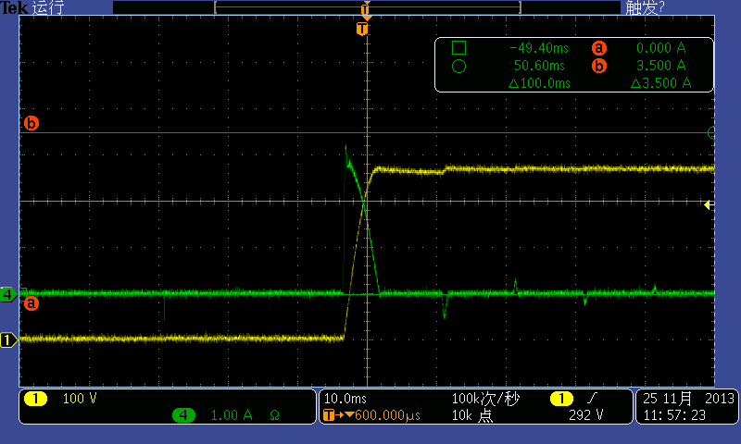
Vin:264Vac Io: 3A
Ch1: Input bulk CAP voltage 100V/div
Ch4: Input inrush current 1A/div
- OUTPUT CHARACTERISTICS

  - STARTUP TIME

Input voltage | Output current | Startup time | Pass/Fail
115Vac | 3A | 584mS
230Vac | 3A | 569mS
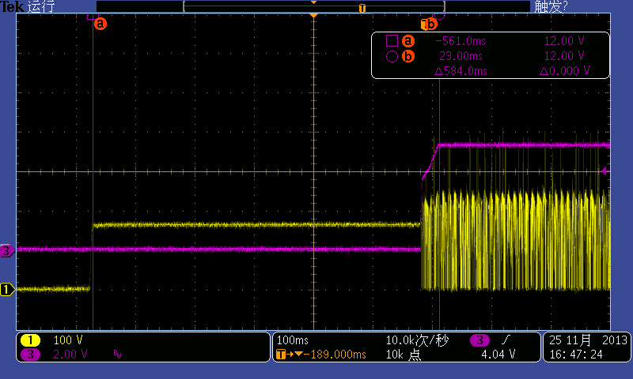
Vin:115Vac Io: 3A
Ch1: MOSFET’s drain voltage, 100V/div Ch3: output voltage, 2V/div
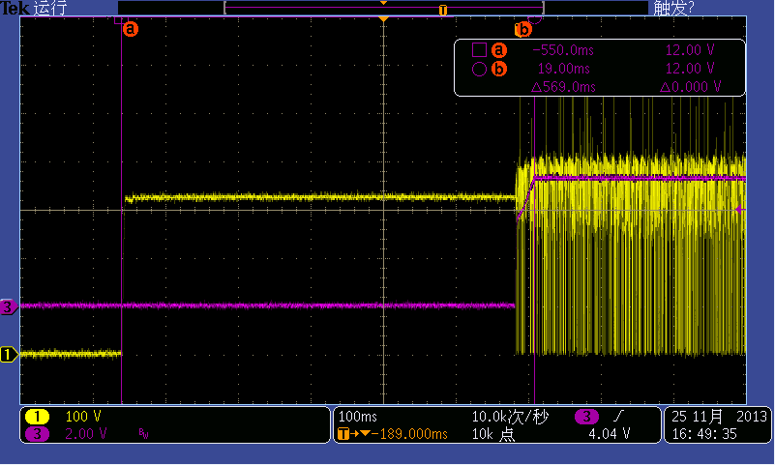
Vin:230Vac Io: 3A
Ch1: MOSFET’s drain voltage, 100V/div Ch3: output voltage, 2V/div

  - OUTPUT VOLTAGE RISE TIME
Input voltage | Output current | Startup time | Pass/Fail
115Vac | 3A | 31mS
230Vac | 3A | 27.3mS

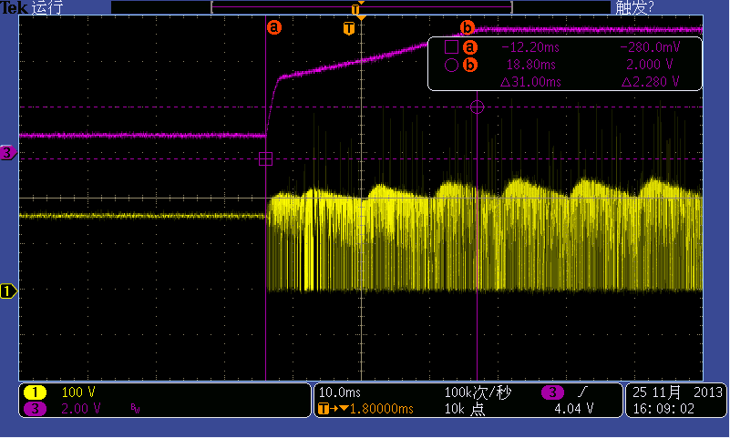
Vin:115Vac Io: 3A
Ch1: MOSFET’s drain voltage, 100V/div Ch3: output voltage, 2V/div
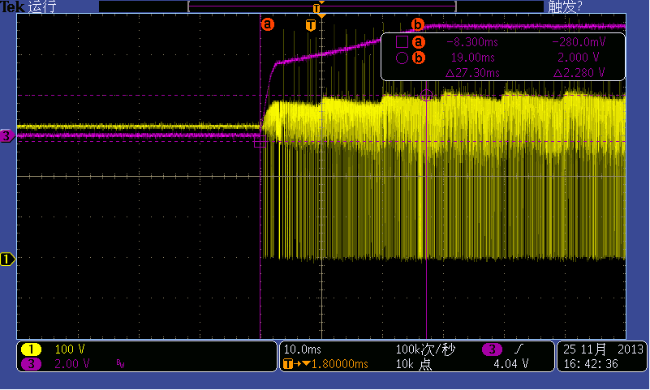
Vin:230Vac Io: 3A
Ch1: MOSFET’s drain voltage, 100V/div Ch3: output voltage, 2V/div

  - OUTPUT VOLTAGE OVERSHOOT

Input voltage | Output current | overshoot voltage | Pass/Fail
115Vac | 0A | <1%
230Vac | 0A | <1%
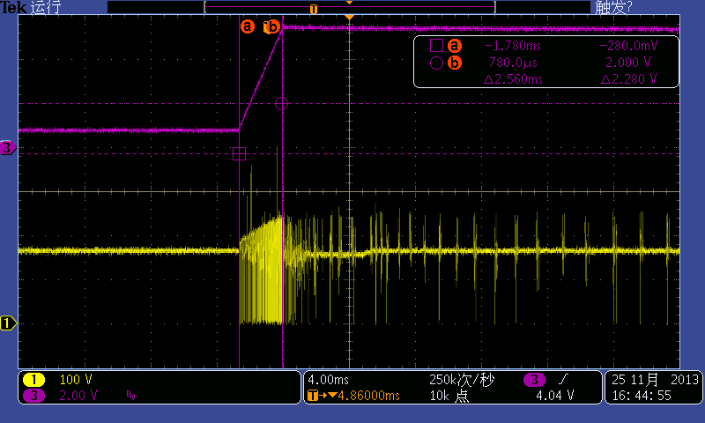
Vin:115Vac Io: 0A
Ch1: MOSFET’s drain voltage, 100V/div Ch3: output voltage, 2V/div
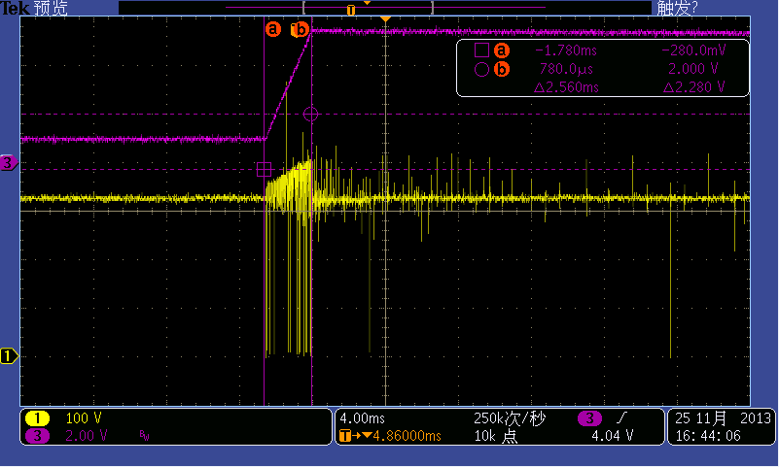
Vin:230Vac Io: 0A
Ch1: MOSFET’s drain voltage, 100V/div Ch3: output voltage, 2V/div

  - RIPPLE VOLTAGE
Input voltage | Output current | Ripple voltage | Pass/Fail
115Vac | 0.75A | 54mV
115Vac | 1.5A | 52mV
115Vac | 2.25A | 70mV
115Vac | 3A | 62mV
230Vac | 0.75A | 36mV
230Vac | 1.5A | 58mV
230Vac | 2.25A | 58mV
230Vac | 3A | 66mV

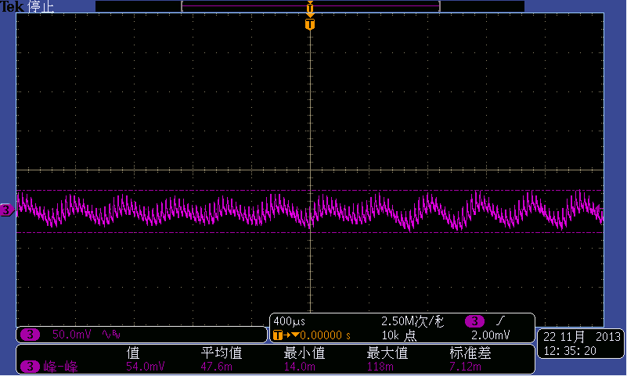
Vin:115Vac Io: 0.75A
Ch3: output ripple voltage, 50mV/div
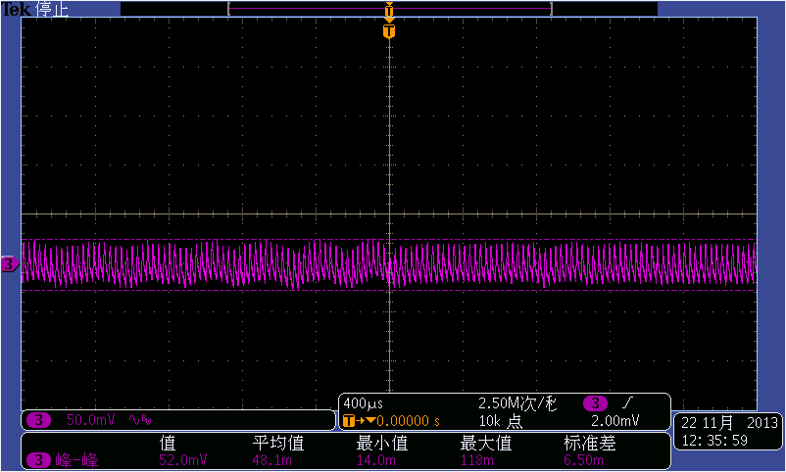
Vin:115Vac Io: 1.5A
Ch3: output ripple voltage, 50mV/div
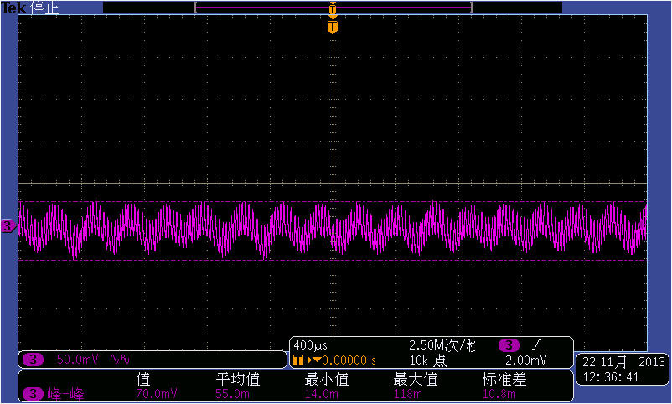
Vin:115Vac Io: 2.25A
Ch3: output ripple voltage, 50mV/div
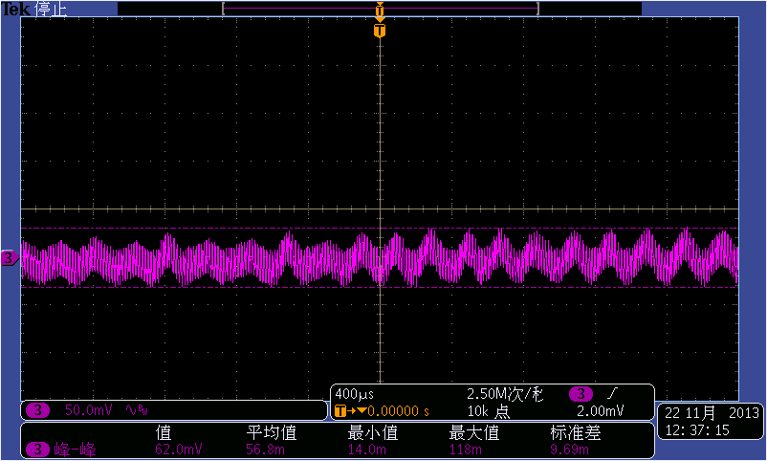
Vin:115Vac Io: 3A
Ch3: output ripple voltage, 50mV/div

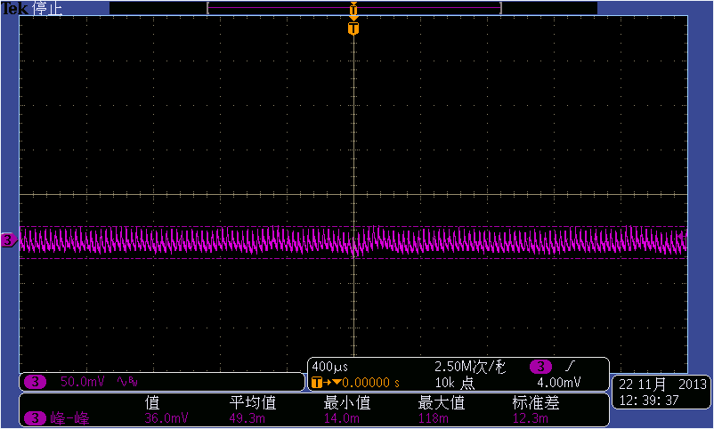
Vin:230Vac Io: 0.75A
Ch3: output ripple voltage, 50mV/div
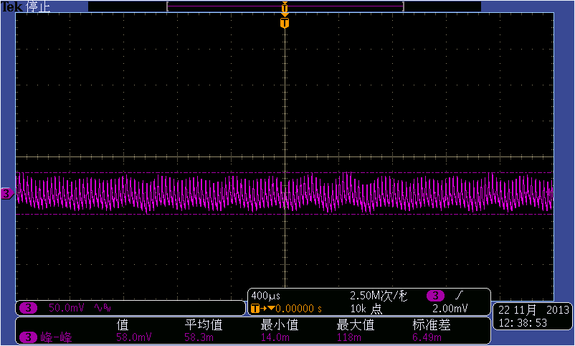
Vin:230Vac Io: 1.5A
Ch3: output ripple voltage, 50mV/div
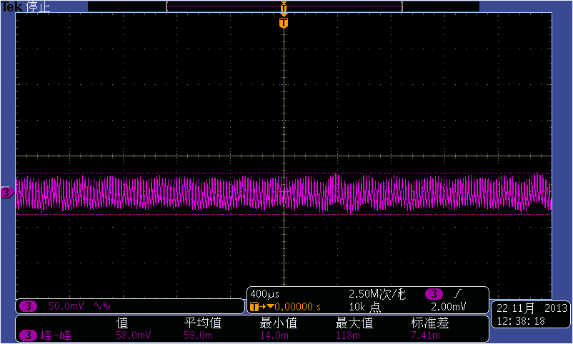
Vin:230Vac Io: 2.25A
Ch3: output ripple voltage, 50mV/div
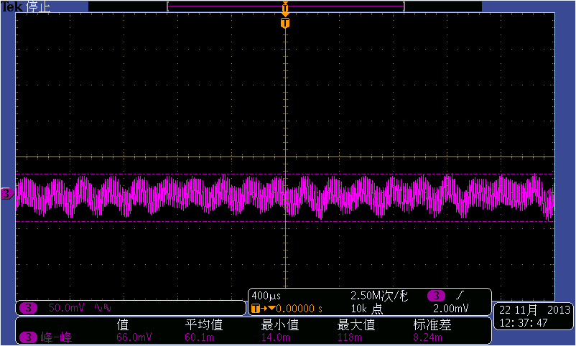
Vin:230Vac Io: 3A
Ch3: output ripple voltage, 50mV/div

  - DYNAMIC RESPONSE
Input voltage | Output current | Max voltage | Min voltage
115Vac | 5%-95% of full load | 5.58V | 4.92V
230Vac | 5%-95% of full load | 5.6V | 4.92V

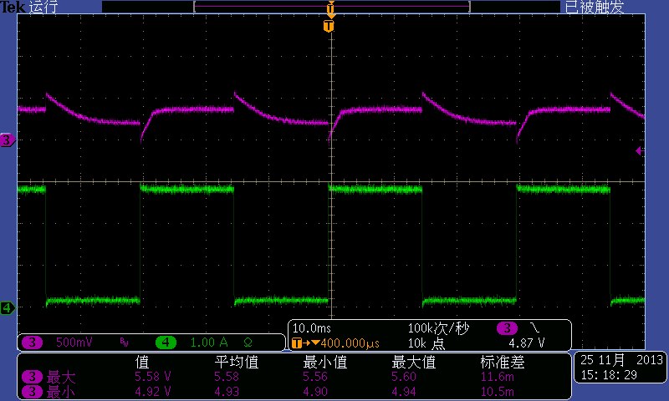
Vin:115Vac test condition: 5%-95% of full load, 0.1A/us, 30ms cycle, 100cm cable
Ch3: output voltage Ch4: output current
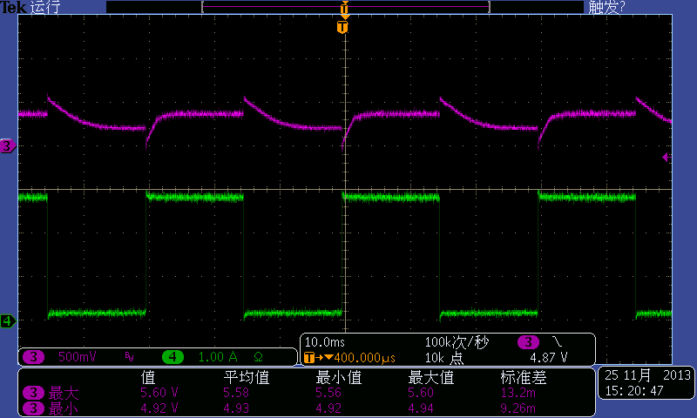
Vin:230Vac test condition: 5%-95% of full load, 0.1A/us, 30ms cycle, 100cm cable
Ch3: output voltage Ch4: output current

  - OUTPUT VOLTAGE PROTECTION
CONDITIONS | Protection voltage（V） | Pass/Fail
Vin (Vac) | Protection voltage（V） | Pass/Fail
115&230 | 6

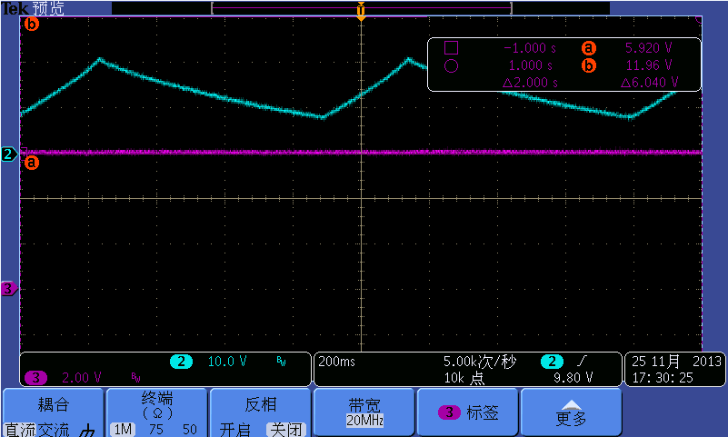
Vin: 115Vac OVP: 6V
CH2: Vdd voltage, 10V/div
CH3: Vo, 2V/div
  - OUTPUT SHORT PROTECTION
Input voltage | Output short protection
115&230Vac | Hiccup up mode

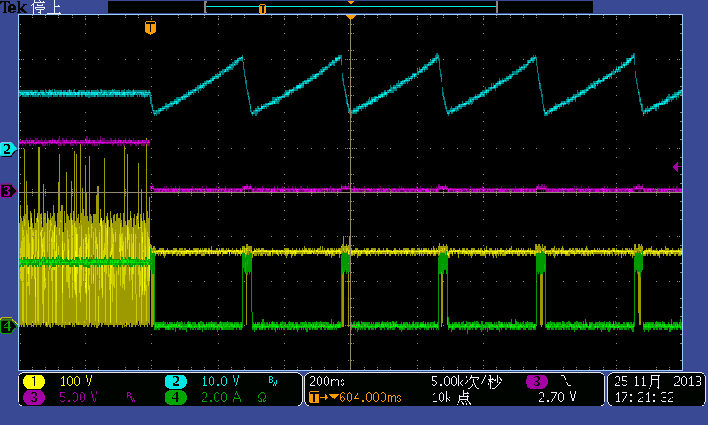
Vin:115Vac
CH1: Vds of MOSFET, 100V/div CH2: Vdd, 10V/div
CH3: Vo, 5V/div CH4: output current, 2A/div
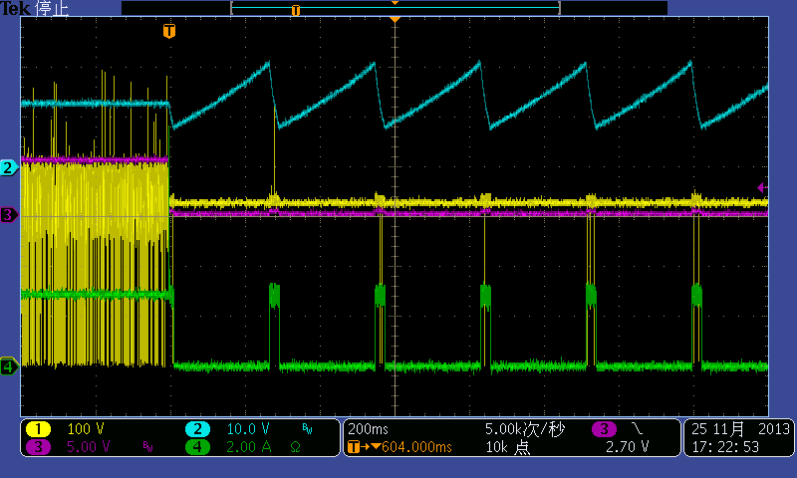
Vin:230Vac
CH1: Vds of MOSFET, 100V/div CH2: Vdd, 10V/div
CH3: Vo, 5V/div CH4: output current, 2A/div
- IV CURVE

- THERMAL TEST
5.1. Thermal test with case at Ta=25ºC

- EMI Test
6.1 Conduction emission
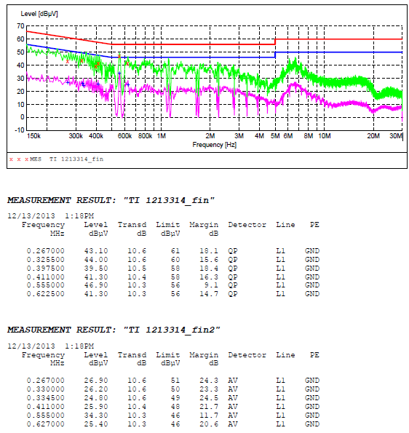
Vin: 230Vac, Line, Io: 3A Test condition: 1.5m cable with 1.77R load resistor
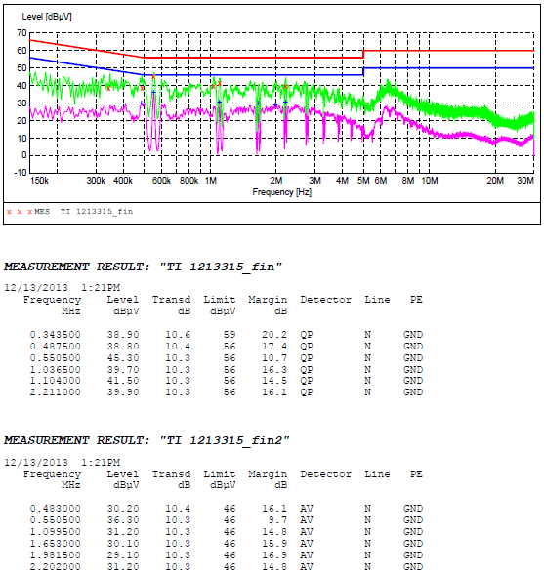
Vin:230Vac, Neutral, Io: 3A Test condition: 1.5m cable with 1.77R load resistor
6.2 Radiation emission
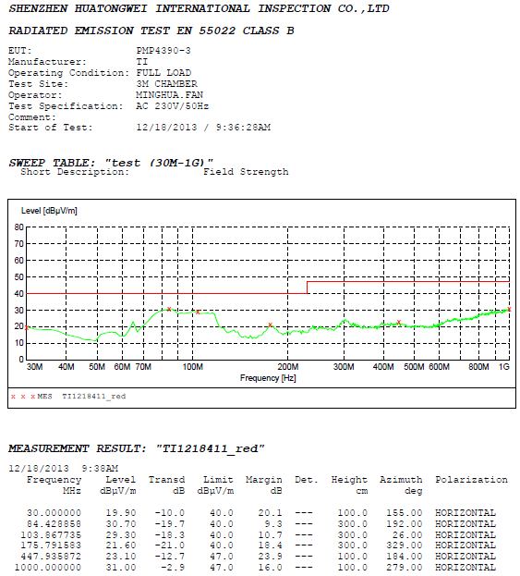
Vin: 230Vac, Horizontal, Io: 3A Test condition: 1.5m cable with 1.77R load resistor
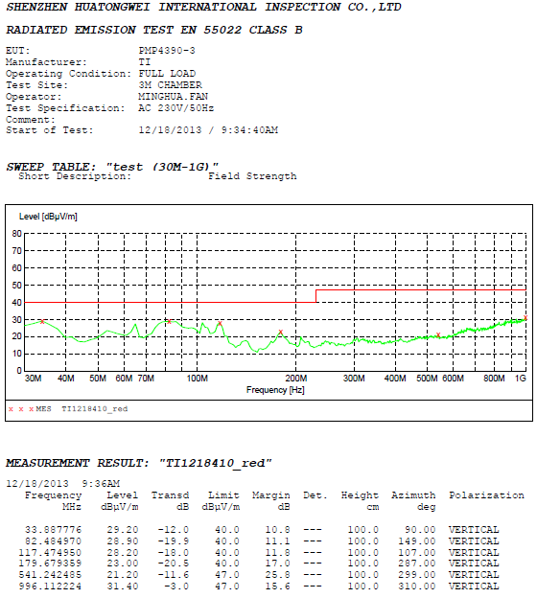
Vin:230Vac, Vertical, Io: 3A Test condition: 1.5m cable with 1.77R load resistor

