CCSV5在windows8中工程的建立
OS: Windows8 Pro 32 bit
IDE: Code Composer Studio v5.1.1
Board: TI MSP430FR5739
本文介绍了CCSV5在微软最新操作系统Windows8上的应用。
1、双击打开CCSV5
2、选择工作空间
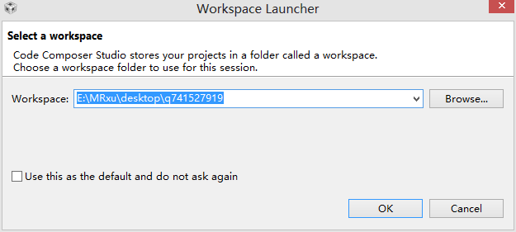
单击OK
3、将鼠标移至Project
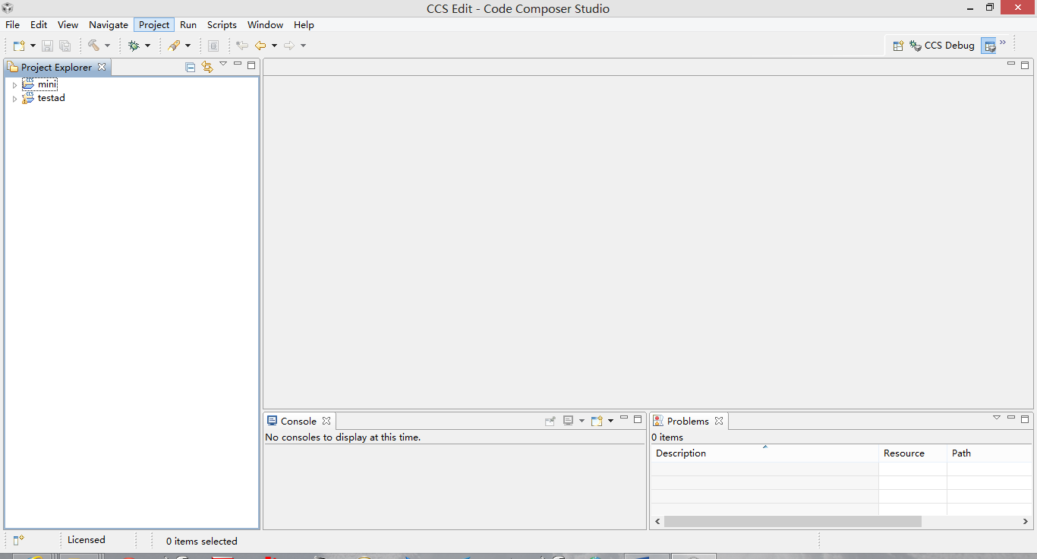
4、单击New CCS Project
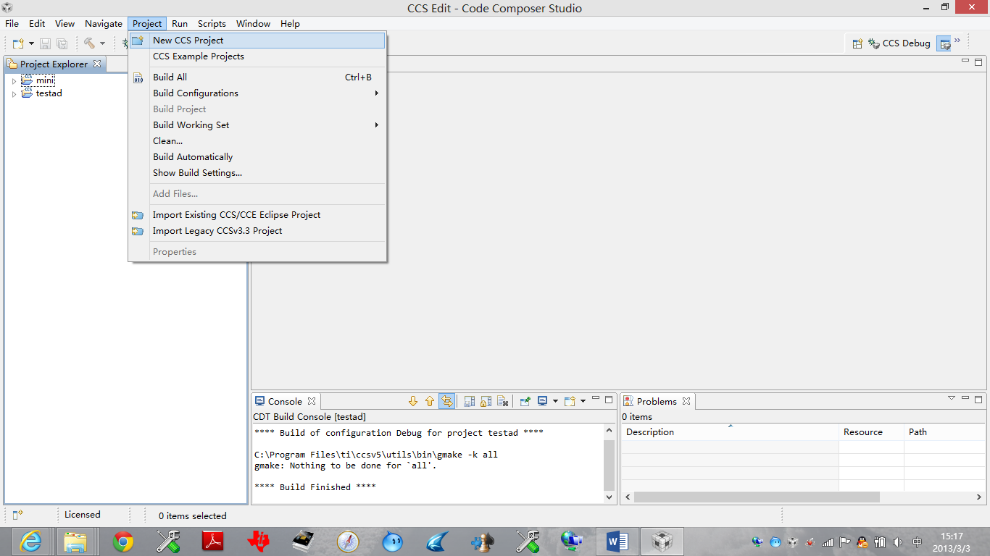
5、在Project name中输入工程名，Family中选中MSP430，Variant中选中MSP430FR5739,Project templates and examples 选择Empty Projects：
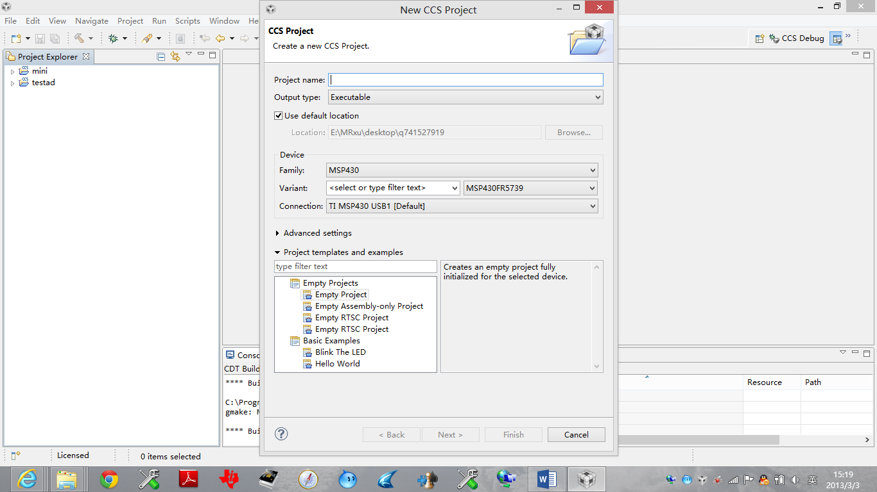
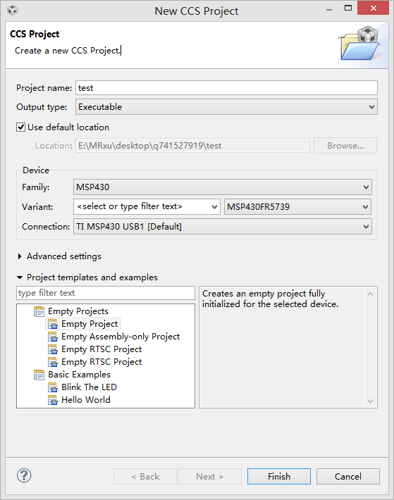
6、单击Finish
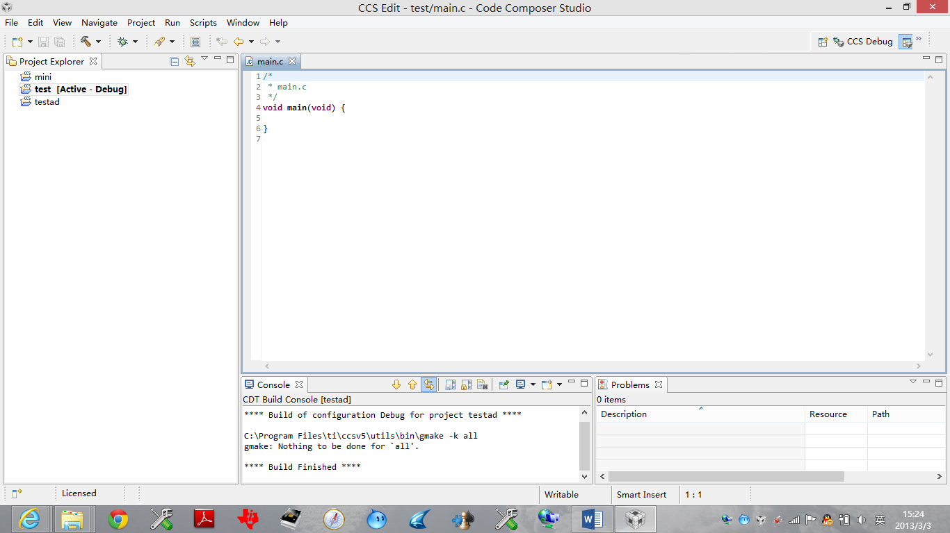
7、在“main.c”键入如下代码：（实现了LED灯的显示）
#include"msp430fr5739.h"

unsigned char date[]={
0X00,0X01,0X03,0X07,0X0F,0X1F,0X3F,0X7F,0XFF,
0X80,0X81,0X83,0X87,0X8F,0X9F,0XBF,0XFF,
0XC0,0XC1,0XC3,0XC7,0XCF,0XDF,0XFF,
0XE0,0XE1,0XE3,0XE7,0XEF,0XFF,
0XF0,0XF1,0XF3,0XF7,0XFF,
0XF8,0XF9,0XFB,0XFF,
0XFC,0XFD,0XFF,
0XFE,0XFF,
0XFF};

unsigned char i;
unsigned char j;
void main(void)
{
WDTCTL = WDTPW+WDTHOLD;
P3DIR |=BIT4+BIT5+BIT6+BIT7;
PJDIR |=BIT0+BIT1+BIT2+BIT3;
while(1)
{
for(i=0;i<45;i++)
{
PJOUT =date[i];
P3OUT =date[i];
__delay_cycles(500000);
}
for(j=45;j>0;j--)
{
PJOUT =date[j-1];
P3OUT =date[j-1];
__delay_cycles(500000);

}
}
}
附：
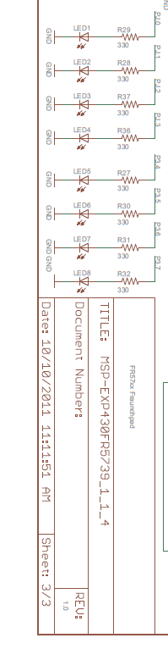
8、依次单击
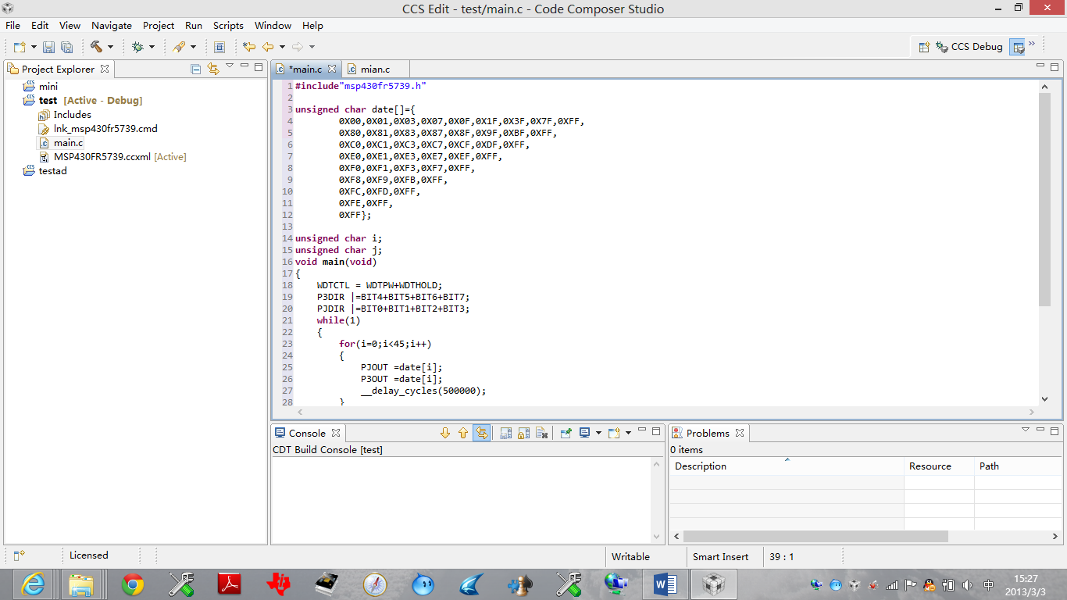
9、效果

