- 主电路拓扑
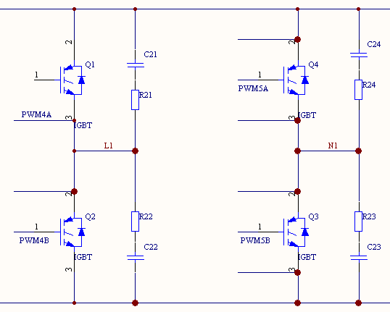
- PWM初始化设置
EPwm4Regs.TBCTL.bit.HSPCLKDIV =1; // /2
EPwm4Regs.TBCTL.bit.CLKDIV = 1; // /2
EPwm4Regs.TBCTL.bit.CTRMODE = 2; // up down
EPwm4Regs.TBPRD = EPWM4_TIMER_TBPRD; //set period
EPwm4Regs.TBCTL.bit.PHSEN = 0; // Disable phase loading
EPwm4Regs.TBPHS.half.TBPHS = 0x0000; // Phase is 0
EPwm4Regs.TBCTR = 0x0000; // Clear counter
// Setup shadow register load on zero
EPwm4Regs.CMPCTL.bit.SHDWAMODE = 0; //shadow mode
EPwm4Regs.CMPCTL.bit.LOADAMODE = 0; // zero load compare value
EPwm4Regs.CMPA.half.CMPA = EPWM4_TIMER_TBPRD;
EPwm4Regs.AQCTLA.bit.CAU=2;//force high,when incrementing
EPwm4Regs.AQCTLA.bit.CAD=1;//force low,when decrementing
EPwm4Regs.TBCTL.bit.SYNCOSEL=1; //计数器为零时输出同步信号
EPwm4Regs.DBCTL.bit.OUT_MODE = 3; //deadband enabled for both rising-edge and falling-edge
EPwm4Regs.DBCTL.bit.POLSEL = 2; //AHc mode
EPwm4Regs.DBCTL.bit.IN_MODE = 0; //EPWMA is the source
EPwm4Regs.DBRED = 30; //rising-edge delay
EPwm4Regs.DBFED = 30; //falling-edge delay

EPwm4Regs.ETSEL.bit.INTSEL = 2; // period interrupt
EPwm4Regs.ETSEL.bit.INTEN = 1; // enable interrupt
EPwm4Regs.ETPS.bit.INTPRD = 1; // Generate INT on first event

EPwm4Regs.ETSEL.bit.SOCASEL = 1; // 选择CTR=Zero 事件作为触发AD转换信号
EPwm4Regs.ETPS.bit.SOCAPRD = 1; // 每发生一次事件产生一次AD采样触发信号
EPwm4Regs.ETSEL.bit.SOCAEN = 1;

EPwm5Regs.TBCTL.bit.HSPCLKDIV = 1;
EPwm5Regs.TBCTL.bit.CLKDIV = 1;
EPwm5Regs.TBCTL.bit.CTRMODE = 2; // Count up
EPwm5Regs.TBPRD = EPWM5_TIMER_TBPRD; // Set timer period
EPwm5Regs.TBCTL.bit.PHSEN = 0; // Disable phase loading
EPwm5Regs.TBPHS.half.TBPHS = 0x0000; // Phase is 0
EPwm5Regs.TBCTR = 0x0000; // Clear counter
// Setup shadow register load on PERIOD
EPwm5Regs.CMPCTL.bit.SHDWAMODE = 0;//shadow mode
EPwm5Regs.CMPCTL.bit.LOADAMODE = 0;
EPwm5Regs.CMPA.half.CMPA = EPWM5_TIMER_TBPRD;
EPwm5Regs.TBCTL.bit.SYNCOSEL=0; //EPWM4SYNC
EPwm5Regs.AQCTLA.bit.CAU=2;//force high,when incrementing
EPwm5Regs.AQCTLA.bit.CAD=1;//force low,when decrementing
EPwm5Regs.AQCTLB.bit.CAU=1;//force low,when incrementing
EPwm5Regs.AQCTLB.bit.CAD=2;//force low,when decrementing

/*set deadband*/
EPwm5Regs.DBCTL.bit.OUT_MODE = 3; //disable deadband
EPwm5Regs.DBCTL.bit.POLSEL = 2; //AHc mode
EPwm5Regs.DBCTL.bit.IN_MODE = 3; //EPWMA is the source
EPwm5Regs.DBRED = 30; //rising-edge delay use TB clock
EPwm5Regs.DBFED = 30; //falling-edge delay

- 输出电压波形
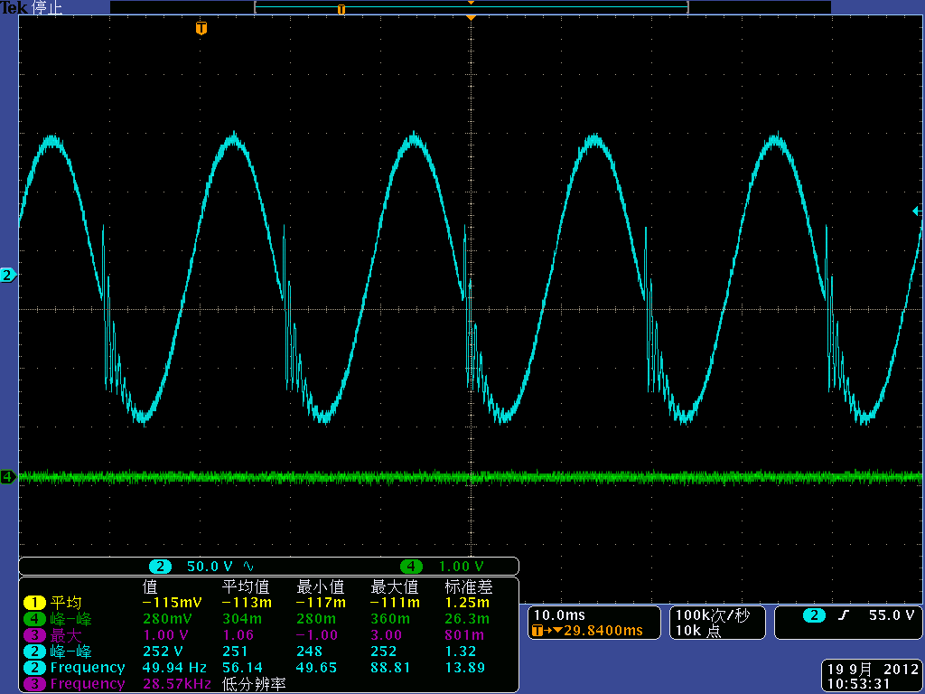

- 驱动波形
负向过零时1,3号管子的驱动波形
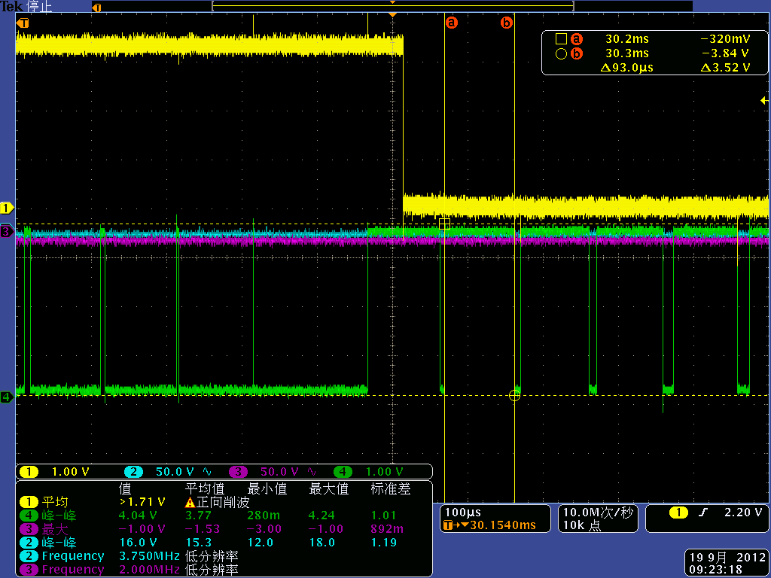
注： 1通道为1号管子的驱动波形
4通道为3号管子的驱动波形
正向过零时1,3号管子的驱动波形
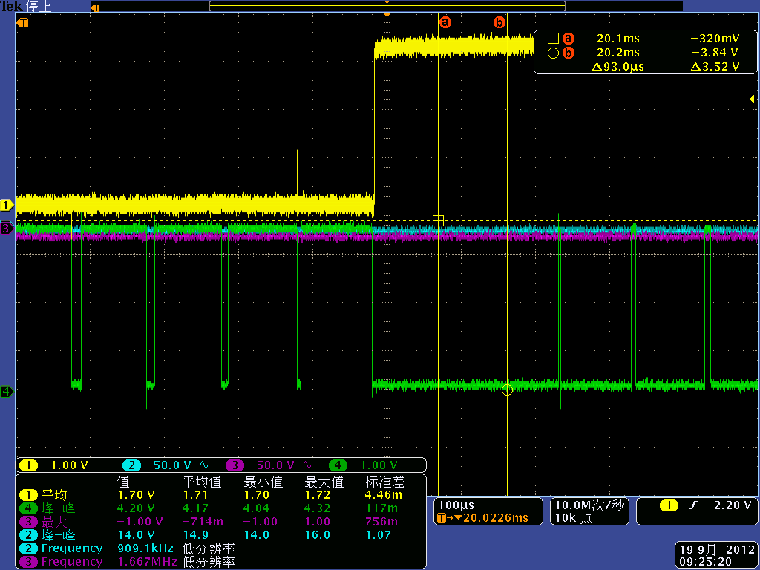

负向过零时2,4号管子的驱动波形
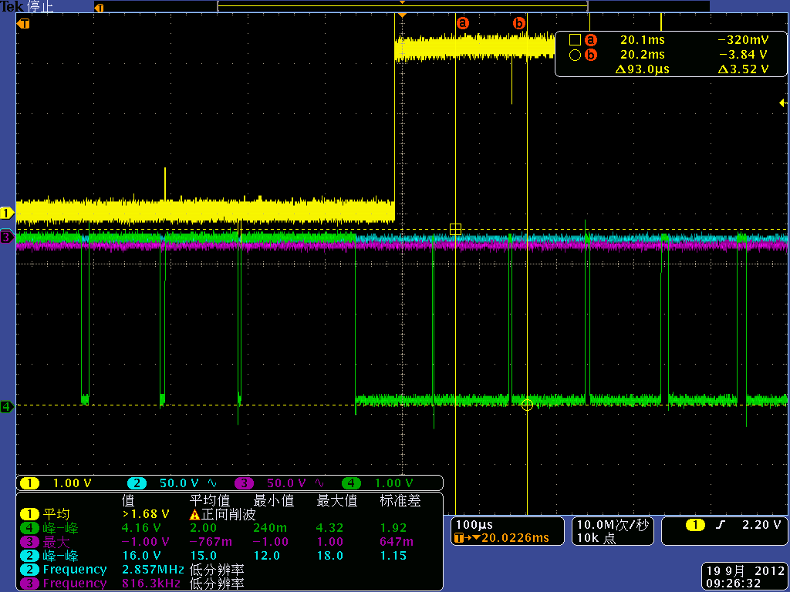
注：1通道为2号管子的驱动波形
4通道为4号管子的驱动波形
正向过零时2,4号管子的驱动波形
