TMS320F28027 - DSP/BIOS入门

1、File->New->CCS Project

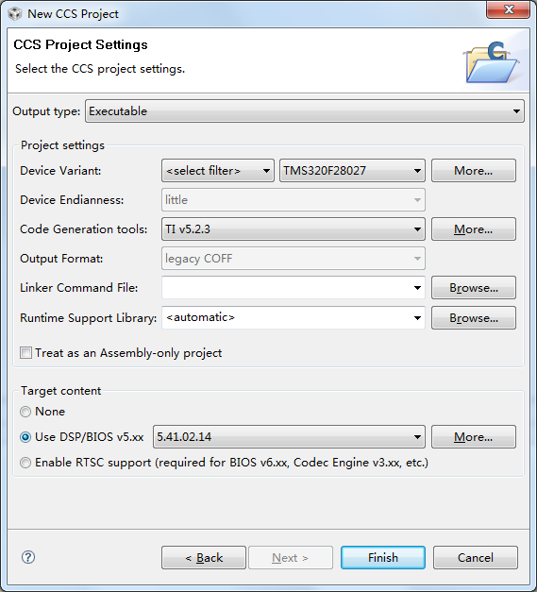

2、File->New->DSP/BIOS v5.xx Configuration File

3、配置PLL时钟
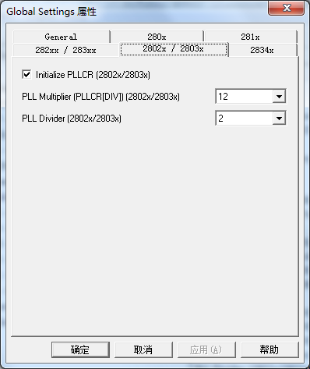

4、配置Dynamic Memory Heaps

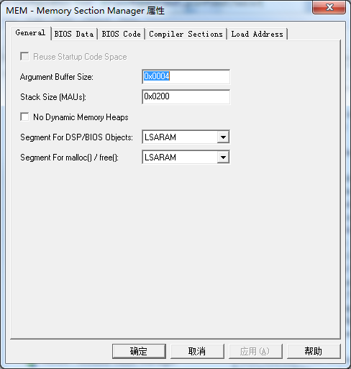

4、配置Clock
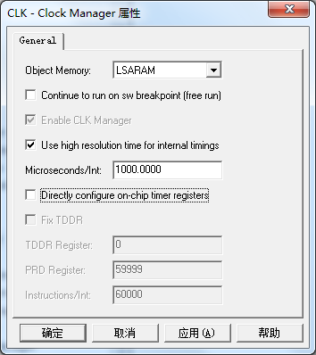

5、创建任务Task0

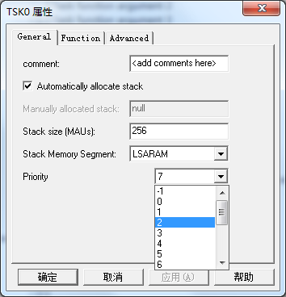

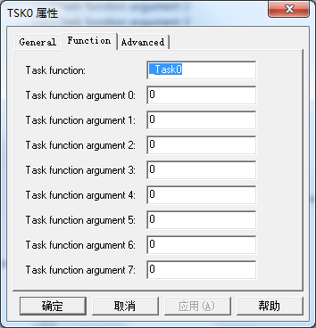

void Task0(void)
{
For(;;)
{
ToggleLed();
TSK_sleep(1000);
//TSK_yield();//相同优先级任务切换
}
}

6、Boot From Flash
定义UserInit
参照f28027.cmd创建MEMs，自由分配FLASH及RAM
更改Compiler Sections及Load Address

extern unsigned int trcdata_loadstart;
extern unsigned int trcdata_loadsize;
extern unsigned int trcdata_runstart;

void UserInit(void)
{
/*** Initialize the .trcdata section before main() ***/
memcpy(&trcdata_runstart, &trcdata_loadstart, (unsigned long)&trcdata_loadsize);
}

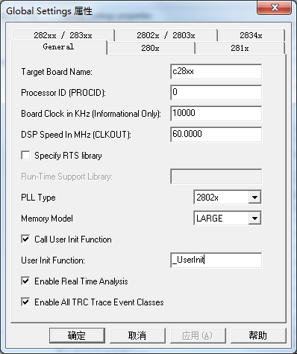
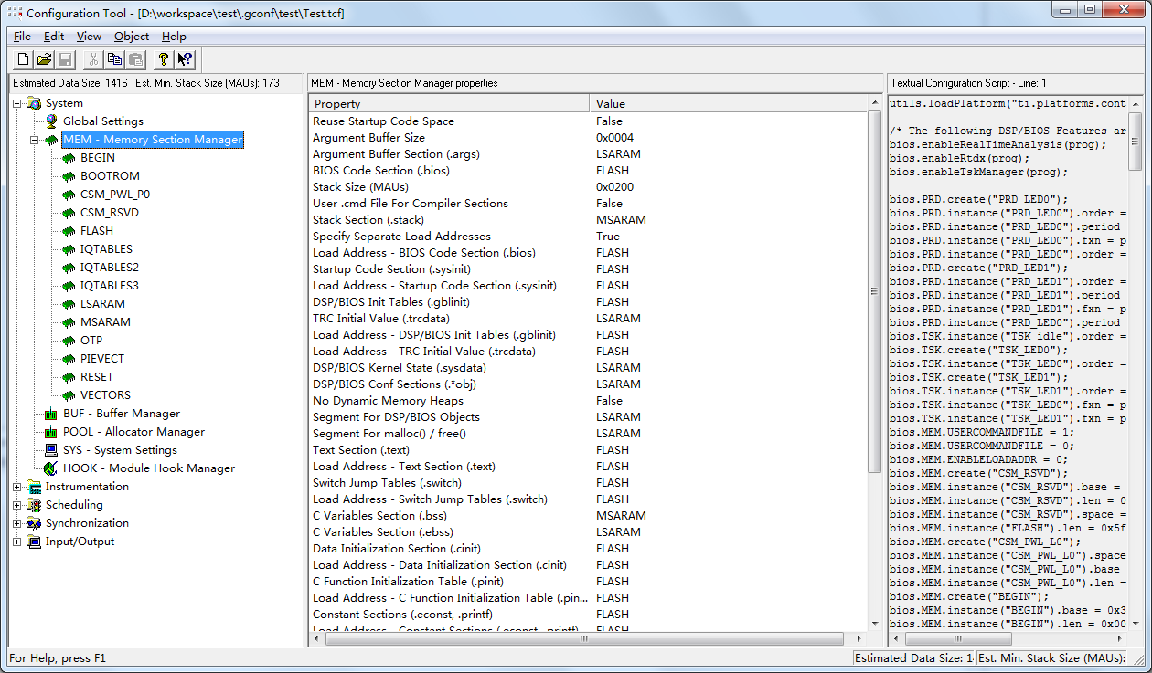

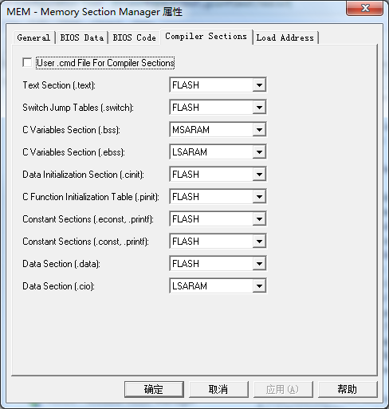

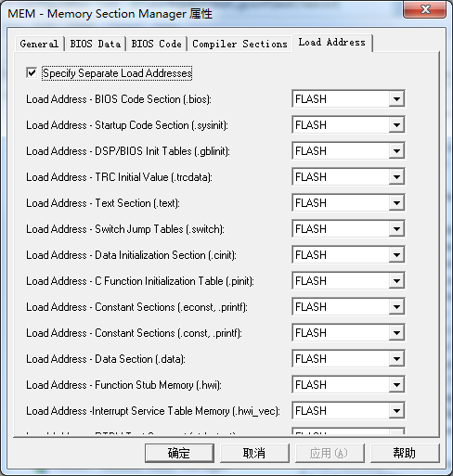

增加.cmd 自定义SECTIONS

SECTIONS
{

/* Allocate program areas: */
codestart : > BEGIN PAGE = 0
ramfuncs : LOAD = FLASH,
RUN = LSARAM,
LOAD_START(_RamfuncsLoadStart),
LOAD_SIZE(_RamfuncsLoadSize),
RUN_START(_RamfuncsRunStart),
PAGE = 0
csmpasswds : > CSM_PWL_P0 PAGE = 0
csm_rsvd : > CSM_RSVD PAGE = 0
otp : > OTP PAGE = 0

.reset : > RESET, PAGE = 0, TYPE = DSECT
vectors : > VECTORS PAGE = 0, TYPE = DSECT
}

初始化HWI
extern unsigned int hwi_vec_loadstart;
extern unsigned int hwi_vec_loadsize;
extern unsigned int hwi_vec_runstart;

void main()
{
asm(" EALLOW");// Enable EALLOW protected register access
memcpy(&hwi_vec_runstart+6, &hwi_vec_loadstart+6,
(unsigned long)(&hwi_vec_loadsize-(unsigned int*)6));
asm(" EDIS");
}

7、SCIa_Isr&Print(“Hello DSP/BIOS!”)

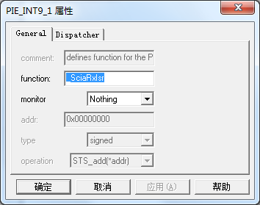

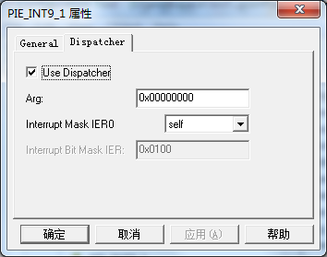

void InitScia(void)
{
//InitLedIO

//InitScia
CLK_enableSciaClock(myClk);
SCI_disableParity(mySci);
SCI_setNumStopBits(mySci, SCI_NumStopBits_One);
SCI_setCharLength(mySci, SCI_CharLength_8_Bits);
SCI_enableTx(mySci);
SCI_enableRx(mySci);
//SCI_enableTxInt(mySci);
SCI_enableRxInt(mySci);
SCI_setBaudRate(mySci, (SCI_BaudRate_e)(60000000UL/4/8/BAUD-1));
SCI_enable(mySci);
PIE_enableInt(myPie, PIE_GroupNumber_9, IE_InterruptSource_SCIARX);
CPU_enableInt(myCpu, CPU_IntNumber_9);
}

void SciaRxIsr(void)
{
//User Code Here

PIE_clearInt(myPie, PIE_GroupNumber_9);
}

创建任务Task1优先级高于Task0
void Task1(void)
{
For(;;)
{
Print(“Hello DSP/BIOS!”);
TSK_sleep(500);
}
}

其他文件
F2802x_asmfuncs.asm
\f2802x_headers\include and \source \cmd 直接寄存器访问
\f2802x_common\include and \source 库函数访问(driverlib.lib)

