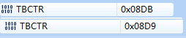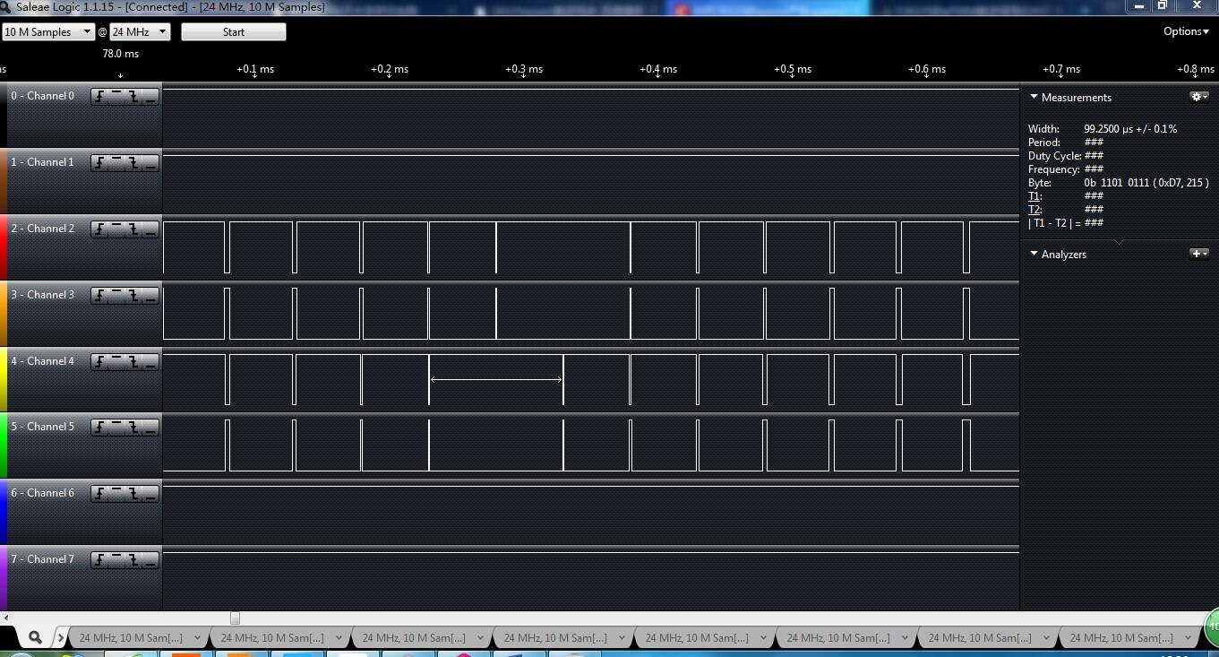

#include "DSP28x_Project.h"
//#include "IQmathLib.h"
#include "math.h"

#define EPWM1_TIMER_TBPRD 3750
#define EPWM2_TIMER_TBPRD 3750

void InitEPwm1Example(void);
void InitEPwm2Example(void);
interrupt void epwm1_timer_isr(void);
interrupt void epwm2_timer_isr(void);
Uint32 k1=0,k2=0;
Uint32 Sintable[200]={0,58,117,176,235,294,352,411,469,528,586,644,702,760,818,875,
932,989,1046,1102,1158,1214,1270,1325,1380,1435,1489,1543,1596,1649,1702,1754,
1806,1857,1908,1959,2009,2058,2107,2156,2204,2251,2298,2344,2390,2435,2479,2523,
2567,2609,2651,2692,2733,2773,2812,2851,2889,2926,2963,2998,3033,3068,3101,3134,
3166,3197,3227,3257,3286,3314,3341,3367,3393,3417,3441,3464,3486,3507,3528,3547,
3566,3584,3601,3617,3632,3646,3659,3672,3683,3694,3703,3712,3720,3727,3733,3738,
3742,3745,3748,3749,3750,3749,3748,3745,3742,3738,3733,3727,3720,3712,3703,3694,
3683,3672,3659,3646,3632,3617,3601,3584,3566,3547,3528,3507,3486,3464,3441,3417,
3393,3367,3341,3314,3286,3257,3227,3197,3166,3134,3101,3068,3033,2998,2963,2926,
2889,2851,2812,2773,2733,2692,2651,2609,2567,2523,2479,2435,2390,2344,2298,2251,
2204,2156,2107,2058,2009,1959,1908,1857,1806,1754,1702,1649,1596,1543,1489,1435,
1380,1325,1270,1214,1158,1102,1046,989,932,875,818,760,702,644,586,528,
469,411,352,294,235,176,117,58};

void main(void)
{
InitSysCtrl();
InitEPwm1Gpio();
InitEPwm2Gpio();

DINT;
InitPieCtrl();
IER = 0x0000;
IFR = 0x0000;
InitPieVectTable();

EALLOW;
PieVectTable.EPWM1_INT = &epwm1_timer_isr;
PieVectTable.EPWM2_INT = &epwm2_timer_isr;
EDIS;

EALLOW;
SysCtrlRegs.PCLKCR0.bit.TBCLKSYNC = 0;
EDIS;

InitEPwm1Example();
InitEPwm2Example();

EALLOW;
SysCtrlRegs.PCLKCR0.bit.TBCLKSYNC = 1;
EDIS;

IER |= M_INT3;
PieCtrlRegs.PIEIER3.bit.INTx1 = 1;
PieCtrlRegs.PIEIER3.bit.INTx2 = 1;
EINT;
ERTM;
for(;;)
{
asm(" NOP");
}

}

void InitEPwm1Example()

{
EPwm1Regs.TBPRD = EPWM1_TIMER_TBPRD;
EPwm1Regs.TBPHS.half.TBPHS = 0x0000;
EPwm1Regs.TBCTR = 0x0000;
EPwm1Regs.CMPA.half.CMPA = 1500;
EPwm1Regs.CMPB = 1500;
EPwm1Regs.TBCTL.bit.CTRMODE = TB_COUNT_UPDOWN;
EPwm1Regs.TBCTL.bit.PHSEN = TB_DISABLE; //禁止加载同步信号
EPwm1Regs.TBCTL.bit.SYNCOSEL = TB_CTR_ZERO; //同步信号输出
EPwm1Regs.TBCTL.bit.HSPCLKDIV = TB_DIV1;
EPwm1Regs.TBCTL.bit.CLKDIV = TB_DIV1;
EPwm1Regs.CMPCTL.bit.SHDWAMODE = CC_SHADOW;
EPwm1Regs.CMPCTL.bit.SHDWBMODE = CC_SHADOW;
EPwm1Regs.CMPCTL.bit.LOADAMODE = CC_CTR_ZERO_PRD;
EPwm1Regs.CMPCTL.bit.LOADBMODE = CC_CTR_ZERO_PRD;
EPwm1Regs.AQCTLA.bit.CAU = AQ_CLEAR;
EPwm1Regs.AQCTLA.bit.CAD = AQ_SET;
//EPwm1Regs.AQCTLB.bit.CAU = AQ_SET;
//EPwm1Regs.AQCTLB.bit.CAD = AQ_CLEAR;
EPwm1Regs.ETSEL.bit.INTSEL = ET_CTR_ZERO;
EPwm1Regs.ETSEL.bit.INTEN = 1;
EPwm1Regs.ETPS.bit.INTPRD = ET_1ST;
EPwm1Regs.DBCTL.all = 0xb;
EPwm1Regs.DBRED = 0;
EPwm1Regs.DBFED = 0;
}

void InitEPwm2Example()
{
EPwm2Regs.TBPRD = EPWM2_TIMER_TBPRD;
EPwm2Regs.TBPHS.half.TBPHS = 0x0000;
EPwm2Regs.TBCTR = 0x0000;
EPwm2Regs.CMPA.half.CMPA =1500;
EPwm2Regs.CMPB = 1500;
EPwm2Regs.TBCTL.bit.CTRMODE = TB_COUNT_UPDOWN;
EPwm2Regs.TBCTL.bit.PHSEN = TB_ENABLE; //加载同步信号
EPwm2Regs.TBCTL.bit.PHSDIR = TB_UP;
EPwm2Regs.TBCTL.bit.SYNCOSEL = TB_SYNC_IN;
EPwm2Regs.TBCTL.bit.HSPCLKDIV = TB_DIV1;
EPwm2Regs.TBCTL.bit.CLKDIV = TB_DIV1;
EPwm2Regs.CMPCTL.bit.SHDWAMODE = CC_SHADOW;
EPwm2Regs.CMPCTL.bit.SHDWBMODE = CC_SHADOW;
EPwm2Regs.CMPCTL.bit.LOADAMODE = CC_CTR_ZERO_PRD;
EPwm2Regs.CMPCTL.bit.LOADBMODE = CC_CTR_ZERO_PRD;
EPwm2Regs.AQCTLA.bit.CAU = AQ_CLEAR;
EPwm2Regs.AQCTLA.bit.CAD = AQ_SET;
//EPwm2Regs.AQCTLB.bit.CAU = AQ_SET;
//EPwm2Regs.AQCTLB.bit.CAD = AQ_CLEAR;
EPwm2Regs.ETSEL.bit.INTSEL = ET_CTR_ZERO;
EPwm2Regs.ETSEL.bit.INTEN =1;
EPwm2Regs.ETPS.bit.INTPRD = ET_1ST;
EPwm2Regs.DBCTL.all = 0xb; //高定平互补
EPwm2Regs.DBRED = 0;
EPwm2Regs.DBFED = 0;
}
interrupt void epwm1_timer_isr(void)
{
if(k1 >= 200)
{
k1 = 0;
}
EPwm1Regs.CMPA.half.CMPA = Sintable[k1];
EPwm1Regs.CMPB = Sintable[k1];
k1++;
EPwm1Regs.ETCLR.bit.INT = 1;
PieCtrlRegs.PIEACK.all = PIEACK_GROUP3;
}
interrupt void epwm2_timer_isr(void)
{
if(k2 >= 200)
{
k2 = 0;
}
EPwm2Regs.CMPA.half.CMPA = Sintable[k2];
EPwm2Regs.CMPB = Sintable[k2];
k2++;
EPwm2Regs.ETCLR.bit.INT = 1;
PieCtrlRegs.PIEACK.all = PIEACK_GROUP3;
}

